

Teachers’ notes

The Superpower of Looking:
the three wise men who visited Jesus

How to use this resource
In class, open a full-screen version of the zoomable image in a new window.
Use the prompts in these notes to guide your students through the lesson.

Contextual background for teachers
The Adoration of the Kings (1510–1515)
Jan Gossaert (c.1478–1532)
Oil on oak
H 177.2 x W 161.8 cm
The National Gallery, London
https://artuk.org/discover/artworks/the-adoration-of-the-kings-115396

This large painting illustrates the Biblical story of the three kings (also known as the wise men or magi) who came to worship the newly born Jesus and to give him their gifts.
According to the Bible, they had travelled a long way, following a mysterious star from the east that eventually led them to the stable in Bethlehem where Christ was born. His parents, Mary and Joseph, had not been able to find a room in an inn.
In Gossaert's scene, the stable has been substituted for a palace, now in ruins. Two shepherds are also looking on in the background, and beyond them, an angel sent by God is telling shepherds about the birth of Christ too.

Jan Gossaert was a French-speaking artist from the Low Countries. He was one of the first Northern European Renaissance artists to visit Italy and was employed by a range of royal and noble families. Across Europe during the Renaissance, new techniques in oil painting had been developed to such a degree that every texture and minute detail could be painted in the most astonishing way.
Gossaert seems to have painted this altarpiece between 1510 and 1515 for the church of St Adrian at Geraardsbergen in East Flanders (which is in Belgium today). It is said that the church had a piece of clothing belonging to one of the three kings in its possession in 1519, so this may be why Gossaert painted the kings' clothing in such rich detail.
On King Baltazar's crown, the signature of the artist can be seen. Text also appears in several other places within the painting. In blue at the bottom of Baltazar's scarf is written the start of a prayer. There is writing on the scroll held by the angel in green on the left which translates to 'glory to God in the highest'. Finally, on the lid of the chalice of myrrh at the Virgin's feet presented by King Caspar, his name is written.

Tip: if you'd like more insight into the painting before teaching the lesson, an audio description is available. It is accompanied by a full written transcript which can also be used to describe the painting.

Look, describe and discuss
You can start by showing the whole image, and then use the zoom feature to explore details of the painting. Or you might like to start by using the zoom feature to show a detail from the image, and then zoom out to see more.

Encourage your students to look carefully – this is their superpower! It’s best to not give too much background information about the artwork at this stage, so students can develop their own ideas and opinions.

Nudge questions
Now when looking at the painting, ask more specific ('nudge') questions:
- What do you think is going on here? Who or what does the artist want us to look at first?
- What do you notice about the people in the painting? Can we learn anything about their different characters?
- Besides the human figures, is there anything else in the painting that helps to set the scene?
- What smells and sounds might you experience if you were transported into the painting?

Questions from The Superpower of Looking Kit
Now we can start to explore the 'elements' of the painting. For this artwork, you will focus on figures, composition and light.

Ask your students to evidence their points:
- Where exactly are they looking when they make a statement?
- Can everybody see what they see?
- Slow down, take time to really look closely

You can introduce knowledge from the contextual background for teachers while asking these bespoke questions with helpful responses below.

Figures
- Who are the key figures in this painting? How is this made clear?
Christ and Mary are central, with the kings also in the foreground. Christ is seated as if on a throne and holds a gold coin.

- Look at the three kings. How can we tell they are wealthy? What does their body language tell us about how they view Christ?
The king on the left (Baltazar) has an attendant who carries his cape and stands with a gift offered out to Christ. He is wearing a crown, pearls, gold, lynx fur, and leather boots so fine we see the form of his feet beneath the surface.
The stance of the king with grey hair (Caspar) is respectful as he kneels before Christ with his hands held together as though in prayer. He is also wearing gold and jewels, as well expensive fabrics including fur and a patterned robe.
The king on the right (Melchior) wears clothing which is rich in detail, including tiny golden pins which hold the pearls of his hat in place.

- King Melchior is surrounded by figures. What do you notice about them? Are any looking at us?
While some of the men look beyond the edge of the painting, the second man from the right looks in our direction. The horse is also looking at us! He is carrying an old man who looks weary and seems to be using a stick for further support.

- Do you notice any other figures? Who do you think they are?
Nine angels are in the sky. A tenth peeps through the crack in a wall to the right of Joseph and above an ox (we can just see the white edge of one of its wings). Two shepherds watch at the back of the stable, with more shepherds on the hillside in the background.

Composition
- What can be found at the centre of the painting? What shape do the figures of Mary and Christ form?
Christ and Mary are positioned centrally – on what is called the central vertical axis. Together, their figures form a triangle shape. The curve of Mary’s outline is even mirrored by Joseph, the figure in red who stands behind Mary.

- Where in this painting do you think the artist used a ruler? Why?
The artist appears to have used a ruler to draw the lines of perspective in the tiled flooring; we can tell that the lines will meet as they recede towards the horizon line. This creates the illusion of three-dimensional space which draws us right back into the composition. The architecture is made up of lots of straight lines – a contrast with the rounded forms of the many figures in the scene.

- What can you say about the setting amongst the buildings? Does it look like a comfortable place for a baby?
Rather than the traditional stable, the setting is the ruins of an old palace with open and grand architecture. The shape of the buildings acts as a frame for Mary and Christ, emphasising the importance of the figures, and of the event that is taking place.

- What can you see going on in the distance and the hills around?
In the distance, we see a naturalistic landscape and diminishing figures who are all intending to gather at the scene. On the far right, we see a winding hilltop path with a continuous procession of horseback riders, all heading this way too.

Light
- Can you see a light source? Does it suggest a particular mood or time of day?
An oversized star, the Star of Bethlehem, dominates the scene from high in the sky. Stars are usually only seen at night, but this scene seems to be bathed in natural daylight. This helps to suggest a celebratory mood.

- Look closer at King Baltazar (standing on the left) and his possessions. Does light help us to distinguish between different textures?
There are differences in how the fabrics Baltazar wears interact with light: the thick furs absorb light, while the clean white scarf reflects it. His precious gold vessel reveals its hard shiny surface by reflecting the light too. All of these plays on light emphasise that Baltazar's belongings are precious and expensive, and that this is an important event.

- Does light help us to pick out other important elements in the painting?
Light is also used to illuminate key elements of the scene, e.g. Christ appears starkly illuminated against Mary’s dark blue robe.
Everyone learning
You can find out more about The Superpower of Looking SEND/ASD/ALN/ASN approach on the Superpower homepage.

Now it's time to explore the artwork in different ways. This list of sensory activities encourages students to apply their learning and can suit a variety of learning needs.

Make
We suggest creative activities for all learners, including a tactile option to support students with vision impairment: these activities explore the tactile qualities of materials or involve gestural mark-making to further explore the artwork.

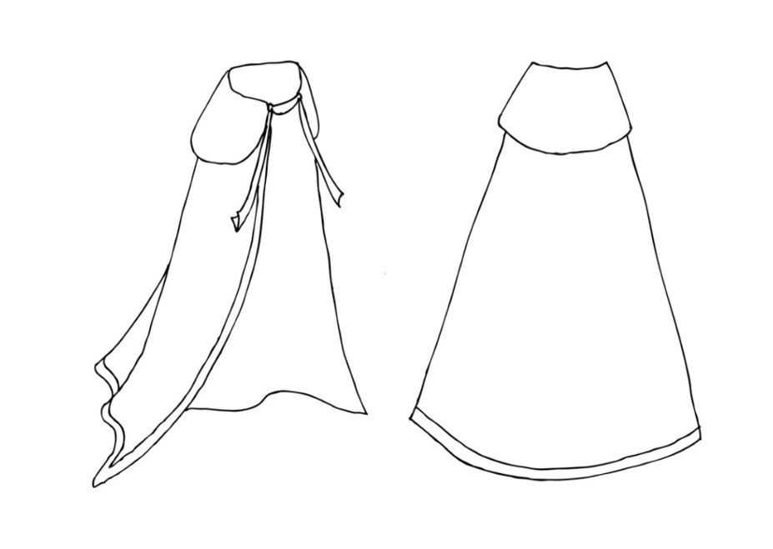
- Students could design their own royal robes in their sketchbook, including different patterns, textures and colours. Are they patterned all over, or just in the border? Can they include their name as a hidden detail like in the painting? Print out this template: students can either colour them in or use them for reference for their own drawings.

- Tactile option: the feathered wings of the angels are based on bird wings. Cut out a pair of wings from card for your students. Cut out short strips of paper (like feathers) and glue one row of paper strips across the bottom of the wing. Next, glue a second row just above the first so that the feathers start to overlap. Keep building up the rows until you have made the texture of a feathered wing. You could even change the colour of the paper after a few rows, taking inspiration from the colour of the wings in the painting.

Experience
- Create a sensory box: fabrics in the painting include velvet, fur (you could use a fluffy teddy or a faux fur hat!), brocade, tassels (look for curtain accessories), silks/satins and ribbons. Collect feathers: long ones like pigeon feathers, and maybe even peacock feathers like the ones on the left of the painting. Find a decorative metal box, candlestick or vase. Don’t forget scent: essential oils are widely available to recreate two of the gifts, frankincense and myrrh.
- Listen to the audio description of the painting.
- Learn We Three Kings on the recorder.

Communicate
- Learn the Makaton signs for ‘angel’ and ‘king’.
- Create a procession around the classroom as if the class were ordinary people journeying to see Jesus. Encourage students to share conversations about how they are feeling and what they expect when they arrive.

Final stage: review
Ask your students to:
- share their sketchbooks in groups and discuss the 'elements' they have identified
- choose an element/aspect they find most interesting about the artwork and record it in their sketchbooks
- choose their own name/s for the title of the artwork
- think of a question they would like to ask the artist

Congratulations!
You have now completed The Superpower of Looking lesson resource.
There are more resources in this theme to try – have a look in the ‘next lessons’ section below.

Next lessons
Now try these other lesson resources as part of the history theme:
A lady, a curse and tales of King Arthur
A battle in Renaissance Florence
Pop Art planes inspired by comics

