Surrealism, Salvador Dali, and Edward James
Source: | https://artuk.org/learning/resources/surrealism-salvador-dali-edward-james
Key Stage | Art Terms | Resource Type | Topics
KS2 (ENG) | Surrealism | Lesson Plan | Dreams

Overview
Find out about Surrealism and then using cheap materials make a Surrealist sculpture yourself. This lesson can be used:
- As an introduction to Surrealism and the art of Salvador Dali.
- To develop idead and understanding of processes and materials.
- As part of study of any artist using automatism, juxtaposition, and dream sequences in their work.
- As part of individual study

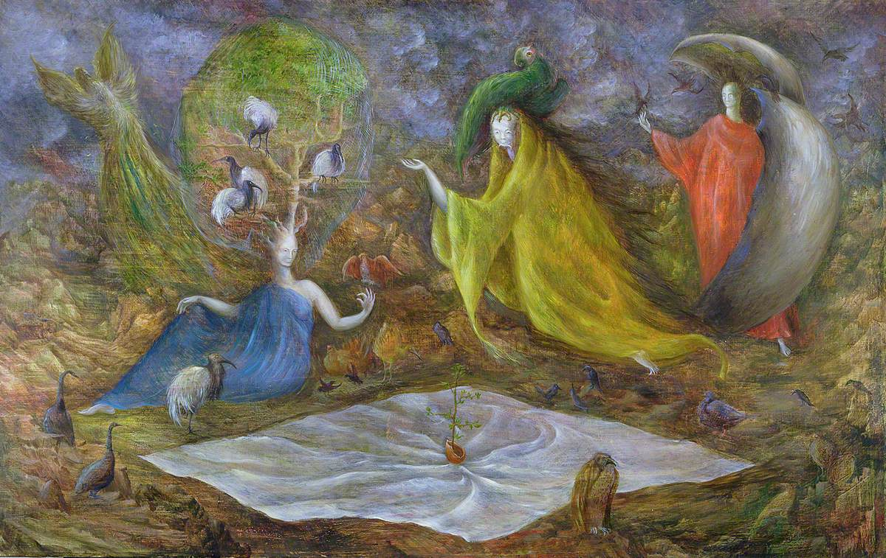
The Pomps of the Subsoil 1947
Leonora Carrington (1917 – 2011)
Sainsbury Centre for Visual Arts
https://artuk.org/artworks/1831

Learning Outcomes
- Pupils should increase their understanding of Surrealism and the Surrealist artist’s interest in the unconscious mind.
- In addition, students can gain knowledge and understanding of this work and approaches of artists, designers from historical contexts
Questions about Metamorphosis of Narcissus

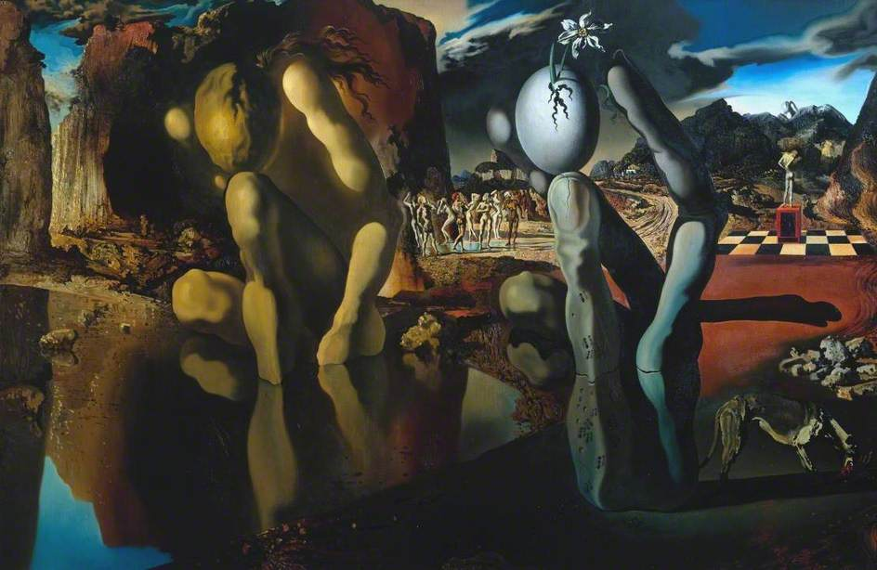  Metamorphoses of Narcissus  Salvador Dali (1904 – 1989)  Tate  https://artuk.org/artworks/117794 | - What was your first reaction to the artwork?  - What elements seem dreamlike or imaginary?  - What do we know about the artist after viewing this artwork?  - How did the artist use line, shape and colour to contribute to the mood?

Activity: Exquisite Corpse

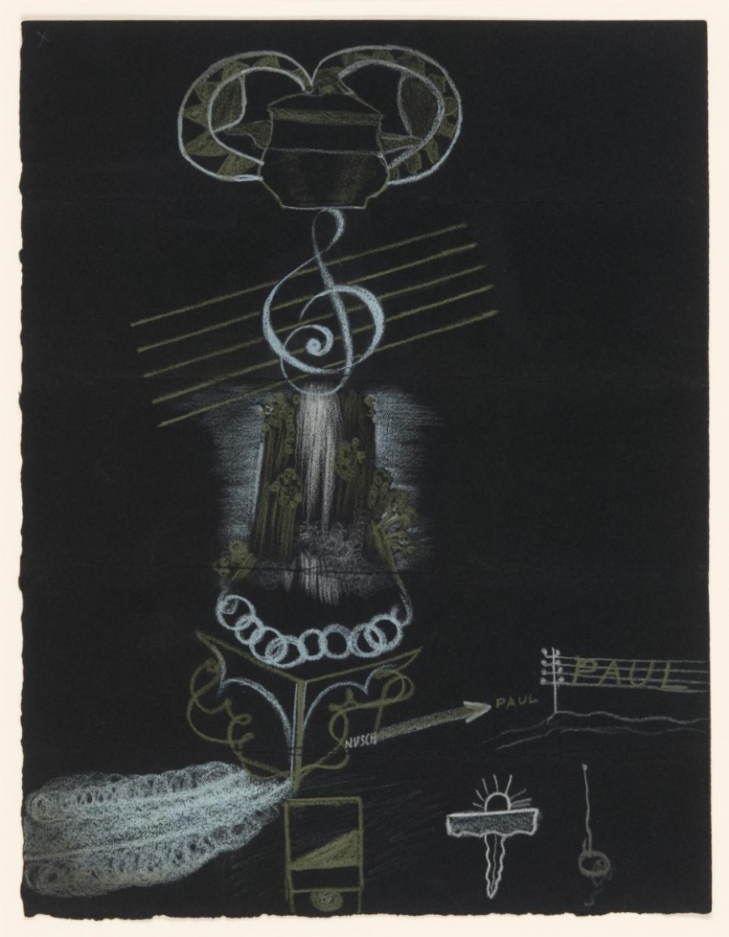  Metamorphoses of Narcissus  Salvador Dali (1904 – 1989)  Tate  https://artuk.org/artworks/117794 | Have a go at this game yourselves. Fold a piece of A4 paper into four equal sections. In the top section the first person draws the head of a creature.  Make sure there are two lines from the neck that are visible on the next fold and pass the paper to the next person. The second person draws the upper body, the third the lower body, and the fourth the legs,feet, or tail.  When the paper is unfolded, there should be a unique fantasy creature produced as the product of four minds.

Stetch and Challenge
There are a number of other resources on CultureStreet about artists influenced by Surrealism in their work that can be used to support this lesson plan. You could start with Joan Miro who made sculpture as well as paintings. There is also a creative writing workshop from Seven Stories in which children produce imaginative writing that links to the experiments the Surrealists tried in the 1920’s.
Further Reading
Get more inspiration for this lesson by exploring our stories:
The art of dreams: creativity through the unconscious

