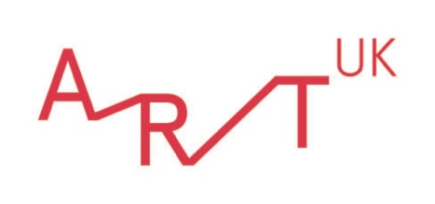

The Superpower of Looking Kit

About this resource

This kit is a central resource for The Superpower of Looking, helping to unlock the power of any image.

Using a 'questions' approach, The Superpower of Looking (SPoL) gives anyone the ability to explore a work of art and develop their visual literacy skills. Head to The Superpower of Looking homepage for an overview of the full resource which has been designed for KS2 / CfE Second Level.

The Superpower of Looking Kit is copyright © 2021 Alison Cole and Penny Huntsman, hosted by Art UK. All rights reserved.

Supporting students to read pictures by themselves

There are certain simple questions you can ask yourself and your students when looking at art. Answering these questions can reveal the unique elements that make up that work of art. This question and answer method will increase their visual literacy – The Superpower of Looking. By repeating this process with your students across Superpower lessons, previously hidden or encoded meaning will become increasingly easy for them to decode. In the process, students will become familiar with a vocabulary that will help them analyse and articulate what they see.

Below, key elements which make up a painting are explained alongside a set of questions to support students to interpret them in relation to different pictures and images. They are: composition, space, colour, line, light, scale, materials and techniques, and finally, figures – their expression, gesture, symbols and attributes.

Before you start, the following film demonstrates The Superpower of Looking Kit in action: https://www.youtube.com/watch?v=XgEmRM5YCWA

Top tips

- Complete the initial stages in each Superpower lesson plan first; when you get to Stage 3, there are suggestions as to which elements of the Kit to focus on in relation to each picture.
- It may be worth considering narrowing down how many questions you ask at one time by focusing on those most relevant to a particular work and/or those not yet covered in previous discussion.
- Reword or rephrase questions to suit the current knowledge and understanding of your students; their art vocabulary and confidence in using it will increase across each lesson.

Composition

Composition refers to the shapes within the picture and the arrangement of the picture.

Is the painting upright (portrait shaped) or horizontal (landscape shaped)?

How has the artist chosen to fill the space (picture plane)?

Where are our eyes led first? (Tip: try squinting, it really helps!) Are we made to focus on anything in particular? Has the artist 'zoomed in' on anything? Why?

Can you see any shapes in the picture, e.g. squares, circles, triangles, rectangles? Are any of these shapes used more than once? When the same shapes are used repeatedly does it create harmony (like notes in music)?

Is the painting symmetrical or asymmetrical? If it is not symmetrical, is it balanced?

Are there any framing devices, e.g. if there is an object on the left-hand side of the painting, is it balanced by another on the right? Is it random, or even chaotic?

Has the subject matter been cropped or edited, in the same way that we can adjust an image on our camera/phones? What does this tell us about what the artist finds important?

Is the work still or is there a sense of movement? If so, is the movement gentle or dynamic? Does it move in a certain direction? Do brushwork and line create a sense of movement?

Colour can also be used compositionally, to help organise the picture and direct your eye, e.g. red advances (stands out), blue recedes (stands back). Some colours like black or white are really powerful. Is colour used compositionally in the work?

Light and shade can also be used to direct our eye and focus our attention. Has the artist used light to illuminate certain things, as in a film, or even shadow to draw our attention?

Gesture can also be compositional. For example, is the way people use their arms and hands being used to direct the eye to key elements in the picture?

Space

- Has the artist created a believable space? Although the canvas is flat, do we feel that we could enter the space? Do you feel you could walk deeper into the painting? Do the objects/figures become smaller in size as they get further from us?
- Is there an obvious arrangement of space: a foreground, middle-ground and background? Is the creation of a convincing space important to the artist? If not, what do you think is more important?
- How has the artist created the illusion of three-dimensional forms in space? Have they used line? Does line create the sense of a door or window opening into another space? Do parallel lines recede in a checkerboard floor?
- Has the artist used colour to help create a sense of distance, e.g. the colour becomes paler as it gets further away?
- Has the artist used shading/modelling to create three dimensional, solid-looking forms, e.g. shading on a face or other object?
- Are there any shadows thrown by figures or objects to imply three-dimensional space?
- Are we made to look up or down at the object (we call this a high or low viewpoint) or are our eyes meeting the object at the same level? What effect does this have on our interpretation of the subject?
- Is anything shown at a dramatic angle that makes the object look believably realistic (three dimensional in space) either as it recedes or advances towards us (foreshortening)?
- Has the artist used layering and/or overlapping to create a sense of space?

Colour

For some artists, colour is very important; for others, it may be line or brushwork. It's up to us to work out the importance of colour and its significance by asking a few questions.

- What range of colours has the artist used? In other words, what is their colour palette? Perhaps the artist has used very little or no colour (black/white/grey – monochromatic). Has the artist used primary colour (red, blue, yellow)?. These colours are bright and pure so what effect do they have? Has the artist used secondary colour (orange, green, purple)?
- Has the artist used warm colours (red, orange, yellow) or cool colours (blue, green turquoise), or both, and if so, how does that affect the way we feel about the painting?
- Has the artist used complementary colours (these are opposite colours such as red/green; yellow/purple; orange/blue)? These combinations provide a 'pop' effect. Why has the artist chosen to use colour in this way?
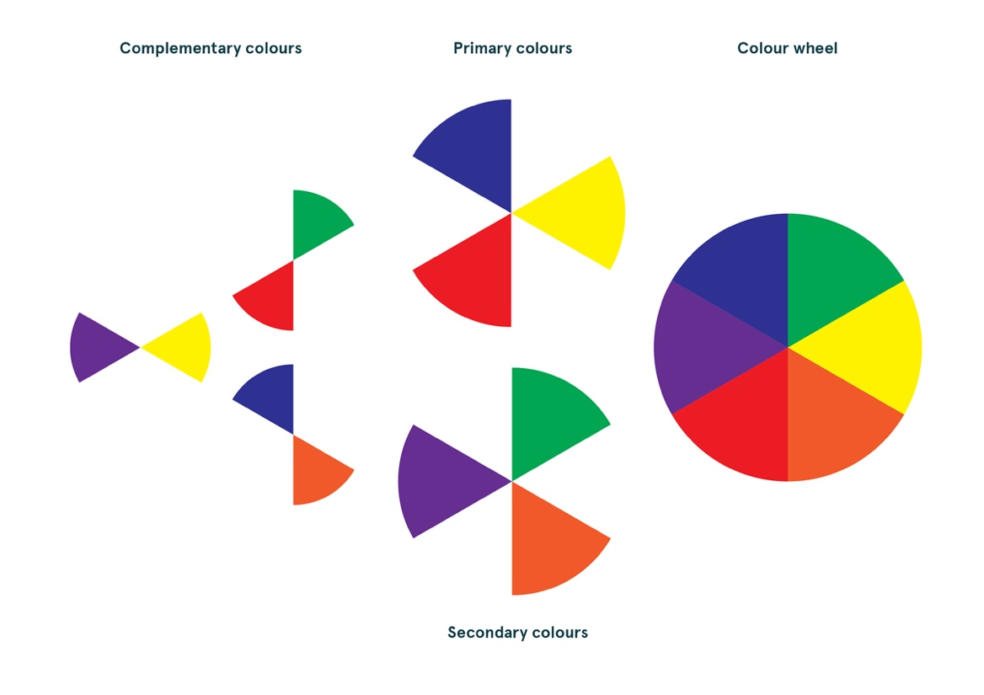
- Has the artist used saturated colour (bright and vivid) or is the colour pale and washed out?
- Has the artist used colour descriptively, as we see it in nature (the real world) or expressively and non-naturalistically?
- Is the painting modelled to create a realistic three-dimensional effect or is it flat, using colour in blocks, to create a two-dimensional effect?
- Has colour been used expressively to express emotion and create mood, e.g. psychological tension?
- Has colour been used symbolically, in accordance with social convention, e.g. darker colours signifying low mood or evil, red signifying passion or war, depending on the context?
- Have similar colours been dotted around to create a sense of unity in the composition? Or, has colour been used to create clashing disharmony?

Line

- Do we notice outlines in the painting or are the lines invisible as they are in real life?
- Does the brushwork include prominent lines? To what effect? Does the artist use brushwork to create patterns, movement or texture?
- If line is present, is it thick or thin, rounded or angular (straight)?
- Is the object/subject contained by line or broken up by it?
- Is line used very carefully to make things look realistic or is line used more expressively (distorted) to create a feeling or a mood?
- Have lines been used to make the painting more interesting, e.g. as diagonals are more dynamic than vertical or horizontal lines?
- How does the use of line create a sense of movement?

Light

- Can you see a light source or light sources in the work? Is it man-made like a candle or a lamp, or natural like the sun or moon? Does light help to create mood? Does the moon create a frightening atmosphere in the same way that the sun creates a happy one?
- Does the light look realistic, e.g. are there shadows?
- Does the light help you to distinguish between different textures, e.g. hard objects or soft fabrics, flesh or furniture?
- Does light pick out the most important element of the composition?
- Does light change as we go from the foreground to the distance: how does this help create a feeling of space and atmosphere?
- How do light and shadow create a sense of volume – a three-dimensional quality? The use of a strong tonal contrast in this way is known as chiaroscuro (pronounced 'kee-AR-uh-SKOOR-oh').
- Does the light suggest a time of day? How important is this to the story that the picture tells?

Scale

- Are the painting's dimensions particularly large or small? Where do you think it might have hung, e.g. in a grand palace or a private room? How do size and scale relate to meaning and status?
- Are some elements in the picture larger to imply importance?
- Tip: the dimensions of works are provided in the context box near the beginning of each lesson plan page and on the artwork's individual page. Use rulers or metre sticks to measure out the size of an artwork in class, on the floor or on a whiteboard.

Materials and techniques

- What has the artist painted on? A canvas, wood, tin?
- What type of material (medium) has the artist used, e.g. oil paint, acrylic paint, etc.? What effect does the choice of medium have on the appearance of the work?
- What are the characteristics of the medium?
Oil: this medium dries slowly and can be blended to create the illusion of reality (a three-dimensional world). Brush marks in oil paint can either be hidden (disguised) or applied boldly and thickly (impasto) to create more texture and a sense that the paint has only just been applied (immediacy).
Acrylic: this medium dries more quickly than oil and so shading (modelling) is more difficult to achieve. This makes an acrylic painting look flatter and more graphic in comparison to one painted in oil. The flat blocks of colour characteristic of acrylic create a more modern feel.
- Tip: the medium of each artwork is provided in the context box near the beginning of each lesson plan page.

Figures

A careful look at the figures can reveal a great deal about their character and the narrative (story) of the scene.

Expression: happiness through a smile; sadness through the downward inclination of the corners of the lips, perhaps tears and a furrowed brow; surprise through raised eyebrows and mouth ajar; anger through flared nostrils and perhaps even exposed teeth; disgust through a wrinkled nose and bulging cheeks, etc.
- How would you describe the expression of each figure? What might this tell us about them?
- If the artwork has a multi-figure composition, do the figures have different expressions and do these help to tell a story?

Gesture: the action, form and pose of a figure such as the way we can communicate using our bodies, e.g. through our hands or another body part. Some gestures can be emphatic such as punching the air, splaying fingers or pointing a finger at someone. Other gestures, such as standing strong with both feet grounded, may convey confidence in a figure.
- Does the figure's pose and/or gesture show us what they are thinking or feeling?
- Does the figure's pose and/or gesture direct our gaze anywhere? (This overlaps with composition.) Does gesture create movement or a sense of direction on the canvas?

Symbols and attributes: symbols offer a second and deeper meaning, and in art can be found in many forms including clothing, jewellery, animals, plants, etc. For instance, a rose can be a symbol of love. An attribute is usually an object which often has symbolic meaning, e.g. Saints can be identified by their attributes – keys often identify Saint Peter (keys to heaven).
- What are the figures wearing? Is this symbolic in any way? e.g. leg-of-mutton sleeves could indicate royalty, as in Elizabeth I's Armada Portrait.
- Are they in possession of any objects? What does this tell us about them? e.g. the globe and the crown indicate power over the seas and Queenship, respectively, in the Armada Portrait.
- How does the appearance and/or attributes of each figure compare with others in the picture?

Art UK

Art UK is the online home for every public art collection in the UK. We are a charity, and our website represents a collaboration between over 3,300 British institutions. Through our work, we make art available for everyone – for enjoyment, learning and research.

Art UK is the operating name of the Public Catalogue Foundation, a charity registered in England and Wales (1096185) and Scotland (SC048601).

https://www.artuk.org

