Milan, 05/12/2020

To the kind attention of the dr . Marion Richards and of the
Art Detective UK and of RAM

Distinguished Dr Richards and companions of search ,
here under I will report some further information collected in Bergamo, after having exceptionally, in this period of pandemic, moved for one day to the Mai Library to get a look to some papers , that I've thought for the descriptions given that could have reported some more details to comprehend the genesis of the Giacomo Mazoni’s marble kept by RAM.
I apologize of not having shared those information before, but I hoped to give a complete answer including also the photographs promised me another time by Dr Clelia Epis , after contacting her another time between the 7th and the 10th November (archivio@teatrodonizzetti.it ) , some other ones coming from the first piece placed into the Lochis Chapel in Mozzo . I hoped also that the responsible to the collection of newspapers of the Mai Library would have replied another time to a precise request made on the article published by the eco of Bergamo on the commission of the Piatti bust owned by the Donizzetti, but no answer , till now. It wasn’t’ impossible to have till now those information, as it was now, clearly assumed that is impossible to have some more documents on Giacomo Manzoni , due to the fact that were not found some living relatives, or people having some additional materials recollected on his life and his artistic path and career . By the living nephew of a cousin of the last grand nephew of the Cellist Piatti I was made aware of the sad history interesting the family Piatti Lochis and how probably the familiar heritage had been erased by many dispersions and by thefts, also ocurred close to the transfer of the great grand nephew of A Piatti, the poet and female artist of a greatheart Rufina Ruffoni -born in 1908 in Grezzona - to an hospice. So that it's impossible to find some relevant additional information on the commission of the Celli busts. Other information can be only traced by the texts analyzed by me in Bergamo and by the ones pointed out to me by dr Annalisa Barzano' Lodetti, the titular of "My Cello" website that has had the possibility, in past, to read all the papers of the fund Lochis PIatti stocked into the Mai Library of Bergamo.
1) Bergamo, Biblioteca (Library) Angelo Mai Found Piatti – Arnal, 1712 (n. 8) .
Parchment of great format produced for the dedication of the bust to Alfredo Piatti (1903),reporting as first signature the one of Arrigo Boito .

Format : 33,0 cm X 45, 0 cm ; Date ; 28 /03/1903
Text (tr.) : Present the undersigning Masters and Artists/ With the auspice /of the daughter widow Countess Lochis / the evening of the 28 march 1903, into the Lochis Villa / at the Crocette of Bergamo / has been inaugurated the bust of the great Cellist / ALFREDO PIATTI /[following the autograph signatures of : Arrigo Boito / G. Gallignani / Salvatore Gallarati (?)/ Fanny Davies March 25 th 1903/ Maria Goodwin / A. Simonetti / W. E Whitehouse /Lucy Stone /Cecilia Galli (?) / A Great concert succeeded as a real feast of art / closed / the unforgettable evening with the plause /of admirators , of kin, of friends .
Among the people signing the parchment there is the name of cellist Whitehouse. The name of the Whitehouse is kept (with its address ) also into an address book dedicated in 1902 by Costanza Piatti to her daughter Margherita (the only surviving object of Lochis remaining into the hands of the nephew of the cousin of Rufina Ruffoni ) .
2) Bergamo, Biblioteca (Library) Angelo Mai Papers Piatti – Ruffoni , MIA DEP. 54
Letter sent to the director of the Musical conservatory Donizzetti of Bergamo fro the Gavarana of Grezzana 08/01/1951

The letter expresses the desire of the “only and last living nephew “ of the Piatti to move the mortal rests kept into the Chapel of the family Lochis into the fraction of Mount of the city of Mozzo to the Church of Santa Maria Maggiore in which are storaged the body of Mayer and of other musicians. Into the church of Mozzo, over the tomb, it was left a gravestone lied down by his great friend Arrigo Boito which reports a a text reffering of the dead person and of his values. She has asked for the translation due to the fact that “the tomb was left in complete abandon , because the Lochis property has been all sold , and her, the only surviving direct nephew , was living from many years , into a stable way in Verona “.

3) Bergamo, Biblioteca (Library) Angelo Mai Papers Piatti – Ruffoni , MIA DEP. 51.
A black notebook bounded by the stationery shop Francesco Zappini in Verona , reporting on the cover , in silver letters , the script “Alfredo Piatti”. Inside this notebook, over the first pages there’s an autographic dedication left by Rosa Piatti Lochis in Ruffoni to her son and to her daughter “ To my dear sons Rienzo and Rita Ruffoni 20 August 1902, the mother Rosa “.

The first publication bounded into this notebook is the text edited by DOTT. V. CAMPLANI , a biography on Alfredo Piatti (Alfredo Piatti, Cenni biografici, Bergamo, Tipo- Litografia Mariani, 1902, ). Of this book were reproduced with some photographs taken by the pages 54, 55, 56, 57, 58, 59 and 60, shared in the next pages , reporting of his retirement in Italy , when in 1898 he has decided to spent his later days with her daughter Costanza, divided between some long staying for the summer and autumn vacations into a villa in Como Lake at Cadenabbia (Villa Piatti , where he hosted "his old friends and English acquainted people" p. 54) and the long stays in the house in Crocette. “But his later years, instead of flowing quitely , were shocked by a sequence of tremendous accidents. In the beginning of the January 1898 , when he was obliged to a long stay at Cadenabbia withheld by a pneumonia , he had to left his villa in a weakness state to move to her daughter's house in Crocette , because it was going to be overwhelmed by the flood of the Como lake' that had interested the docks and the gates of his residence (p. p. 54 – 55). The later year he suffered a lot for the sudden death of his son in law, the count C. Lochis, caused by a “cruel and inexorable disease “ two days after coming back to Crocette from Rome. “From that moment on , his already damaged health collapsed. The cold seasons were very frightening, so he was forced to live a life, we would almost say relegated “ . Despite his illness, he continued to work and to revise his to read , to revise his compositions aided by her daughter and by some professors of the Pia Scuola (the Bergamo's conservatory) that have played also with him some music, remembering the past times. Among the persons that have visited in past Piatti, there was the commander Boito that was waiting by a long time to have a Piatti's portrait , but he had withheld himself , as long as , helped by the cellist's daughter, he has received one with a long dedication composed as a virtual dialogue between the two visitors in which Piatti presented as a "friend and admirator "of Boito. Boito has replied this kindness with the letter “as pretty as sculptural “ sent the 26 th march 1900 from Milan in which he has given a lot of thanks to the daughter of the musician and to the musician himself for having received the portrait so desired for a long time . Then Boito, after taking a lot of joy from the humoristic scene written into the dedication, decided in his letter to name Piatti as" distillator of pure spirits of art, of musical quintessentials , you that are a squeezer of souls" (p. 56) , concerning that he was first named by the cellist as a "doctor". The letter continued to be arranged with a direct reference to the portrait and to the fact that the musician was holding a book of the "Divine Bach " with him that the cellist can claim to have "squeezed " very well . He had closed the letter , after some comparisons funny developed on the "squeezing" with a wish made to the cellist : "Life is therefore a juice. I wish you (a life ) sweet and juicy for many and many years yet." The biography continued referring the last months of Piatti spent with the daughter Costanza in playing Schubert , his most favorite author, and his preferred the most piece, the Ave Maria that the cellist considered as a “Sea” . He composed also his last work in 1901 - mostly unpublished - a “danza moresca”, pushing the author of this life to make a comparison with the friend Verdi that have closed his career with an “opera buffa”. Camplani remembered of having seen for the last time , in June , the cellist, finding him entertained in the reading of a comical letter criticizing a ballet opera defined as a failure in the beginning of the '800. (p. 57) Two days before dying, leaving his hands into the ones of the daughter , he was working to a reduction . The author of the biography continued to remember the great number of sincere condolences received by Costanza by England and by English people, the articles published by the foreign press, and how forgotten Piatti was by the journals of Milan, despite being a former student of the local conservatory , only being mentioned for the next selling of his Stradivari for the marvelous sum of 100.000 lire. Camplani goes on remembering the Piatti’s burial and a commemoration done days after : “After an impressive funeral, a spontaneous reminder of the esteem he enjoyed, he was buried in the family tomb of the Lochis Counts, there near the Crocette, where the austere Bergamo hill descends majestically, down with a gentle slope, skirting the pleasant valley, and to rest, lapping with Brembo blue. There, in that site of peace of poetry, before the ceremony was over, a nucleus of elected artists of the Pia Scuola Musicale di Bergamo performed, amidst religious meditation, an andante for string quartet, of posthumous works by Schubert, a favorite of the glorious artist and designated by his taste in life and desire after death. A few days later the same memory was renewed in the chapel, assisted by close friends and convinced admirers. That piece is well worthy of the sad ceremony that will remind us every year of the illustrious extinct. The master Comm. Arrigo Boito, officiated for the compilation of the epigraph (p. 58) to be placed on his tomb, answered the following to his daughter [in Costanza]: "
Dear Countess, I thank you, moved for the mission that you entrust to me. If adverse circumstances took away from me any other occasion in which to demonstrate my devoted soul to the mind and character of your father, at least this one of remembering his virtues on marble, let it be reserved to me. As soon as I have composed the epigraph, I will send it to you, begging you to make those modifications that you think are most appropriate. Although good Bisiach had told me of a serious deterioration, the news of that death came to me as a cruel surprise. I feared for him the first cold of autumn, but his image had remained impressed on me from the day I saw him at the Crocette, so playfully vital that I couldn’t think of him, so soon at the end. The deep regret that I feel in my soul gives me the measure of what the pain of her and that of Joachim and of all those who in England and Italy had the good fortune to live long with him must be. - I also think of how much Verdi's pain would have been, if this had not preceded him in the grave. Accept, dear Countess, the sadness of my devoted greetings. "The text of the tombstone, a true masterpiece, could not be more portrayed of him. Here it is: [Text of the grave yard p. 59 – p. 60 ] On the eighteenth of August 1902, thirteen months after his death, on the facade of the house in Borgo Canale where he was born was solemnly affixed, with the intervention of the city authorities and representatives, a perennial marble memory with a simple writing [....] This inauguration [...] was promoted and completed for the flourishing artistic circle of Bergamo [...] "

The notebook bound also some articles referring of some other celebrations and commemorations of Piatti held after the first ones taking place in Bergamo and Mozzo.
b) MARCELLO BALLINI /, Nel cinquantesimo anniversario della morte /Alfredo Piatti/ uomo e artista in: Eco di Bergamo, luglio 1951 (tr = In the fiftieth anniversary of the death/Alfredo Piatti/ man and artist , Eco of Bergamo , July 1951) , s. p. / foto P. R. / Busto di A. Piatti nella cappella Lochis alle crocette di Mozzo (tr= photography P. R /A. Piatti bust in the Lochis chapel at Crocette di Mozzo “
The article gives a description of the chapel Lochis as settled at those times into a “property of the Rusconi “ family. into that space there were with “pure golden letters engraved over a black marble of the Belgium the names of illustrious families Vailati, Lochis, Borromini […. ] At the end , by the left for who is getting into, the one [the gravestone] of A. Piatti , half hidden from the bust in a pallid pink marble of the master in which , however, no data appears . The gravestone , however, bears a noble epigraph dictated by Arrigo Boito . " The text continued by adding some information on Piatti’s death ocurred into the night between the 18 and the 19 July and on his funeral that was attended by some Professors of the Musical conservatory Donizetti (Lucca, del Grosso, Prestini, Pezzotta) that have played the Andante piece from the "Quartett in D min of Schubert". Piatti, was also, as reported by the Ballini, celebrated through the dedication of a gravestone fixed on the walls of his birthouse , by a painting done by the Boni, by a marble bust left into the Donizzetti theatre and in Milan by a bronze bust of the Scola with the epigraph dictated by the Boito kept into the Conservatory theatre.

- V. R., Alfredo Piatti commemorato nel cinquecentenario della morte. La figura del grande violoncellista rievocata dal prof. Ballini in : Eco di Bergamo , 05/11/1951, p. 6.

The article reports the presence of a granddaughter of the cellist at his new celebrations and does a resume of the former ones. In 1902 , as reported by the Nuova Gazzetta di Bergamo (tr. = the new Bergamo Gazette ) of the 09/01/1902 the cellist was also commemorated by the promotion and displaying of a portrait made by Giacomo Bossi .

This is all. The texts I have read gave a little more details on the structure of the chapel of Mozzo, on the commission of the gravestone left there and over the marble of Mozzo (that was reported as not signed) .

No further information were found over the Piattis's bust kept by RAM and on its commission. I am very sad for not having found other information and also because, compared to other studies I have conducted in past, perhaps ( due to these times of covid, or due to unknown impediments to me), I have not been able to have the very few further and useful information that I d been requested by the initial post such as the possible presence of other signatures of the artist Giacomo Manzoni of Calusco and some precise measurements of other pieces.

I was forgetting also to give a proof I have found (reproduced here down), during the last and authorized flea market in Milan of my identification of the famous artist Novelli described into an article of the 1906 as a great collector of Manzoni's sculptures with the actor Ermete Novelli. This is the dedication of an essay called "Lo spirito delle maschere " (tr. = The spirit of the masks ) of 1901. The dedication to Novelli has some great references to literature (H. Taine ) and to arts (Salvator Rosa the “bizarre artist, poet, comedian “, ) that testify as probably the actor would have shared some common interests , passions and knowledge with the dedicant.
Best regards ,
Victor Rafael Veronesi
Dr in art history and criticism
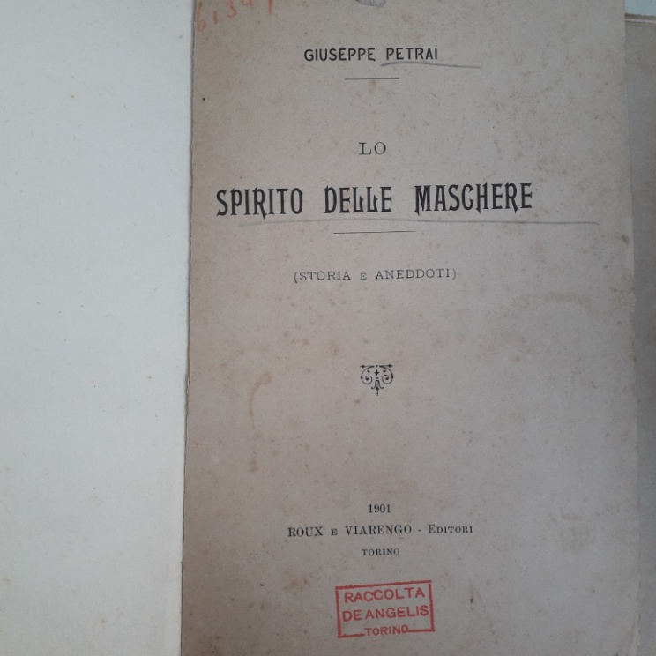 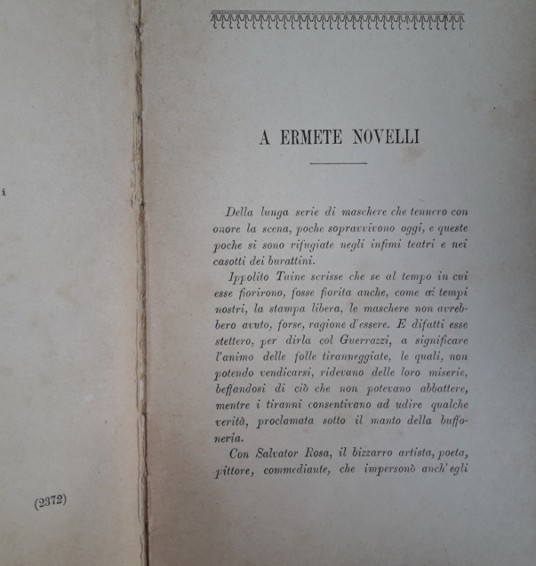

And being allowed only to consult three documents and no more.
I have received in that time not the photograph of the bust owned by the Theatre (that is closed and it's going to finish its restorations) , but some photographs of the base , of the shelf over which it was placed the sculpture. This base reported a text written over the plaster that don't resembled the original one, the one reported by the journals edited close to the dedication made in 1909. Probably the insertion of this new text into a tab was done under the fascist era to delete an evident sign of the collaboration between Bergamo and London , even if it made to celebrate a common musical glory and not with any political aim . Dr Epis has said me that the museum personnel was close to put back the artwork in its former position, so that I have imagined that I would have been quickly given of the requested images and information . From the 10th November I haven't had no additional news.
I have given in the last months some phonecalls to two of three numbers of some families owning the surnames of Brizio and Marinoni living in Colle Lochis street in Mozzo, that is the street in which the Lochis chapel is located (the surnames were found in some on line publications referring of some past accesses to the Chapel ). Only a person has replied last week to a phone call, ensuring me to be recalled, or to be sent an email of reply to the questions previously advanced. I'm still waiting for a reply till now.
The article published by dr Vincenzo Guercio Moretti through the Eco di Bergamo Journal on Giacomo Manzoni – close to the feast of Saint Alessandro - have not sorted an effect .
http://legacy.bibliotecamai.org/cataloghi_inventari/musiche/fondi_musicali/inventario_piatti_arnal/sommario.html
“In this tomb of family rests/ Alfredo Piatti/ of the array of the highest Italian music players / pride of the XIX /all extinct with him / Soul and spirit / in him admirably arranged / blowing an aura of ancient virtues / simplicity and frankness/ disdain of the vain apparences / grace and wisdom and noble ardor / composed into a competition of perfection / the man and the artist /to the fervid industriousness / of his vigorous age /elected / as glorious field England / asked /to the sweet and singing native land / the rest in life, the rest in dead/ born 8th January 1922 , dead 18th July 1901/ The only daughter /Countess Rosa Piatti Lochis /during her pain has left “.
Settled close the hotel Bellevue in Bellagio, villa Piatti in Cadenabbia was chosen after A. Piatti’s death as summer residence by Gladys Parrish Huntington , author of Madame Solario (https://mylakecomo.co/it/libri/chi-ha-scritto-madame-solario/) .

