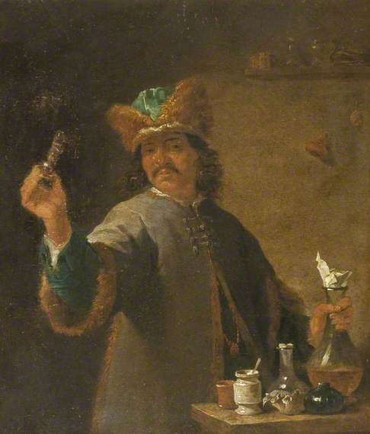
Harris Museum, Preston
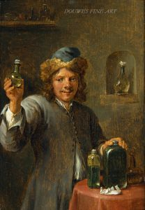

David Teniers the younger "A youthful Alchemist, offering Theriaca for sale" signed 'D. TENIERS. F' (l.r.) (Douwes Fine Art)

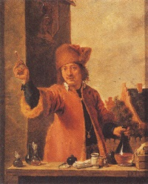
http://www.artnet.com/artists/david-teniers-the-younger/a-quack-doctor-standing-behind-a-table-a-view-of-wbNRNtvb30rzRXN7ebRHJA2 ‘Follower of Teniers’
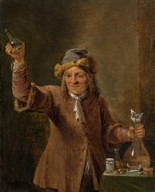
http://www.artnet.com/artists/david-teniers-the-younger/the-quack-doctor-83IzxefSVDi9c-C4w92U9A2 ‘Circle of Teniers’
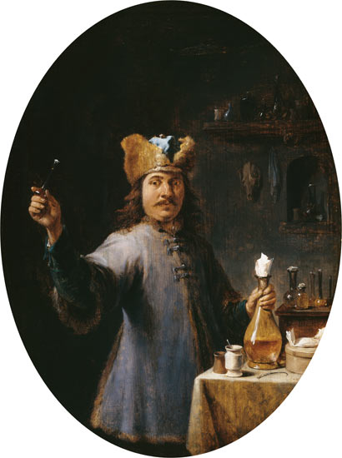
https://www.art-prints-on-demand.com/a/david-teniers-the-younger/the-quack-doctor-1.html ? (Leipzig) David Teniers

