Lord Chief Justice Ward.
Artist: Attributed to – Hudson but not signed.
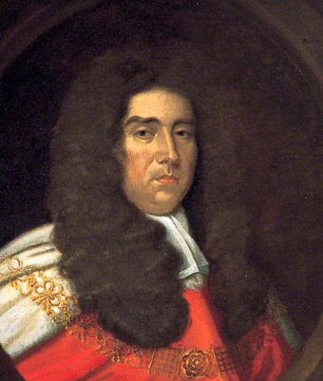
But who?
The painting is of a judge wearing a black full bottom wig, fashionable in the 17th and 18th centuries, judicial robes, neck bands and chain of office.
The plaque on the frame is inscribed ‘Lord Chief Justice Ward’ but without a first name.
‘The Public Catalogue Foundation – Oil Paintings in Public Ownership’ attributes the painting to – Hudson and describes Lord Justice Ward as Mayor.
There is no record of a mayor by the name of Ward in Deal in the 18th century in the list held by the Town Hall or in Pritchard.
There is no evidence of a signature on the painting.
Lord Justice Ward.
Black full bottom wigs were worn by judges from c1668 until c1725.
Sir Edward Ward is the only judge named Ward during this period. He was born in 1638 and died in 1714.
He was appointed Attorney General on 30 March 1693 and named Lord Chief Baron of the Exchequer on 08 Jun 1695.
The most important event in Deal during this period was the granting of the Town Charter by William III in 1699.
The Artist.
The only listed portrait painter of the period with the name Hudson is Thomas Hudson (1701-1779).
He would have been 13 years old when Sir Edward Ward died.

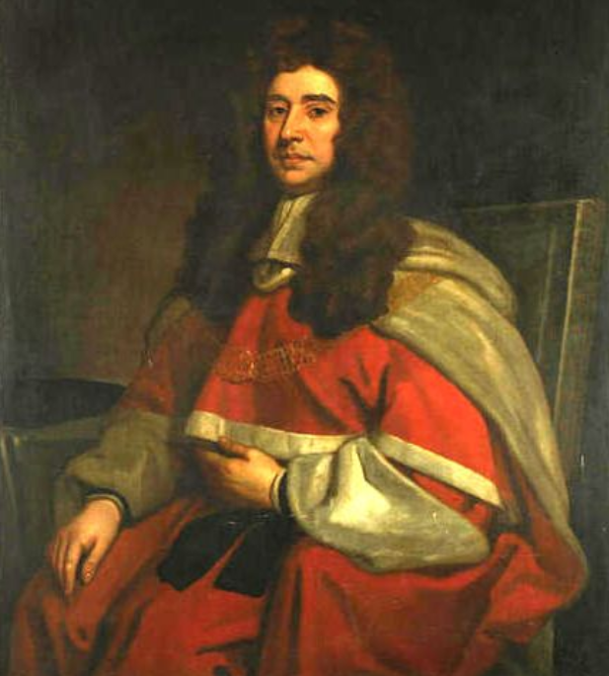
Sir Edward Ward [Sir Godfrey Kneller]

The signed paintings of Sir Edward Ward are by Godfrey Kneller, later Sir Godfrey Kneller.
There appears to be a distinct difference between the painting of Sir Edward Ward by Godfrey Kneller and that with an unknown attribution to – Hudson in the Town Hall.

This raises the following questions:
- Does the painting in the Town Hall depict Sir Edward Ward or another Judge?
- There is a discrepancy in the dates, so is the artist Thomas Hudson, or another artist with the same surname?
- Is the source of the attribution for the artist known?
- Could the portrait be a copy based on the engraving Sir Edward Ward after Kneller by Robert White [NPG D37482] c1702 in which the sitter has a slightly fatter face? [see comparisons]
- The reversed image of the Kneller portrait gives greater similarity.
- Why is the painting in the Town Hall? Could it be because Sir Edward Ward was Lord Chief Baron of the Exchequer [1695-1714] when William III granted the Town Charter to Deal in 1699?

‘The Public Catalogue Foundation – Oil Paintings in Public Ownership’ Public Catalogue Foundation 2004 https://artuk.org
Stephen Pritchard History of Deal 1864
Dictionary of National Biography Vol 59 1885-1900
The Judges of England with sketches of their Lives. Vol. VIII Edward Foss London 1864.
Stephen Pritchard History of Deal 1864
A Biographical and Critical Dictionary of Painters and Engravers Vol. I Michael Bryan London 1816.

