Pietro Giacomo Manzoni ( Calusco d’adda , 26/04/1870 – Bergamo 31/07/1910)
0)ORIGINS

“G. Medolago reports that a bough of the family present in Calusco that had branched out in many places including Barzio, where the family of the writer Alessandro Manzoni derived from his descendants. The first mentions of the Manzoni in Calusco date back to the fifteenth century, more precisely to 1421. Still on October 31, 1566 the origin was specified from Brumano indicating the people with this surname as Manzoni di Brumano inhabitants of Calusco. From Calusco they also moved to other areas. For example, on 1 September 1485 we find Defendino was Alberto Manzoni di Calusco, resident of Rosciate. The Manzoni sculptors and carvers belonged to this family. Costanzo 1829 + 1903 / Achille Giacomo Michele known as Giacomo (1866 + 1909) / Pietro Giacomo (1870 + 1910) /Obviously they should not be confused with Manzù. “
In: SOCIETA’ STORICA LOMBARDA , Manzoni in: Enciclopedia delle famiglie Lombarde in: https://servizi.ct2.it/ssl/wiki/index.php?title=Manzoni .

1) ACTS OF BIRTH – AND DEATH OF PIETRO GIACOMO MANZONI AND SOME OTHER MEMBERS OF THE FAMILY MANZONI OF CALUSCO
From those acts we intend that the real name of Giacomo Manzoni of Calusco was Pietro Giacomo Manzoni (the second name was the same of his grandfather) and that his father Costanzo (or Costante) was a carver and a farmer with a wealthy condition that had married Filippini Giovanna of Achilles, an housewife , and that have probably had a close relationship, meanwhile, with a peasant, certain Felicita Zonca starting from the last decade of the XIX century . Probably Giacomo have spent his first years in the native house in Via Luprita 43 , moving across the 1877 to the number 12 of the same road. He would have probably studied carving under his father’s aegis .
A) GIACOMO ACHILLE MANZONI
Giacomo Achille Manzoni, 1866, Reg. 53, Archivio di Stato di Bergamo, Stato civile italiano, Indici decennali, 1866 – 1875, Calusco d’Adda.
http://dl.antenati.san.beniculturali.it/v/Archivio+di+Stato+di+Bergamo/Stato+civile+italiano/Calusco+dAdda/Nati+indici+decennali/1866-1875/2/007259756_00013.jpg.html?g2_imageViewsIndex=0
We have probably a partial registration for the first brother of Pietro Giacomo Manzoni.
B) N. 42 , Act of Birth of Elisa Antonia Cattarina Manzoni , Archivio di Stato di Bergamo, Stato civile italiano, Calusco d’Adda, Nati 1868, Vol. 112.
Elisa Antonia Cattarina Manzoni, 1868, N. Reg. 42, Archivio di Stato di Bergamo, Stato civile italiano, Nati indici deccenali 1866 – 1875, Calusco d’Adda.
http://dl.antenati.san.beniculturali.it/v/Archivio+di+Stato+di+Bergamo/Stato+civile+italiano/Calusco+dAdda/Nati/1868/122/007034841_00032.jpg.html
http://dl.antenati.san.beniculturali.it/v/Archivio+di+Stato+di+Bergamo/Stato+civile+italiano/Calusco+dAdda/Nati/1868/122/007034841_00033.jpg.html?g2_imageViewsIndex=0
http://dl.antenati.san.beniculturali.it/v/Archivio+di+Stato+di+Bergamo/Stato+civile+italiano/Calusco+dAdda/Nati+indici+decennali/1866-1875/2/007259756_00013.jpg.html?g2_imageViewsIndex=0
One of the sisters of Giacomo was born the 12 July of 1868 from the “Costanzo of the late Giacomo , wealthy, carver of years forty nine “ and Filippini Giovanna of the late Achille in the house of Via Luparita at N. 43
C) PIETRO GIACOMO MANZONI OF CALUSCO
N. 24 , Atto di Nascita di Pietro Giacomo Manzoni ( tr. = Act of Birth of Pietro Giacomo Manzoni ), Archivio di Stato di Bergamo, Stato civile italiano, Calusco D’Adda, Nati, 1870, Vol. 111.
“N. 24
In the year one thousand eight hundred and seventy , in the day twenty nine of the month of April, in the city hall, at 12 o’clock, in the morning. In front of me, Foglieni Fedele, Secretary of the Calusco city council, Circondary and Province of Bergamo, deputy to accomplish to the functions of Officer of the Civil Registry for the acts of birth and death from the city major of this city hall of Calusco, with the act of the day two of the month of February one thousand eight hundred and sixty eight , number thirty seven, compared Manzoni Costanzo of the late Giacomo, of years 41, wealthy, domiciled in Calusco , that have presented me a child of male sex , that declares that was born to him the day 26 of the month of April , at the 10 of the night , from his wife Filippini Giovanna of Achille , domiciled with him into the house of his residence settled in this city of Calusco in Via Luprita at the civic number forty-three , to whom son he intend to give the names of Pietro Giacomo. This declaration is made with the presence of Colleoni Giovanni of the late Francesco of 48 years old and of Manzoni Sebastiano of the late Paolo of 42 years old , both wealthy and domiciled in Calusco, made witnesses by the same that declares and , after having had a lecture of the present verbal process made at the same time on the two registers originals, have , with me and the declarant, subscribed.
Manzoni Costanzo , declarant
Colleoni Giovanni, witness
Manzoni Sebastiano , witness
Foglieni Fedele, deputy officer “.

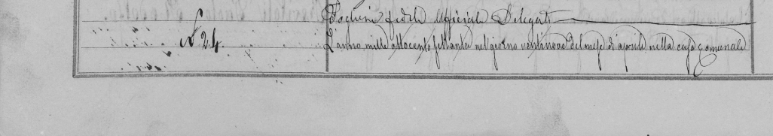
Source : database « Antenati gli archivi per la ricerca anagrafica” (tr. = Ancestors the archives from the genealogic research ) , Direzione Generale degli Archivi (tr. = General direction of Archives) - Sistema Archivistico Nazionale ( tr. = National Archive System ), Ministero dei Beni culturali e del Turismo (tr.= Ministry of the cultural goods and tourism ) http://dl.antenati.san.beniculturali.it/v/Archivio+di+Stato+di+Bergamo/Stato+civile+italiano/Calusco+dAdda/Nati/1870/111/007014663_00017.jpg.html?g2_imageViewsIndex=0

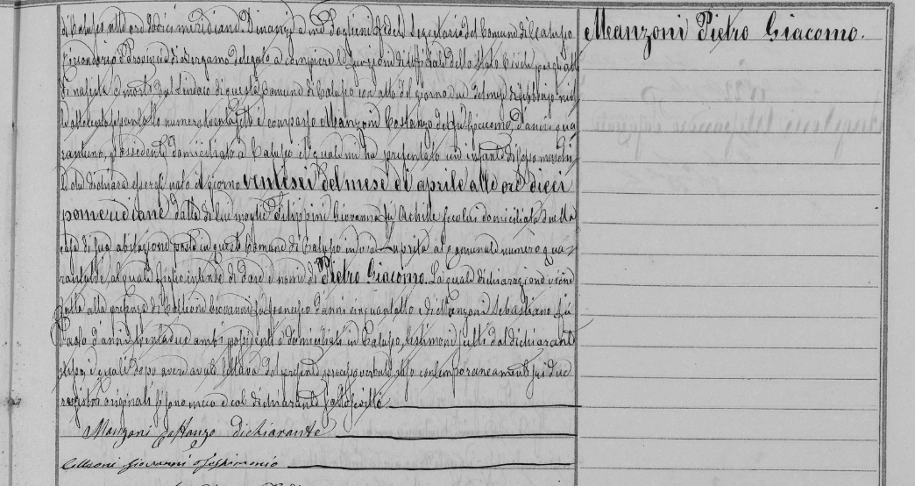

http://dl.antenati.san.beniculturali.it/v/Archivio+di+Stato+di+Bergamo/Stato+civile+italiano/Calusco+dAdda/Nati/1870/111/007014663_00017.jpg.html?g2_imageViewsIndex=0

Manzoni Pietro Giacomo, Reg. N. 24, 1870, Archivio di Stato di Bergamo, Stato civile italiano, Nati indici deccenali 1866 – 1875, Calusco d’Adda.
http://dl.antenati.san.beniculturali.it/v/Archivio+di+Stato+di+Bergamo/Stato+civile+italiano/Calusco+dAdda/Nati+indici+decennali/1866-1875/2/007259756_00014.jpg.html?g2_imageViewsIndex=0
D)
N. 7 , Atto di Nascita di Elisa Giuseppa Manzoni ( tr. = Act of Birth of Elisa Giuseppa Manzoni ), Archivio di Stato di Bergamo, Stato civile italiano, Calusco D’Adda, Nati, 1873, Vol. 111

http://dl.antenati.san.beniculturali.it/v/Archivio+di+Stato+di+Bergamo/Stato+civile+italiano/Calusco+dAdda/Nati/1873/111/007095186_00009.jpg.html?g2_imageViewsIndex=0
http://dl.antenati.san.beniculturali.it/v/Archivio+di+Stato+di+Bergamo/Stato+civile+italiano/Calusco+dAdda/Nati/1873/111/007095186_00010.jpg.html?g2_imageViewsIndex=0

Manzoni Elisa Giuseppa, 1873, Reg. 7 Archivio di Stato di Bergamo, Stato civile italiano, Calusco D’Adda, Indici decennali, 1866 – 1875.
http://dl.antenati.san.beniculturali.it/v/Archivio+di+Stato+di+Bergamo/Stato+civile+italiano/Calusco+dAdda/Nati+indici+decennali/1866-1875/2/007259756_00013.jpg.html?g2_imageViewsIndex=0
By this the act of birth of Elisa Giuseppa Manzoni we know that one of sisters of Pietro Giacomo Manzoni was born the 5 march of 1873 into the home of via Luprita 43 and that she has married then , the 28/11/1894 certain Alessandro Angioletti in Bergamo.

E) N. 17 , Act of Birth of Giulia Maria Clotilde Manzoni , Archivio di Stato di Bergamo, Stato civile italiano, Calusco D’Adda, Nati, 1877, Vol. 111.
A supposed another sister (the scanned documents start from 1860) of Pietro Giacomo was born the 20 April 1877 by Costanzo Manzoni, mentioned another time as a person living into a “wealthy “ , and the mother as a subject living a “civil condition of cohabitant“. From the same act we know also that she would get married the 20/01/1901 in Bergamo with certain” Giuseppe Colombi was Francesco” and that the family has moved to via “Luprita 12”.
http://dl.antenati.san.beniculturali.it/v/Archivio+di+Stato+di+Bergamo/Stato+civile+italiano/Calusco+dAdda/Nati/1877/111/007059301_00018.jpg.html

F) N. 24 , Act of birth of Giorgio Enrico Manzoni , Archivio di Stato di Bergamo, Stato civile italiano, Calusco D’Adda, Nati, 1882, Vol. 111.
Another probable brother of Pietro Giacomo was born the 19/01/1882 from Manzoni Costanzo - at those time said of 53 years and carver- and from Filippini Giovanna, described as the “wife” of Costanzo , a “housekeeper “ and “cohabitant”.
in:
http://dl.antenati.san.beniculturali.it/v/Archivio+di+Stato+di+Bergamo/Stato+civile+italiano/Calusco+dAdda/Nati/1882/111/007077604_00024.jpg.html
G) N. 90, Act of death of Elisa Manzoni , Archivio di Stato di Bergamo, Stato di Civile Italiano, Calusco d’Adda, Morti 1890, Vol. 111.
The 5 October 1890 was dead to” Costanzo Manzoni , farmer “and “Zonca Felicita, peasant …unmarried”, the little Manzoni Elisa of 37 days.
in:
http://dl.antenati.san.beniculturali.it/v/Archivio+di+Stato+di+Bergamo/Stato+civile+italiano/Calusco+dAdda/Morti/1890/111+Parte+1/005722152_00050.jpg.html
H) N. 10, Act of death of Giovanni Manzoni , Archivio di Stato di Bergamo, Stato di Civile Italiano, Calusco d’Adda, Morti 1896, Vol. 111, part 1.
The 22 February 1896 was dead to “ Costanzo Manzoni , farmer “and “Zonca Felicita, peasant … unmarried”, the young Giovanni Manzoni of two years. Comparing as witness for the declaration of death there is a certain “Fumagalli Alessandro of 43 , carpenter”. To left the declaration of death there was certain “Zonca Pietro, of 36 years, teacher, living in Calusco d’Adda”, maybe a relative of the mother of the young dead child.
In:
http://dl.antenati.san.beniculturali.it/v/Archivio+di+Stato+di+Bergamo/Stato+civile+italiano/Calusco+dAdda/Morti/1896/111/005878589_00011.jpg.html
3) The Academic Career of Manzoni Pietro Giacomo into the Carrara Art Academy

The results of this archivistic search were kindly given by the Professor of the University of Pavia and Conservator of the Carrara Museum of Bergamo (and there responsible of the historic Archive of the Carrara Art Academy) , PhD Paolo Plebani, yesterday afternoon at 5.45 pm, through an email of recap and by sending some scanned pages of the six documents kept into the Archivio della Commissaria, ACBG (= Accademia Carrara Bergamo) , Fascicolo Personale (= personal folder) , Manzoni Giacomo and some information taken by the registers linked to the classes that Manzoni have attended.

Part 1)
Archivio della Commissaria, ACBG (= Accademia Carrara Bergamo) , Fascicolo Personale (= personal folder) , Manzoni Giacomo

The paper folder reports by outside these words: “ Manzoni Giacomo di Costanzo born in Calusco the 26 April 1870 / years of School / 1896 – 1897= School of painting , first year, frequented the school of nude /1897 – 1899, the same , second , the same , the same “.

Those are the documents kept into the folder that unveil, for example, that Giacomo Manzoni, has begun to carve before the 1896 , due to the fact that he defines himself as a “carver” in his first signature dating to November 1897 :

A ) GIACOMO MANZONI, Richiesta inviata alla Onorevole commissaria per l’ammissione alle lezioni di nudo tenute nella scuola dell’Accademia Carrara , da Bergamo, 16/11/1898 (tr. = Letter of request of admission to the classes of the nude school held into the Carrara Art Academy sent to the Hon. Commisaria by (Pietro) Giacomo Manzoni “sculptor “from Bergamo the 16 November 1898).

“To the honorable Commissaria Carrara/ of the Academy of Arts, / Bergamo / Me, the undersigned Giacomo Manzoni sculptor, / ask this respectable Commissaria in order to be admitted to the nude / school at this academy , the year 1898 – 1899 . / Certain to be accepted, I advance / many thanks . Very devoted, / Manzoni Giacomo sculptor. / Bergamo 16 November 1898”.

B) GIACOMO MANZONI, richiesta di ammissione alle classi di nudo tenute nella Academia Carrara, inviata alla Onorevole Commissaria, da Bergamo, 8/11/1897 (tr=
Letter of request of admission to the classes of the nude school held into the Carrara Art Academy sent to the Hon. Commissaria by (Pietro ) Giacomo Manzoni “carver” , from Bergamo the 8 November 1897).

“Honorable Commissaria Carrara/ of the Academy of Arts, / Bergamo / Me, the undersigned Giacomo Manzoni / advance the request to be admitted / to the frequentation of the nude school / into this Academy for the / academic year 1897 - 1898 / With respect/ very devoted/ Manzoni giacomo garver /. Bergamo 8 November 1897.

C) GIACOMO MANZONI , Lettera alla Direzione della Commissaria, s.p. s.d. (tr= Letter to the Direction of the Commissaria Carrara from Manzoni Giacomo, s.p., s.d.).

“Honorable Direction / The undersigned asks to / be enrolled / as student of figure / in the nude school /of this Academy/ Reserving to present / the due document in days / waiting for him from Calusco d'Adda, being this my hometown. Sure of his production, he sends you his heartfelt thanks. Manzoni Giacomo.

D) COMUNE DI CALUSCO D’ADDA, DISTRETTO DI BERGAMO, Certificato di Vaccinazione, 26/10/1896 (tr. =Certificate of vaccination produced by the city hall of Calusco d’Adda , Bergamo district, the 26 October 1896) .

Art (icle 23 ) of the regulation 30 October 1859
City hall of Calusco , District of Bergamo
CERTIFICATE OF VACCINATION
The undersigned attests that Manzoni Giacomo
of years 26
native of Calusco d’Adda
living in Bergamo
son of the living Costanzo
and of the living Filippini Giovannina
had been with success vaccinated the day 25
of the month of September 1870
In faith, Given by Calusco d’Adda the 26 November 1896
The Vaccinator
F. Foglieni Secretary

E) Copy of the act of birth of Pietro Giacomo Manzoni taken from the parrish registers of Calusco by the priest Gioacchino Valsecchi the 2 November 1896.

Province and department of Bergamo
Mandament of Ponte S Pietro
City Hall and Parrish of Calusco
The day 2 November 1896
Me undersigned priest declares of reporting
from those Parrish registers that Manzoni Pietro Giacomo of the living Costante
and of the have lived Giovanna Filippini
was born in this Parrish the day
26 of the month of April of the year
1870 – One thousand eight hundred seventy.
In faith
The clergyman Gioacchino e Valsecchi Priest
F) certificate of Good behavior of Giacomo Manzoni living in Bergamo , released by the office of the public surveillance of the city hall of Bergamo the 3 April 1892.

(Coat of arms of the city of Bergamo)

Municipality of Bergamo
office of public surveillance
N. 4223 Prot. (ocol ) Gen . (eral)
N. 1316 Div. (ision) VIII
Object (tr. = Oggetto)

Bergamo the 3 April 1892

The Major of Bergamo
certificates
that Manzoni Giacomo of
Costanzo, of 22 years worker (or, student, or servant?)
carver , lives in this city
Pontida square N. 36 is person of
good manners and behavior .
It’s released on ordinary paper
for charity.
Signed for the city major
Unknown signature
(Stamp of the Municipality of Bergamo)

Part 2
The Academy registers

The following information are also derived by the search done by Professor Plebani on the registers of the Archive of the Commissaria . I will only translate some of the information given by Professor Plebani, following the order given by him .
“
ACBg, Archivio della Commissarìa, busta (= folder ) 50, fascicolo (= file ) 716, Anno Scolastico ( tr. = Academic year) 1896-1897. Elenco degli alunni inscritti nella Scuola di Pittura: “Allievi che chiedono di essere inscritti per il I anno […] Manzoni Giacomo. Non presenta nessun documento attendendoli da Calusco.” ( tr. = List of the students enroled into the School of Painting: “Scholars that ask to be enroled for the first year […] Manzoni Giacomo. He hasn’t presented any document , by waiting from it from Calusco “)

ACBg, Archivio della Commissarìa, busta 50, fascicolo 716, Anno Scolastico 1896-1897. Elenco degli alunni inscritti nella Scuola di Pittura: “Allievi che chiedono di essere inscritti per il I anno […] Manzoni Giacomo di Costante. Condizione della famiglia: Intagliatore. Domicilio: Bergamo. Nato il 26 aprile 1870. Anni di Scuola: 1.”
(tr = List of the students enroled into the School of Painting “Scholars that ask of being enroled for the first year […] Giacomo Manzoni of Constate. Family condition: carver. Domicile: Bergamo . Born the 26 april 1870. Years of School: one”).
ACBg, Archivio della Commissarìa, busta 51, fascicolo 717, Anno Scolastico 1897-1898. Elenco degli alunni inscritti nella Scuola di Pittura: “Frequentano la sola Scuola del Nudo […] Manzoni Giacomo di Costante. Condizione della famiglia: Intagliatore. Domicilio: Calusco. Nato il 26 aprile 1870. Anni di Scuola: 2. Classe: Nudo. Annotazioni: Frequentò la Scuola nel solo Inverno e saltuariamente.”
(tr= List of the students enroled into the School of Painting “Frequent the only nude school […] Manzoni Giacomo of Costante . Family condition: carver. Domicile: Calusco. Born the 26 april 1870. Years of School: two, Class : nue. Notes: Frequented the school in the whole winter and occasionally “)

ACBg, Archivio della Commissarìa, busta 51, fascicolo 717, Anno Scolastico 1898-1899. Elenco degli alunni della Scuola di Pittura: “Manzoni Giacomo di Costante. Condizione della famiglia: Scultore. Domicilio: Calusco. Nato il 26 aprile 1870. Anni di Scuola: 2. Classe: Nudo. Annotazioni: Inscritto nella sola Scuola del Nudo.”
(tr= List of the students enroled into the Painting School: “Manzoni Giacomo of Costante . Family condition: carver. Domicile: Calusco. Born the 26 april 1870. Years of School: two, Class : nue. Notes: Inscribed only in the nude school”)
“
3) RELIGIOUS COMMISSIONS
This short catalogue was done by crossing the information reported into the 1969 publication of LUCA PAGNONI, Chiese Parrocchiali Bergamasche, Appunti di storia e arte [ Bergamo, Banca Provinciale della Lombardia – Monumenta Bergomensia (= publishing house ; Grafiche Cattaneo = print), p. p. 439] and the ones given by “beweb “ catalogue (the national catalogue cultural goods belonging to the dioceses of Roman Catholic church ) . This thing was compulsory because the more recent catalogue , even if is accessible on line, for some privacy matters and supposed to be matters of safety , has decided to erase all the references to the localizations of goods (that should be given by request, having a great loss of time to have a reply that could also be with a negative end). This analysis was considered compulsory after having relieved the probable confusion made by the curators of the Pope Giovanni XXIII publications previously mentioned (GIOVANNI XXIII, Il giornale dell'anima e altri scritti di pietà, Edizioni di Storia e di Letteratura , Roma ,1975 (VIII ed; I ed.1964), p. 347.
EMANUELE RONCALLI, AMMINISTRAZIONE COMUNALE DI SOTTO IL MONTE - GIOVANNI XXII (a.c.), Giovanni XIII, un pontefice e la sua terra, Bergamo, Grafica & Arte, 1988, p. p. 9- 25.) that matched the big statue of the Assunta of Sottomonte , maybe produced by the workshop of other carvers (the brothers Manzoni) sharing the same surname and living in the same district (Bergamo and its shire ) , with Giacomo. I’ve decided also, for being more precise , to report into the footnotes the full productions of the others Manzoni. The information concerning Giacomo Manzoni, instead, were put into a tab with a chronologic order, reporting the older productions in the beginning and the newly ones at the end. In the first column I’ve decided to report the name of the city in which Manzoni has left an artwork and the name of the Parrish. In the second column are reported first the pages interesting the church (the PAGNONI text uses this criteria and puts all the information of the local parishes into some sections marked with by the names of the cities and towns of Bergamasco ). I have stressed the difference between the only words mentioned by Pagnoni to divide his text sections (a sort of chapters) out the sections , by using some capital letters and , on the other hand , by using some lower case letters for the name of the parishes and churches mentioned by the text as the ones keeping some Manzoni’s objects . The pages mentioned into the second column correspond to the number of the pages of each chapter and the ones in which we can find the precise reference to a Giacomo Manzoni artwork. The following column describes the work that Giacomo Manzoni has left into a church and the year of the production. I have reserved the last one column to make a correspondence by the objects that I’ve previously found into Pagnoni’s book and the links to the cataloguing sheets of the corresponding artworks given by the “ beweb “ catalogue on line .
PRESEZZO  Santi Fermo e Rustico | p. p. 292-293/ p. 293 | (1893) Golden and polychrome carvings for the wooden niche of the Virgin of sorrows and presbytery benches .
CALUSCO D’ADDA  Chiesa della Beata Vergine immacolata e San Fedele | p. p. 109 – 110/ quote = 110 | (1897 ) Wooden statue of Saint Joseph . | 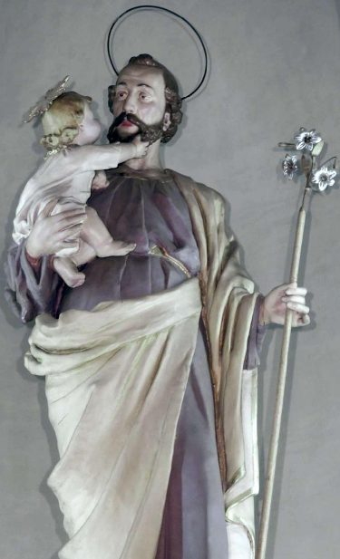
SANT ALESSANDRO IN COLONNA | p. p. 30 -32/ p. 32 | (1898- 1901) Oratory chair – stall in walnut wood following a drawing of the architect Virginio Muzio . | 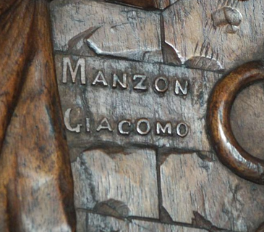
SANTA MARIA DELLE GRAZIE | p. p. 35-37/ p. 36 | Sculptures of the pronao in sandstone designed by architect Elia Fornoni (others designed and realized by Alfredo Faino, Andrea Paleni and Cesare Archenti in 1906).
BORGO DI TERZO Santa Maria Assunta e San Michele Arcangelo | p. p. 89 – 91/ p. 89 | (First years of XX century) Assumption of Virgin statue put over the bell tower crown /pediment. | 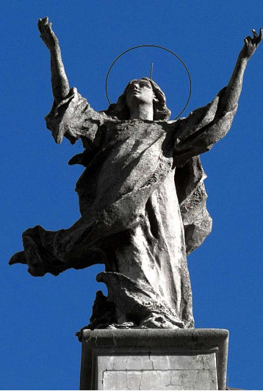
AVIATICO  San Giovanni Battista | p. 68 / p. 68 | (First years of XX century): confessionals. | 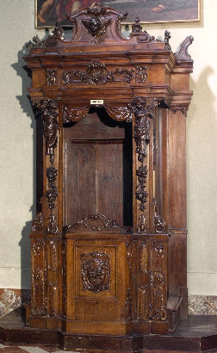
ALMENNO  San Salvatore | p. p. 54 – 55 / p. 55 | (First years of XX century) lacked and golden wooden pulpit and , ecclesiastical chair and prepositural banks .
ENDENNA  Santa Maria Assunta | p. p. 174-175/ p. 175 | (First years of XX century- 1905 ?): Assumption of Virgin statue ?. | 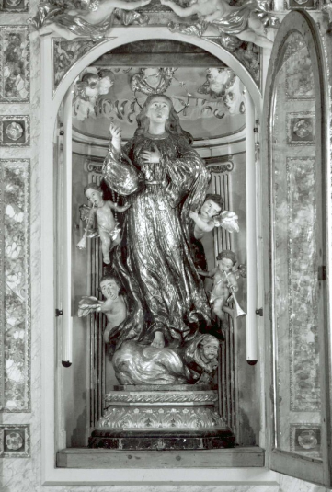
MARTINENGO  San Fermo | p. p. 231 - 232 | (1901) carved the parts of a Presbyterian bench designed by Francesco Domenighini with marquetries of Giulio Mansanda | 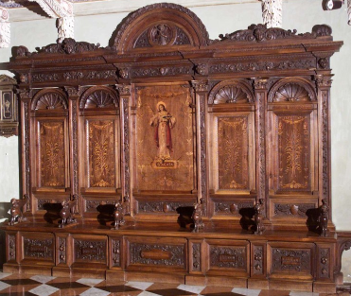
OLERA  San Bartolomeo apostolo | p. 253/ p. 253 | (1902) Throne of saints and choir .
PONTERANICA  St Alessandro e San Vincenzo | p. p. 284 – 285/ p. 285 | (1902) He had carved the frame ,following the drawing of Virginio Muzio for the Lorenzo Lotto ‘s altarpiece paintings – a polypthyc - at those times recently restored by Steffanoni. The goldening of the frame was executed by Pietro Angileri. | 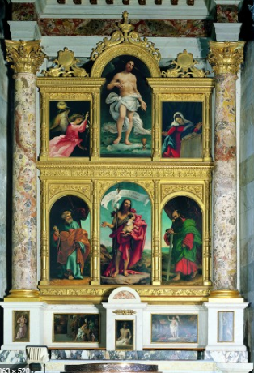
ALBINO  San Giuliano | p. p. 48 – 50 / p. 49 | (1903 ) Statuary group in concrete conglomerate removed in 1969 .
GRIGNANO  Santi Apostoli Pietro e Paolo | p. p. 208- 209/ p. 209 | (1901 ? - 1903) Wooden statue of Saint Joseph. | 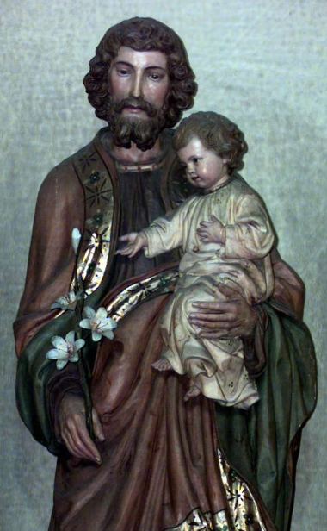
CALUSCO D’ADDA, Chiesa della Beata Vergine immacolata e San Fedele | p. p. 109- 110/ 110 | (1904) Wooden statue of the Immaculate . | 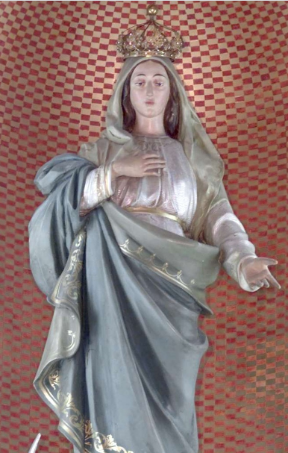
VERDELLINO  Sant’Ambrogio vescovo e dottore | p. p. 397 – 398 / 397 | (1906) Statues in concrete of the balaustrate (Faith , Piety, Hope , Charity) of the churchyard designed by Architect Giovanni Barboglio. | 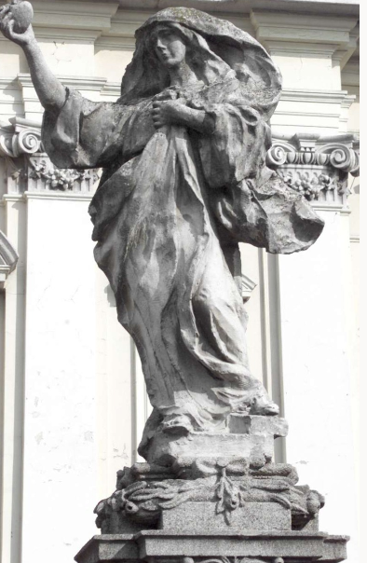
GRUMELLO DEL MONTE  San Nicola | p. p. 212-213/ p. 213 | (1908) baptismal font ‘s case in walnut. | 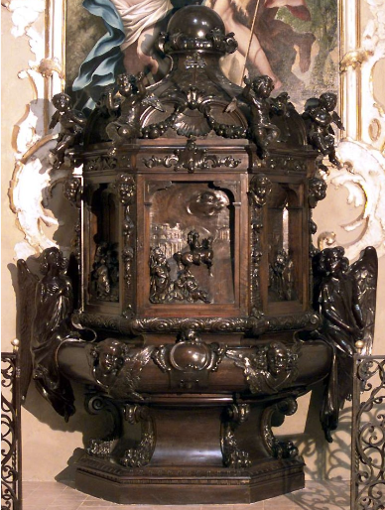
CALUSCO D’ADDA, Chiesa della Beata Vergine immacolata e San Fedele ; | p. p. 109-110/ 110 | (1908) Wooden statue of Sacred Heart of Jesus and Saint Louis. | 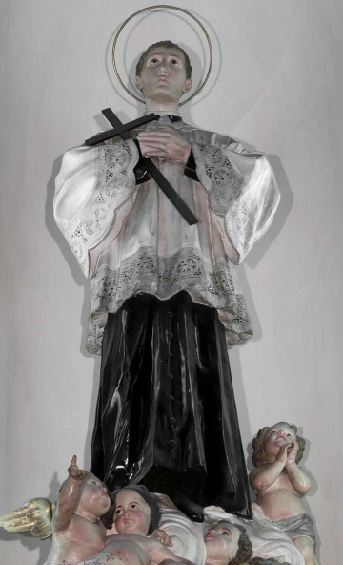
PRESEZZO  Santi Fermo e Rustico | p. p. 292 – 293/ p. 292 | A statuary group in concrete for the gable and the attic of the neoclassic pronao drawn by the architect Angelo Cattò with monumental columns and pillars in artificial granite (1910)stu | 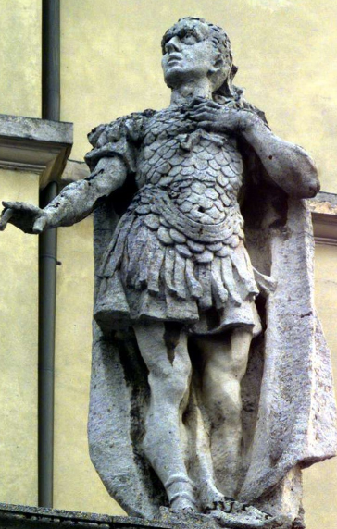
SAN LEONARDO |  | Statue of San Leonardo in concrete, 1900 - 1910 ca. (before ) | 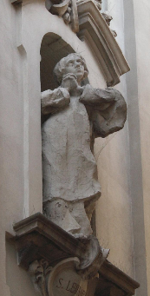

5A ) PRIVATE COMMISSIONS AND WORKS EXPOSED INTO SOME SHOWS

“Per tradizione , a lungo gli allievi della scuola hanno esposto le loro opere in occasione degli anni accademici . Una di quelle mostre in una cronaca dei primi del Novecento “ (… ) Nello stesso salone è notevole un lavoro in gesso dello scultore Giacomo Manzoni che rappresenta un Cristo Morto che giace disteso, al di sopra della sua testa , inerte , si rizza improvvisa ,e non annunciata da alcun motivo di esecuzione , la testa di Maria “ (tr. “By tradition, the scholars have longer exhibited their works during the academic years. One of those shows into a chronicle of the first years of the twentieth century “ in the same saloon is remarkable a work in plaster of the sculptor Giacomo Manzoni who represents a dead Christ , lying , and to which, over his head , inert , stands up , suddenly , and not announced by no reason of execution , Mary’s head. “) | 1903. Exhibits a pity at the Carrara’s Academy Annual exhibition
"Scultura (tr= Sculpture )  [...]  Manzoni (Giacomo )  Ebbra d'amore (Gruppo in gesso )  tr = "Inhebriated with love", group of plaster  n. 162  [...]  Manzoni (Giacomo)  Dolore materno (statua in gesso)  n. 203  tr= mother's grief , plaster statue  " | Exhibiting two artworks in plaster into the art exhibition connected to the 1906 expo of Milan. | 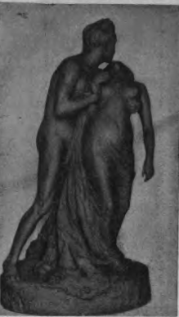  Ebbra d’amore ( tr. = Inhebriated of Love )
Monument - tomb to Federico Maironi ( after the 10/02/1906), Bergamo’s cemetery (?)
Edicola made for Mr. Giovanni Ferrari nel cimitero di Bergamo (tr. = Ferrari Chapel in the Bergamo’s cemetery)  The Chapel was made by the engineer Aristide Caccia and was constructed by the company Copini & Carrara with “pietra Simona “ before march 1908 . | Giacomo Manzoni has made the models for the figures . | 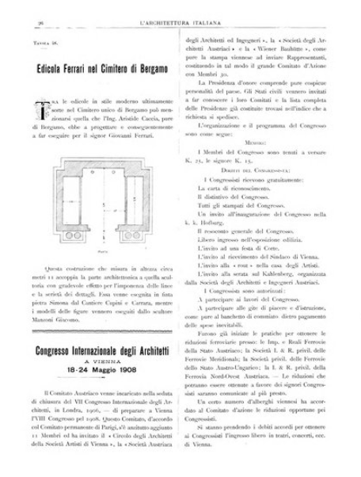

5 B) OTHER JOBS , RESIDENCES
S . N., “Scuole industriali e commerciali, Bergamo, Scuola d’arte applicata all’industria Andrea Fantoni “ in : S. N., Annuario del Min. di Agricoltura , industria e commercio, N. Serie, Roma, Tipografia Nazionale di G. Bertero e C., 1904, p. 196.
Teaches plastic into the school of applied studies to the industry “Andrea Fantoni”, founded in 1898 in which directive board were present Comm. Camillo Boito as honorary president, the engineer Giacomo Frizzoni as delegate of the Industrial society and the major Giuseppe Zanchi as delegate inspector of the Circolo artistico. Other teachers of this association were some friends and collaborators of Manzoni as the Architect Elia Fornoni (who taught art history), Francesco Domenighini (who taught decoration applied to all the industries). His permanence as teacher of plastic into the over mentioned decorative arts schools, as referred by the History of Bergamo and I Bergamaschi of Belotti, seems to be started since 1903, from the exact year in which he was appointed to the teaching of the predict art. He has also had his own studio in Ermete Novelli street in 1910.
https://books.google.it/books?id=09QmAQAAIAAJ&pg=PA196&dq=manzoni+giacomo+bergamo&hl=it&sa=X&ved=2ahUKEwiFl4e8pIzrAhUF3aQKHQnlBYgQ6AEwB3oECAkQAg#v=onepage&q=manzoni%20giacomo%20bergamo&f=false
6) LOCAL PRESS REGARDING THE CERIMONY OF INAUGURATION OF THE BUST TO A PIATTI INTO THE DONIZETTI THEATRE AND THE DEATH OF GIACOMO MANZONI

All those local press published for the dedicational ceremony for the Manzoni’s bust to Alfredo Piatti was kindly sent and shared by the central civic library Angelo Mai of Bergamo and by the responsible of the department of newspaper and press of the over mentioned cultural institute , Dr Luca Guaschetti, only for this research. It was pointed out and shared at 16.09 of yesterday with an email and by sending some scans , with We transfert service, of the article published by the Eco di Bergamo local newspaper. I have chosen to give here under a complete translated transcription of the texts , where possible, reporting some sections of the Italian text .

a)
S. N. , L’inaugurazione del Busto ad A. Piatti al Teatro Donizetti in: L’Eco di Bergamo, n. 89, 21-22 /04, Bergamo, 1910, p. 3. (tr= The inauguration of the Bust to A. Piatti into the Theatre Donizetti)
La cerimonia inaugurale (=The inauguration ceremony)  At 16 the Lobby of the Theatre Donizetti is getting more crowded ; on the two sides of the door that faces to the Sentierone rise, over two beautiful corbels , on the right the bust of the tenor Rubini, gifted by Mrs Ortolani , on the left the Piatti’s one executed by the sculptor Giacomo Manzoni . With the electric lighting, the lobby has a solemn and snugged atmosphere. We notice , between the present the M.(aestr)o Arrigo Boito, Mrs. Fanny Davies, Mr Marchetti, Miss Gates, the Rev. Dachworth, Anglican Abbot of Westminister, the barrister Ferrario, counselor in prefecture , the president of the Congregazione di Carità (Congregation of Charity ) the knight Ferrario, the city major barrister and knight Preda, the Commendatore (commander) Nievo, a lot of professors and scholars of the musical institute of the flag, the Hons. Rota and Benaglio , the M. (aestr)o Donnini, the librarian Prof. Mazzi, the M. (aestr)o Ferroni in representation of the Conservatory of Milan , the Professor Loverini and much more sirs and ladies. Makes the honors of the house owner the knight and doctor Camplani .  Parla l’ing Fornoni (Talks the engineer Fornoni) .  Talks as first the engineer and knight Elia Fornoni, vice president of the Artistic Circle “Talks as first the engineer and knight Elia Fornoni, vice president of the Artistic Circle “To honor men that with their works have illustrated our nation into the field of arts and to point out them as an example for the future generations ; to favorite with the avaible mediums the development of all the arts in their own manifestation , it’s one of the main aims of our Artistic Circle , and as in the musical field it procured to honorate the Mayr, the Petrali and the Cagnoni , he wouldn’t forgot Alfredo Piatti who have had his birth in our city and not to catch the so luckily chance it was presented . For the initiative of the Professors of the Conservatory Giuseppe Verdi of Milan and of some artistic figures of that city , in the December 1908 emerged the need to honor the memory of the students of that institute in the occasion of the centenary feasts for the foundation of the Conservatory and it was decided to place a bust of Alfredo Piatti in the concert hall, alongside those of Ponchielli, Bazzini, Coronaro, Catalani and other musicians. Apart from distinguished personalities from Milan, many others from Italy and abroad took part in the open subscription, so that the memory was worthy of the fame of our fellow citizen, a memory illustrated by the noble epigraph dictated by the illustrious master Arrigo Boito. The board of the local artistic club, learning of this, met expressly and upon proposal of the councilor Dr Camplani resolved to compete in the subscription publicly for that memory and sitting immediately opened a subscription, to which then, for the interest of the local press , took part the town hall, the Congregation of Charity, the Quartet Society, and all those who were admirers and friends of Piatti. Meanwhile , into the same Club , was born the laudable thought , soon accepted with enthusiasm , of remembering the fellow citizen also in Bergamo into a public meeting place, in order to keep his memory alive even in his hometown , so that , paid the amount already allocated for the subscription of Milan, this was kept alive and covered with other donations from the citizens of the provincial deputation and of the local credit institutions, competing the City Hall with a second offer. Meanwhile, in London, where the memory of Piatti remains alive and tenacious, his friends, at the head of which the famous pianist Fanny Davies, played a great concert in his honor which was attended by his old friends, pupils and admirers. The sum thus obtained came with a delicate and kind thought of the distinguished artist sent to Italy, to be destined partly to Milan, partly to Bergamo, as a contribution of the Londoners to the conceived honors. The Circolo wanted the inscription to be placed under the bust of the Piatti to remember the bond of affection that unites Bergamo and London in the present honors. The location chosen by the commission selected to perform and place the desired memory was the atrium of this temple of art, where several times the melodies created by the Bergamasco swan gushed clear and incomparably brilliant from Piatti's cello, next to the bust that recalls a another equally noble and brilliant interpreter in the singing part. or the choice of the bust, a jury was created composed of the gentlemen comm Butti, knight Bignami and Dott Camplani, and among the present essays the sketch prepared by the sculptor Giacomo Manzoni was chosen, which translated into marble, with an acute feeling of art today ago to relive in our eyes the noble and modest features of the artist. The memory of our Piatti will not be easily forgotten by those who were lucky enough to hear the miraculous harmonies treated by his instrument, but will last for posterity in gratitude to those who brought the name of his homeland honored to distant countries. The Artistic Club through me delivers this bust to the Honorable Theater Society, so that it will be preserved with admiration by our fellow citizens and those who love our glories. Everything is passenger in this world, and if by a case, certainly painful, the Society comes to melt, pass this memory to the City Hall which will keep it dear, since this doesn’t only represent the homage of the city to one of its most worthy children , but also the brotherhood of two cities far from each other, but bound by the same feeling in honoring art and great artists. "  Il Cavaliere Ciro Caversazzi (=the Knight Ciro Caversazzi).  After the engineer Fornoni , speaks the knight and doctor Ciro Caversazzi.  Artist of the energic and shaping word, he carves with love artistic figure of Alfredo Piatti, through his biography, but the late hour doesn’t allow us to gave a summary of the beautiful speech . He wonders why the bust of the Piatti, performer and composer of pure music, is inaugurated here in the theater of art. It could be said, he replies, that it is done because Piatti played often in this theater, which is the home to the major musical events in the city; But the main reason is this, that the Piatti sang on the cello in the beautiful manner of the singers of his country; he had the perfection of the vocal timbre of the virtuous, which acts on the sense, the accent and the expression which acts on the feeling; and had the virtue of style, which acts on the intellect, clairvoyance that is not learned and not taught, that is not judged and is not defined, for which Arrigo Boito, who honors this conference, defined the Piatti " Squeezer of souls, distiller of musical quintessence ". Honor and gratitude therefore to the one who | has created for the European audiences the more noble musics. His exhorter image relies to this marble : his spirits lays on ethereal thalamus. The wonderful speech was acclaimed by lively applauses . Talks then the city major knight Preda.  Il discorso del Sindaco (The speech of the city Major).  “Bergamo, called with a good reason the predestinated city to great music players, cheers today with complacence this feast of the musical art , in which the clever and benevolent effigy of Alfredo Piatti reappears with his glance into a marble bust of exquisite workmanship , made through civic subscriptions. Best place it couldn’t be found if not there , in the lobby of our highest, alongside of the bust of Rubini, as if to join in a beautiful harmony “all that immense voluptuousness of singing “ which could give human voice, that I am about to say divine, which was released by the touch of the magic string. Cavaliere Ciro Caversazzi has already spoken to you about the Piatti; I only allow myself to remember the happily synthetic phrase of Arrigo Boito that defined the Piatti "the most perfect distiller of musical essences". And such he was, whether he made the echo of his delightful harmonies resound on the banks of the Lario, or whether in London he promoted, among many others, a concert, fifty years ago and precisely on the date to remember of 1860, for the benefit of poor families of Bergamo volunteers enrolled in the Garibaldian ranks. I think it is appropriate to remember here this fact , because it was Piatti who for this purpose began a subscription between the elected society of the metropolis of England, remitting to the mayor of Bergamo, a substantial sum with the names of the donors, many of whom accompanied the offer with the most lively expressions of sympathy for the Italian cause.  And today, in the run-up to the fiftieth anniversary of the legendary expedition of dei Mille (= The Thousands), the Mayor of Bergamo, who has the honor of speaking to you, is proud to receive, in the name of the city, this bust of the great fellow citizen, hoping that the memory of glorious times here for art and for the homeland always live in the heart of Bergamo, as the sweet and pure echo of the magical notes of Alfredo Piatti “.Even this speech , vibrant of patriotism , is greeted by applauses . After the ceremony , the signing of the deed of delivery of the monument, signed by notary Francesco Finardi. It is signed by the Major, the engineer Giuseppe Fornoni and the Count Giuseppe Malliani, as well as the witnesses dr. Campanini and prof . Levorini.  Il busto (=The bust).  The bust of Piatti is an excellent work of the sculptor Giacomo Manzoni of our city and is in Carrara marble: the work, as is known, won the competition held by the artistic club. The bust is of a great resemblance and of easy and sure execution, so as to do great honor to the fellow citizen sculptor, who does his second work in marble; the first was a bust of Alfredo Piatti which is now in the London Academy.

b)

S . N., Per Alfredo Piatti (tr.=For Alfredo Piatti) , Tra carte e documenti ( tr.=Between papers and documents) in: ANGELO FRANCESCO ROMANENGHI (Gerente Responsabile ; tr. = managing editor ) , Bollettino della civica Biblioteca di Bergamo (tr. = Bullettin of the civic library of Bergamo ) , Vol. 1 and 3, 01-09, Milano, Tip. Luigio Cogliaghi, 1910, p. p. 43 – 45.

In:
https://www.bdl.servizirl.it/bdl/bookreader/index.html?path=fe&cdOggetto=3925#page/44/mode/2up

p. 43

“last 21 April in the lobby of the Donizetti Theater a marble bust was inaugurated to the famous cellist from Bergamo (1822 - 1901). The pedestal bears the following inscription: “To Alfredo Piatti- Bergamo and London - sisters in remembrance ". Ciro Caversazzi gave a commemorative speech (1) ; and the ceremony was made solemn by the presence, as well as the authorities and Representatives, of Arrigo Boito, of the pianist Fanny Davies and of Rev. Dachworth, Abbot of Westminister. Furthermore, on the proposal of Caversazzi himself, the Congregazione di Carità (= Charity Congregation ) entitled the largest concert hall of the Donizzetti Music Institute to the artist's name. We will note here that for the life of Piatti must be consulted the biographical sketch that Morton Latham drew up in 1901 and that Piatti partly revised, translated into French by Dr Samuel Bonjour in 1905 (2) and the biographical notes given to the prints by Dr Vittorio Camplani in 1902 (3) . The two works complement each other (4) we add to the details referring to both the one concerning the triumphant concert held by Piatti in London in 1856 with Bazzini, Arditi and Bottesini; where the five string quartets written by Donizetti when he was only nineteen, quartets long time ignored and played then for the first time (5). We still publish two documents that greatly honor Piatti as artist and as man: A letter from Giuseppe Verdi remained unknown to the cellist's biographers, and the text of the London address dictated by Mr. Giuseppe Bennet and presented to Piatti, on illuminated parchment by Miss Agnes Lynch in 1898 when he retired from the artistic life (6). A precious photographic reproduction of the parchment was just donated to Our Library by the Countess Rosa Piatti lochis.

Footnotes

(1)Published by the Istituto d’arti grafiche by the Artistic Circle to which the monument’s initiative its’ also owed.
(2)Nantes, Impr , Saliers.
(3)Bergamo, Tip. Mariani.
(4) ee also Bull, (etin ) ,a (= y) II, p. 142, where in note, about the concert Malibran must be corrected the 1834 in 1835 ; ed id. id., n. 4, p. 281.
(5) The violin makers from Brescia, reading with notes by Prof ANGELO BARENZI, Brescia, 1890 1 st note, p.22
(6) The first of the many illustrious signatures to be read on the parchment is that of Alexandra Victoria of Wales

“

c) S. N. , Cronaca. L’inaugurazione del busto ad A . Piatti (The inauguration of the Bust to A. Piatti) , in: Gazzetta provinciale di Bergamo, Vol. 94, 22-23/04, Bergamo, 1910 a XXXIV, p. 2.

Yesterday at 16 , into the Lobby of the Theatre Donizetti, in presence of a selected and welcomed presence of authorities and representatives , of guests , took place for the initiative of the Circolo artistic, the solemn inauguration of the bust to Alfredo Piatti, famous work of the sculptor of Bergamo Giacomo Manzoni . Among the presents we notice : Arrigo Boito, Mrs. Fanny Davies, Mr Marchetti, Miss Gates, the Rev. Dachworth, Anglican Abbot of Westminister the , the Hons. Rota and Benaglio , the city major Preda, the counselor Ferrario, the Prefect, the Count Comm. Malliani, the Count knight Malliani, the Noble Colleoni of the provincial deputation, the Prof. Loverini, the Comm. Nievo, the Kinght Fumagalli, the President of the Congregazione di Carità (Congregation of Charity ), many professors and scholars of the musical institute Donizetti with the flag, the librarian Prof. Mazzi , the M. (aestr)o Ferroni in representation of the Conservatory of Milan , the prof. Magrini of the Conservatory of Milan. Talks first the engineer Fornoni , vice president of the Circolo Artistico who briefly reports of the beautiful initiative of this partnership, of the public subscription for the bust and of the bond of affection that unites Bergamo and London in the present honors. “  the memory of our late Piatti - Fornoni finally says - will not be easily forgotten by those who were lucky enough to hear the miraculous harmonies drawn by his instrument, but will last for posterity in gratitude to those who brought the honored name of the homeland to distant countries. The Artistic Club through me delivers this bust to the Honorable Theater Society, so that it will be preserved with admiration by our fellow citizens and those who love our glories. Everything is passenger in this world, and if by a case, certainly painful, the Society comes to melt, pass this memory to the City Hall which will keep it dear, since this doesn’t only represent the homage of the city to one of its most worthy children , but also the brotherhood of two cities far from each other, but bound by the same feeling in honoring art and great artists.”After the applauded words of the Fornoni the bust was discovered among the ovations of those who were present.  Il discorso di Ciro Caversazzi (=the speech of Ciro Caversazzi).  Doctor Ciro Caversazzi then takes the floor for the official commemoration. His stupendous speech for height and density of thought, for originality and balance of structure, for nobility and energy of oratory movement , isn’t one of those that force themselves into the dryness of a summary, even widespread; and yet we can only overshadow the essential lines. The speaker begins with a question, which perhaps one of those present is tacitly formulating: why and how is placed in a melodrama theater, next to the bust of an opera singer, the bust of a musician who was a chamber music performer? The speaker sees the possibility of many answers: because the Italic genius had his last exposure in the 19th century in the melodramatic theater, which was the temple of the major musical manifestations; because in this theater, where the bust is inaugurated ,the memories of the childhood of the musician who honors himself , arise; because ,finally ,Piatti was familiar with great opera singers and especially with Rubini. But none of these reasons can satisfy him. Nor he is satisfied by the explanation that the work of the composer Piatti is in part connected to the Theater music; because , if Alfredo Piatti didn't know, or wouldn't sometimes to escape from the fashion of fantasies on opera motifs, his eminent qualities of musician must be sought in concerts of original inspiration and in the transcriptions and reductions from the ancients, with which he rendered invaluable service to true and serious art. Performer, he was a great interpreter of classical music, and as such hailed in England one of the greatest artists of the Victorian era, and everywhere, the greatest cellist in Europe. The real reason why we honor him in this place is that "he sang on the cello in the beautiful way of the singers of his country" - so the speaker concludes, among the applause, the first part of the brilliant speech, in which he found the opportunity to illustrate, with a skilful glimpse, the ascensional life of the great cellist, and to graft, with effective sobriety and right relief, the most significant notes that he remembers, always keeping interest in the audience alive. The speaker, , mentioning the invention - which was Italian, or rather Lombard - of the cello, outlines its history in Italy; and he says of the nobility of the instrument, of its structure, of its soul, with such precision and together with such lyricism as to arouse a long murmur of admiration; An admiration that is repeated, when he makes present with a broad and penetrative sense of art and very rich color, the paintings of a Bergamo’s artist who painted musical instruments in a singular atmosphere of poetry and loved cellos when no one had appeared in Bergamo who could revealed the whole harmonious soul : the painter Evaristo Baschenis. And the great revealer was the great Alfredo Piatti, whose name is legitimately linked to the name of Boccherini. The speaker then undertakes the analysis and definition of the artistic personality of Piatti, who possessed all the perfections of the great cello player; the quality and the vocal timbre of the sound, which acts on the sense, the accent and the expression which act on the feeling ; the virtue of style, which acts on the intellect; virtue, this one , that is not learned and not taught, that is not judged and is not defined. For which Arrigo Boito, who honors today this conference, has defined the Piatti " squeezer of souls, distiller of musical quintessence ". Te explanation of Alfredo Piatti’s artistic individuality succeeds in an admirable and spontaneous glimpse of musical aesthetics, a masterly and passionate painting of moods, to which suggestion and relief hints at episodes taken from the mystique of San Francesco and some superb creation of the Shakespearean theater which is Jessica, daughter of Shyklock. The speaker sees in the extreme desire of Alfredo Piatti the symbol of all his art, the meaning and the conscience of his whole life. The supreme aspiration of the dying musician is evident in the poetry of Mathias Claudius, which inspired the melody of the andante of the quartet in D minor by Schubert, which Piatti wanted to be performed on his grave. Death says to the girl "Here I am in good spirits - I am not coming to punish you. You will sleep sweetly in my arms". The hands that gave so many emotions are now given to the earth; the exhorting image is here entrusted to marble: But the soul sleeps, conforming. He hoped for ethereal thalami. And death, not the horrible death, but the serene death which is in the verses of Mathias Claudius, repeats to him the fatal and consoling words whispered to the girl; And Schubert's rhythm measures the breath of the drowsy. The powerful and human poetry of the epilogue deeply moves the audience who listened to the clear speaker with religious attention, totally dominated by his suggestive and impetuous eloquence. | In the end, Dr. Caversazzi made a sign of a cordial, warm-hearted demonstration. Those who were present crowd around him to shake their hands; among the first we note Arrigo Boito who indicates with great pleasure the points of the superb speech that he particularly admired.  Il discorso del Sindaco (The speech of the city major).  Speaks after the city major , barrister and Knight Preda:  “Bergamo, called with a good reason the predestinated city to great music players, cheers today with complacence this feast of the musical art , in which the clever and benevolent effigy of Alfredo Piatti reappears with his glance into a marble bust of exquisite workmanship , made through civic subscriptions. Best place it couldn’t be found if not there , in the lobby of our highest, alongside of the bust of Rubini, as if to join in a beautiful harmony “all that immense voluptuousness of singing “ which could give human voice, that I am about to say divine, which was released by the touch of the magic string. Cavaliere Ciro Caversazzi has already spoken to you about the Piatti; I only allow myself to remember the happily synthetic phrase of Arrigo Boito that defined the Piatti "the most perfect distiller of musical essences". And such he was, whether he made the echo of his delightful harmonies resound on the banks of the Lario, or whether in London he promoted, among many others, a concert, fifty years ago and precisely on the date to remember of 1860, for the benefit of poor families of Bergamo volunteers enrolled in the Garibaldian ranks. I think it is appropriate to remember here this fact , because it was Piatti who for this purpose began a subscription between the elected society of the metropolis of England, remitting to the mayor of Bergamo, a substantial sum with the names of the donors, many of whom accompanied the offer with the most lively expressions of sympathy for the Italian cause.  And today, in the run-up to the fiftieth anniversary of the legendary expedition of dei Mille (= The Thousands), the Mayor of Bergamo, who has the honor of speaking to you, is proud to receive, in the name of the city, this bust of the great fellow citizen, hoping that the memory of glorious times here for art and for the homeland always live in the heart of Bergamo, as the sweet and pure echo of the magical notes of Alfredo Piatti “.Even this speech , vibrant of patriotism , is greeted by applauses . After the ceremony , in the theatre dressing room , it proceeds with the signing of the deed of delivery of the monument, drawn up by notary dott. Francesco Finardi. It is signed by the Major, the engineer Giuseppe Fornoni and the Count Giuseppe Malliani, as well as the witnesses dr. Campanini and prof . Levorini . As soon as the ceremony was over, Maestro Arrigo Boito had to go to Milan to attend the commemoration of Martucci, who was sad that he could not attend the great concert of the Munich orchestra.

in: http://emeroteca.braidense.it/gea/sfoglia_fascicolo.php?IDTestata=3&CodScheda=000B&SearchString=bergamo&SearchField=luogo&PageRec=25&PageSel=1&Anno=1910&Mese=04&Giorno=22_23&IDG=12461&RecSel=19

BERGAMO , Settled into the lobby / atrium of the Donizetti theatre into a niche and over a easel – pedestal carved with a letter reporting those words “Ad Alfredo Piatti, La città di Bergamo / (….) ( tr. : To Alfredo Piatti, the city of Bergamo“. The dedicatory letter and probably the position of the bust had been changed through the years , or have changed from the original purpose concerning that was first reported in that way “Ad Alfredo Piatti, Bergamo e Londra sorelle nel ricordo”. | (PIETRO )GIACOMO MANZONI (probably ), Bust of Alfredo Piatti and pedestal in marble of Carrara,  , before 23/04/1910 | 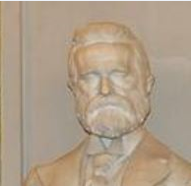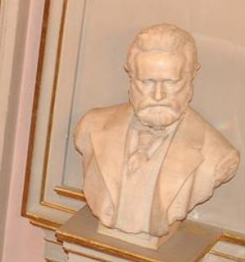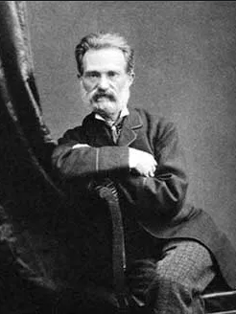
Dimensions:

Height:
Width:
Weight:
 | 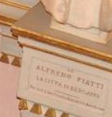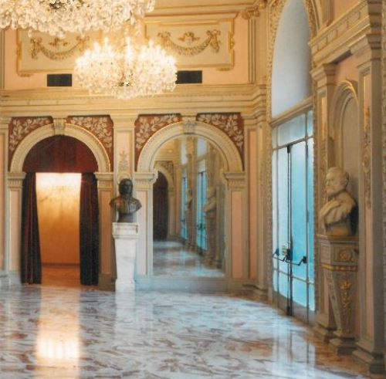

d) FELICE CARNAZZI, INNOCENTE SEBASTIANO CARNAZZI, Giacomo Manzoni scultore, Necrologie e ritratti a cura dei compilatori (tr. = obituaries and portraits curated by the compilators ) in : Diario e guida della Città di Bergamo ( tr. = Diary and guide of the city of Bergamo ) , Bergamo, Ufficio Carnazzi (Milano, Stabilimento Lito tipografico G. Abbiati = printer ) , 1912 – 1913 , a. XX, LVII – LIX .

“In the afternoon of July 31, 1910 in our city, the sculptor Giacomo Manzoni, not yet forty years of age, died of a liver cirrhosis that had troubled him for about four months, leaving in the heartbreak the young bride Narcisa, his sister Elisa and his brother Achille, colleagues and friends. Giacomo Manzoni learned the first rudiments of art in the industrial evening school of good Zenoni. Later he went to the Carrara Academy and the valiant Caesar Tallone was his teacher: he was one of the first distinguished pupils. Awarded at our Academy with a special prize from the Society of Fine Arts; Praised at the national exhibition in Milan he had the satisfaction of selling several works to the artist Novelli. He received praise for the bust of Alfredo Piatti sent to London. He won the competition for the late Avv. Maironi. The distinguished sculptor Butti praised him for the bust of Piatti at the Donizetti theater, and shook his hand in esteem, saying: "Come on young man, the future is yours, you have talent and health!" His funeral was very impressive: on his coffin the Cav Prof. Ponziano Loverini had words of regret. To the relatives all desolated by this loss we send expressions of the deepest condolences”.
In:

https://www.bdl.servizirl.it/bdl/bookreader/index.html?path=fe&cdOggetto=16984#page/170/mode/2up

7) OTHER BUSTS’S OF ALFREDO PIATTI CONNECTED TO THE RAM AND THEATRE DONIZETTI’S ONES

A)

CROCETTE DI MOZZO, Villa Crocetta, Oratorio della famiglia Lochis intitolato alla Purità della Vergine ed a San Guglielmo Abate benedettino (tr. = private oratory titled to the purity of the Virgin and to Saint William benedectine Abbot) Colle Lochis , Proprietà privata fam. Marinoni (Lochis Hill , Private property family Marinoni) | (PIETRO )GIACOMO MANZONI (probably ), Bust of Alfredo Piatti and pedestal in marble of Carrara,  , before 28/03/1903 | 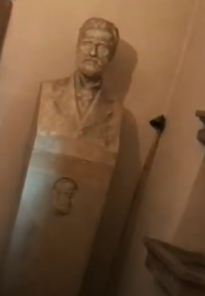
Dimensions:

Height:
Width:
Weight:

B)

Milan , Lobby of the Music Hall Conservatory Giuseppe Verdi | DANIELE SCOLA , Bust of Alfredo Piatti , bronze on a marble shelf  , 1908 – 21/12/1908 | 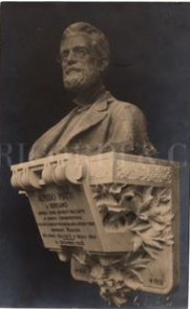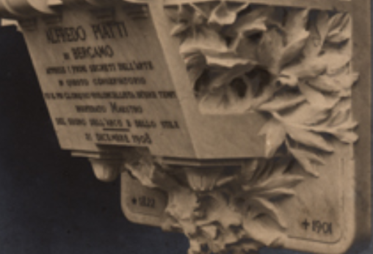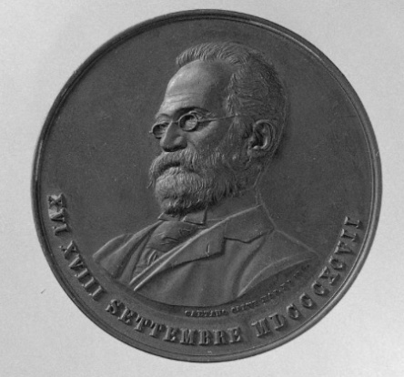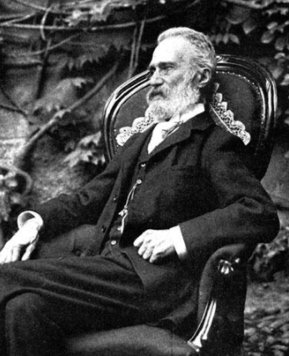  The bust of Milan compared to his probable sources: the Gaetano Calvi (https://www.google.com/search?q=Medaglia+alfredo+piatti&oq=Medaglia+alfredo+piatti&aqs=chrome..69i57j69i61.5811j0j4&sourceid=chrome&ie=UTF-8) medal made in 1897 for the Donizettian celebrations and a photograph taken at the end of the century and maybe making part of a array done by the same author that have viewed another similar portrait of the cellist published with the necrology edited in 1901 by the Review Emporium (P. M., Miscellanea, Necrologio, Alfredo Piatti in: Emporium , Luglio , Vol. 14, N. 79, Bergamo, Istituto italiano d’arti grafiche, 1901, p. 79 ; in: http://www.artivisive.sns.it/galleria/libro.php?volume=XIV&pagina=XIV_079_079.jpg)
Dimensions:
Height:
Width:
Weight:
Letters: “Adolfo Piatti – di Bergamo – apprese i primi segreti dell’arte – in questo conservatorio – fu il più glorioso violoncellista dei suoi tempi- insuperato maestro – del suono dell’arco e dello stile -2 1 Dicembre 1908 - 1822- 1901“ A. Boito (words shaped over the marble shelf).
Sources: | S. N. , Rinnovamento del nostro conservatorio / il nuovo salone dei concerti (tr. = The renewal of our conservatory / the new concert hall ) , Corriere Milanese in: Corriere della sera, 06/12, Milan, 1908, p. 5.  “[…]  This atrium is destined to become the Famedio, that is to say, of the Verdi conservatory. In fact, its walls will contain many of those monumental memories of his students and teachers that were scattered here and there. Indeed, during the musical congress the monuments to Catalani and Coronaro will be inaugurated in that lobby. The beautiful monument to Alfredo Catalani is also ready. It was performed with offers collected by admirers of the illustrious master from Lucca. indeed, the subscription to the conservatory is still open.[…]”  S. N. Il centenario del Conservatorio/ il ricevimento al Castello Sforzesco (tr. = The Centenary of the conservatorio/ the party at Sforzesco castle) , Corriere Milanese in: Corriere della sera, 21/12, Milan, 1908, p. 4.  “[…]La giornata odierna (tr. = Today ) Today the last deliberations will be taken and at 3 pm the busts of Catalani, Coronaro and Piatti will be inaugurated. This last bust – molded by Daniele Scola, with an epigraph by Arrigo Boito - was born by the initiative of artistic personalities, friends and admirers of the illustrious cellist, but the subscription is still open at the Conservatory's bursar.  S. N. , la fine delle feste centenarie del conservatorio, la chiusura del congresso musicale (tr. = The end of the feasts for the centenary of the conservatory, the closing of the musical congress) in: Corriere della sera, 22/12, Milan, 1908, p. 5.  “ […] il monumento a Catalani, Piatti e a Coronaro […] (tr. = the monument to Catalani, Piatti and to Coronaro) The congressmen gathered again in the afternoon to witness the unveiling of the busts to the composer Alfredo Catalani and the cellist Alfredo Piatti, and the medallion to the composer Gaetano Coronaro, located in the atrium of the new hall, among the various monuments to Ponchielli, Angeleri, Bazzini, Lauro Rossi. The two busts and the medallion were very similar. […]Even the bust of Piatti - by the sculptor Scola - is in bronze and lays on a marble shelf on which we read this epigraph written by Arrigo Boito "Alfredo Piatti / of Bergamo / learned the first secrets of art / in this Conservatory / was the most glorious cellist of his time / unsurpassed Maestro / of sound, bow and style / 21 December 1908 - 1822 - 1901 "  “  S. N., Appunti e notizie (tr: notes and news)in: S. N., Bollettino della civica biblioteca di Bergamo, fasc. IV, Ottobre – Dicembre, Bergamo, s.e., 1908, p. 281.  “On 21 December was inaugurated in the hall of the new concert hall at the music conservatory of Milan the bust of the cellist Alfredo Piatti by the sculptor Scola. The bust is in bronze and rests on a marble corbel on which we can read this epigraph written by Arrigo Boito: Alfredo Piatti / of Bergamo / learned the first secrets of art / in this Conservatory / was the most glorious cellist of his time / unsurpassed Maestro / of sound, bow and style / 21 December 1908 - 1822 – 1901”  in : https://www.bdl.servizirl.it/bdl/bookreader/index.html?path=fe&cdOggetto=3923#page/242/mode/2up

c)

THE MIA BUST OF PIATTI

BERGAMO, MIA, Sala Piatti | (PIETRO )GIACOMO MANZONI , Bust of Alfredo Piatti (in marble , or plaster? )21/12/1908 – 21/04/1910 , or before the 28/03/1903 (unknown the date of the access and the provenance ) | 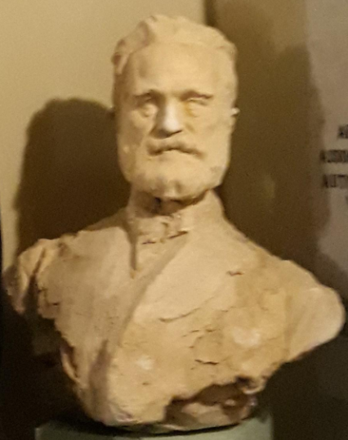
Dimensions:

Height:
Width:
Weight:

9) OTHER MEMORIES ON ALFREDO PIATTI IN BERGAMO
S. N., Lapidi moderne , mausolei e lapidi moderne in: S. N., Bergamo e provincia, guida 1910, Bergamo, Soc. editrice commerciale , Collezione, 1910, p. 87.
“To Alfredo Piatti Borgo Canale 6. Alfredio Piatti, highly educated musician, unsurpassed cellist, had world fame, born in 1822 and died in 1901. The artistic circle posed “

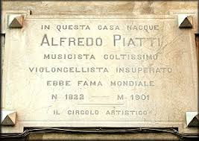
[The image of the Piatti’s stone put over his birthplace was taken by “chi era costui “ website (who’s that man?) , exactly from this page: http://www.chieracostui.com/costui/docs/search/schedaoltre.asp?ID=6167 ].

Some less precise information on the scultor were given by this text : BORTOLO BELOTTI, Storia di Bergamo e dei Bergamaschi, Vol. 8, Bergamo , Grafiche Bolis, 1989 ( I ed.: Ceschina, Milano, 1940-1959), p. 226. None by ALFREDO PANZETTA’s Nuovo dizionario degli scultori italiani dell’Ottocento e del primo Novecento , da Antonio Canova ad Arturo Martini that only, into the second volume, refers that the artist “Giacomo Manzoni ? “ had presented at the Sempione’s exhibition of 1906 “Maternal Grief “and “drunk with Love “ [Vol. 2, M – L, Torino, Ad Arte (III ed.; I . ed : Torino, Allemandi, 1989), 2003 ,p. 566 ].
That signs the act as “Costante”.
Tr.: Bergamo state Archive .
Reported wrongly also as Costante in other documents .
Tr.: Bergamo state Archive .
Maybe will be suitable to report somewhere in the text of the final cataloguing sheet also that this special reference has something to deal with the historical archive of the Carrara art Academy of Bergamo and that it’s also connected to the Archives of the Museum . As I have reported before, this condition is particular and it doesn’t happen in all the art academies of Italy. In Brera , for example, the two archives are separated and the historical archive of the Art academy is kept by the same educational institute and not by the Gallery.
This part of the archive is ordered alphabetically .
Maybe will be suitable to report somewhere in the text of the final cataloguing sheet also that this special reference has something to deal with the historical archive of the Carrara art Academy of Bergamo and that it’s also connected to the Archives of the Museum . As I have reported before, this condition is particular and it doesn’t happen in all the art academies of Italy. In Brera , for example, the two archives are separated and the historical archive of the Art academy is kept by the same educational institute and not by the Gallery.
This part of the archive is ordered alphabetically .
“ Manzoni Giacomo nato a Calusco il 26 aprile 1870/ Anni di Scuola /1896 - 1897 = Scuola di pittura, primo anno, frequenta la scuola di nudo /1897 – 1899 , idem, 2°, idem. “
The n. 3713 on vaccinations.
Brothers Manzoni, Moving teaching desk in walnut made by following the design furnished by the engineer Luigi Angelini , 1931 [REDONA, San Lorenzo Martire, 18]; Brothers Manzoni, the Assunta ‘s group, 1910 [SANTA NARIA AL BOSCO, p. p . 34 – 35; quote = 35 ]; Brothers Manzoni, Saint Joseph and the dead Christ statues, 1944 [BERBENNO, Sant’Antonio abate , p. p. 77 – 78; 78 ]Brothers Manzoni, recovery of the wooden tribune in three corps over two orders belonging to XVII century , 1966 [BORDOGNA, Santa Maria Assunta , p. p. 88 – 89 ]; Brothers Manzoni, Walnut chorus stalls , 1903 [CALCINATE, Assunta, p. p. 105 – 106; 106]; Brothers Manzoni, Virgin of Fatima statue, 1943 [CALEPIO, San Lorenzo, p. p. 107 – 108; 108]; Brothers Manzoni, San Bernardino statue, 1949 [CEPINO, San Bernardino , p. p. 135 – 136; 136]; Brothers Manzoni, Virgin of sorrows statue , 1927 [CHIGNOLOD’ISOLA, San Pietro apostolo, p. p. 139 – 141; 141 ]; Brothers Manzoni , wooden furniture with marquetries and Virgin of the Rosary and Saint Joseph sculptures , 1933 – 1934 [DALMINE, San Giuseppe Sposo di Maria, p. p. 168 – 170; 169]; Brothers Manzoni, Holy heart of the virgin and Holy heart of Christ sculptures, 1955 – 1959 [GAVARNO, Sant’Antonio, p. 197]; Brothers Manzoni, confessionals into a baroque shape , 1921 [MEDOLAGO, Santa Maria Assunta, p. p. 234- 235 ; 234 ];Brothers Manzoni, Saint Joseph Statue [MAPELLO, San Michele, p. p. 229 230; p. 230]; Brothers Manzoni , Saint Louis statue [NESE, San Giorgio martire, p.p. 247-250; 250]; Brothers Manzoni, wooden statue of Saint Joseph 1905 [PARZANICA, San Colombano, p. p. 271 – 272; 272]; Brothers Manzoni, Saint John the Baptist statue, 1936 [PREDORE , Sacro cuore di Gesù e San Giovanni Battista, 290 – 292; 291]; Brothers Manzoni, Saint Louis Gonzaga, 1953 [PREZZATE, St Alessandro, p. p. 293-294; 294] ; Brothers Manzoni, Dead Christ and St Joseph, sculptures [SELVINO, San Filippino e Giacomo martire , p. p. 342-343; 343]; Brothers Manzoni, San Louis, modern sculpture [SONGAVAZZO, San Bartolomeo Apostolo, p. p. 355-356; 356]; Fratelli Manzoni, Virgin of the Assumption sculpture , 1925 ca. [SOTTO IL MONTE – GIOVANNI XIII]; Brothers Manzoni, pulpit, confessionals, and sacristy wardrobe, 1910 - 1913 [SUISO, Sant’Andrea, p. p. 367- 368 ; 368 ]; Fratelli (tr. = brothers Manzoni ), Holy heart of Christ, 1900 [ZANICA, San Fermo , p. p. 417 - 418 ; p. 417].
The new church was designed by the Architect Antonio Preda and built between 24/07/1864 and 07/12/1886 (as reported also in the web page of the city council of Calusco d’Adda : https://www.comune.caluscodadda.bg.it/vivere-citta/cenni-storici .
https://www.beweb.chiesacattolica.it/benistorici/bene/5604358/Manzoni+G.+%281897%29%2C+San+Giuseppe+con+Ges%C3%B9+Bambino#da=81&limite=10&ordine=rilevanza&action=CERCA&o=undefined&frase=Giacomo+Manzoni&locale=it&ambito=&domini=1&regione_ecc_facc=LOMBARDIA
Bergamo City.
https://www.beweb.chiesacattolica.it/benistorici/bene/5574829/Muzio+V.-Manzoni+G.+%281901%29%2C+Cattedra+oratoria+con+rilievi#da=41&limite=10&ordine=rilevanza&action=CERCA&o=undefined&frase=Giacomo+Manzoni&locale=it&ambito=&domini=1&regione_ecc_facc=LOMBARDIA ; https://www.beweb.chiesacattolica.it/benistorici/bene/5574835/Manzoni+G.+%281901%29%2C+Episodio+della+vita+di+S.+Alessandro; https://www.beweb.chiesacattolica.it/benistorici/bene/5574838/Manzoni+G.+%281901%29%2C+Sant%27Alessandro+converte+custode+e+sbirri ; https://www.beweb.chiesacattolica.it/benistorici/bene/5574838/Manzoni+G.+%281901%29%2C+Sant%27Alessandro+converte+custode+e+sbirri ; https://www.beweb.chiesacattolica.it/benistorici/bene/5574833/Manzoni+G.+%281901%29%2C+Sant%27Alessandro+risuscita+un+morto#da=51&limite=10&ordine=rilevanza&action=CERCA&o=undefined&frase=Giacomo+Manzoni&locale=it&ambito=&domini=1&regione_ecc_facc=LOMBARDIA
The architect ( Colognola , 1864 – Bergamo , 1904) frequented the Brera Academy under Camillo Boito, brother of Arrigo, and got his professional license in 1891. Was nominated honorary member of Brera Academy in 1896 and became a teacher of the famous Milanese institution ( from 1896 to 1902) that awarded him the Pensionato Oggioni. In his career of Architect planned some liberty stile architectures as home Paleni in Bergamo and curated the restoration of some buildings into that city as being part of the Conservative Commission to the Monuments of Bergamo , supervising more than 40 projects .He was the father of the rationalist architect Giovanni Muzio.
Bergamo City .
Architect and engineer that has lived and mostly worked into the Bergamo district (Bergamo 29 /05/1847 – 05/12/1925), well known for being a teacher of the Circolo Artistico Bergamasco that have commissioned the Piatti’s bust of The Donizetti theatre. Was very famous for having planned some buildings into an historical style (neogothic, neoromantic and neoclassic ) as the monumental cemetery of Bergamo in 1913. He was a great and prolific writer on subjects having to deal with the local history .
https://www.beweb.chiesacattolica.it/benistorici/bene/5615230/Manzoni+G.+sec.+XX%2C+Madonna+assunta#da=31&limite=10&ordine=rilevanza&action=CERCA&o=undefined&frase=Giacomo+Manzoni&locale=it&ambito=&domini=1&regione_ecc_facc=LOMBARDIA
https://www.beweb.chiesacattolica.it/benistorici/bene/5821462/Manzoni+G.+inizio+sec.+XIX%2C+Confessionale+in+legno#da=1&limite=10&ordine=rilevanza&action=CERCA&o=undefined&frase=Giacomo+Manzoni&locale=it&ambito=&domini=1&regione_ecc_facc=LOMBARDIA;
https://www.beweb.chiesacattolica.it/benistorici/bene/5821297/Ambito+bergamasco+sec.+XX%2C+Statua+della+Madonna+Assunta#da=91&limite=10&ordine=rilevanza&action=CERCA&o=undefined&frase=Giacomo+Manzoni&locale=it&ambito=&domini=1&regione_ecc_facc=LOMBARDIA
https://www.beweb.chiesacattolica.it/benistorici/bene/5682023/Domeneghini+F.-Manzoni+G.+%281901%29%2C+Bancale+da+presbiterio#da=51&limite=10&ordine=rilevanza&action=CERCA&o=undefined&frase=Giacomo+Manzoni&locale=it&ambito=&domini=1&regione_ecc_facc=LOMBARDIA
Painter (Breno , 5/10/1860 – Bergamo, 10/05/1950) active in Bergamo, in Rome, but also in Argentina where he lived for a small part of his life.
Woodcarver (Alzano , 1852 – Bergamo 26/11/1926 ) and author of distinguished marqueteries .
A family of famous restorers also inventors of a method to detach paintings from their original supports to prevent its destruction.
That have worked also on the frame for the Palma’s the old polyptyc in Peghera , Taleggio, Bg.
https://www.beweb.chiesacattolica.it/benistorici/bene/5573391/Manzoni+G.+%281901%29%2C+San+Giuseppe+e+Ges%C3%B9+Bambino#da=91&limite=10&ordine=rilevanza&action=CERCA&o=undefined&frase=Giacomo+Manzoni&locale=it&ambito=&domini=1&regione_ecc_facc=LOMBARDIA
The new church was designed by the Architect Antonio Preda and built between 24/07/1864 and 07/12/1886 (as reported also in the web page of the city council of Calusco d’Adda : https://www.comune.caluscodadda.bg.it/vivere-citta/cenni-storici ) .
https://www.beweb.chiesacattolica.it/benistorici/bene/5604359/Manzoni+G.+%281904%29%2C+Madonna+Immacolata#da=91&limite=10&ordine=rilevanza&action=CERCA&o=undefined&frase=Giacomo+Manzoni&locale=it&ambito=&domini=1&regione_ecc_facc=LOMBARDIA
https://www.beweb.chiesacattolica.it/benistorici/bene/5770742/Manzoni+G.+%281906%29%2C+Statua+della+Fede+nel+sagrato#da=1&limite=10&ordine=rilevanza&action=CERCA&o=undefined&frase=Giacomo+Manzoni&locale=it&ambito=&domini=1&regione_ecc_facc=LOMBARDIA; https://www.beweb.chiesacattolica.it/benistorici/bene/5770743/Manzoni+G.+%281906%29%2C+Statua+della+Speranza+nel+sagrato ; https://www.beweb.chiesacattolica.it/benistorici/bene/5770744/Manzoni+G.+%281906%29%2C+Statua+della+Piet%C3%A0+nel+sagrato ; https://www.beweb.chiesacattolica.it/benistorici/bene/5770745/Manzoni+G.+%281906%29%2C+Statua+della+Carit%C3%A0+nel+sagrato .
Architect of Bergamo (1864 – 1945) has planned a great number of buildings for that city - as the church of the Holy heart of Christ (with Luigi Angelini in 1916) - and across the Lombardy, mostly churches, or private residences (as Villa Cacciamali in Zogno , 1906) .
https://www.beweb.chiesacattolica.it/benistorici/bene/5769538/Manzoni+G.+%281908%29%2C+Fonte+battesimale ; https://www.beweb.chiesacattolica.it/benistorici/bene/5768952/Manzoni+G.+%281908%29%2C+Angioletto+2-4#da=31&limite=10&ordine=rilevanza&action=CERCA&o=undefined&frase=Giacomo+Manzoni&locale=it&ambito=&domini=1&regione_ecc_facc=LOMBARDIA ; https://www.beweb.chiesacattolica.it/benistorici/bene/5769540/Manzoni+G.+%281908%29%2C+Fede#da=41&limite=10&ordine=rilevanza&action=CERCA&o=undefined&frase=Giacomo+Manzoni&locale=it&ambito=&domini=1&regione_ecc_facc=LOMBARDIA; https://www.beweb.chiesacattolica.it/benistorici/bene/5769542/Manzoni+G.+%281908%29%2C+Apparizione+della+croce+a+Costantino; https://www.beweb.chiesacattolica.it/benistorici/bene/5768943/Manzoni+G.+%281908%29%2C+Lesena+a+rilievo+4-4; https://www.beweb.chiesacattolica.it/benistorici/bene/5768239/Manzoni+G.+%281908%29%2C+Testa+di+angioletto+2-2; https://www.beweb.chiesacattolica.it/benistorici/bene/5768954/Manzoni+G.+%281908%29%2C+Angioletto+4-4; https://www.beweb.chiesacattolica.it/benistorici/bene/5768117/Manzoni+G.+%281908%29%2C+San+Giovanni+Battista#da=31&limite=10&ordine=rilevanza&action=CERCA&o=undefined&frase=Giacomo+Manzoni&locale=it&ambito=&domini=1&regione_ecc_facc=LOMBARDIA .
The new church was designed by the Architect Antonio Preda and built between 24/07/1864 and 07/12/1886 (as reported also in the web page of the city council of Calusco d’Adda : https://www.comune.caluscodadda.bg.it/vivere-citta/cenni-storici ) .
https://www.beweb.chiesacattolica.it/benistorici/bene/5604357/Manzoni+G.+%281908%29%2C+Sacro+Cuore+di+Ges%C3%B9#da=91&limite=10&ordine=rilevanza&action=CERCA&o=undefined&frase=Giacomo+Manzoni&locale=it&ambito=&domini=1&regione_ecc_facc=LOMBARDIA .
https://www.beweb.chiesacattolica.it/benistorici/bene/5604355/Manzoni+G.+%281908%29%2C+San+Luigi+Gonzaga#da=71&limite=10&ordine=rilevanza&action=CERCA&o=undefined&frase=Giacomo+Manzoni&locale=it&ambito=&domini=1&regione_ecc_facc=LOMBARDIA ;
Architect that has rebuilt the church of San Bartolomeo in Alzano and San Bartolomeo of Olera and restored some of the portals of Santa Maria Maggiore in Bergamo and the church of San Vincenzo in Ponteranica.
https://www.beweb.chiesacattolica.it/benistorici/bene/5758107/Manzoni+G.+%281910%29%2C+San+Fermo; https://www.beweb.chiesacattolica.it/benistorici/bene/5758178/Manzoni+G.+%281910%29%2C+Redentore+e+due+angeli ; https://www.beweb.chiesacattolica.it/benistorici/bene/5758179/Manzoni+G.+%281910%29%2C+Angeli+con+simboli+della+passione ; https://www.beweb.chiesacattolica.it/benistorici/bene/5758470/Manzoni+G.+%281910%29%2C+Angelo#da=21&limite=10&ordine=rilevanza&action=CERCA&o=undefined&frase=Giacomo+Manzoni&locale=it&ambito=&domini=1&regione_ecc_facc=LOMBARDIA ; https://www.beweb.chiesacattolica.it/benistorici/bene/5758177/Manzoni+G.+%281910%29%2C+San+Rustico#da=21&limite=10&ordine=rilevanza&action=CERCA&o=undefined&frase=Giacomo+Manzoni&locale=it&ambito=&domini=1&regione_ecc_facc=LOMBARDIA .
Bergamo city.
https://www.beweb.chiesacattolica.it/benistorici/bene/1000008868/Ambito+bergamasco+sec.+XX%2C+San+Leonardo#da=1&limite=10&ordine=rilevanza&action=CERCA&o=undefined&frase=Giacomo+Manzoni&locale=it&ambito=&domini=1&regione_ecc_facc=LOMBARDIA.
L’Eco di Bergamo, 31/08, Bergamo, 1903 in: PILADE FRATTINI, RENATO RAVANELLI, ORNELLA BRAZZANI (a.c.) , Il novecento a Bergamo, Cronache di un secolo , Torino , Utet Libri, 2014, p. 257.
S. N., Catalogo Esposizione Belle Arti 1906, Capriolo e Massimino, Milano, 1906, p. p. 161, 164 (consulted into digitami library, the digital historical library of the city hall libraries of Milan : >http://www.digitami.it/opera.do?operaId=271&visual=img&paginaN=263 )
For this fact and to celebrate himself , the sculptor gifted the Angelo Mai library of a copy of the rare edition of the “Rivista internazionale illlustrata . Organo delle arti e industrie italiane ed estere “ (Vol. 2, 15/05, Milano, Tip Lombarda, 1906) as reported into the Bullettin of the library [CIRO CAVERSAZZI (a.c.), Parte speciale, Doni, 1906, stampati in: S. N. , Bollettino della civica di Bergamo, fasc. 1, Luglio – Settembre (tr= July – September) , Bergamo, s. e. , 1907, p. 7]. This happens, also because is given a full page critic to one of MONTINO CELLI (p. 8) to the two exhibited artworks of Giacomo Manzoni, titled “ ( tr: Inhebriated with Love e Mother’s grief che recava questo testo: “ To proceed with order in giving the illustrated description of each exhibitor, we will start from the first room on the right of the first main entrance. Among the plaster works, noteworthy is a splendid subject "Ebbra d'amore" of which Mr. Giacomo Manzoni of Bergamo The first time you send your works to an exhibition, you may be lucky enough to have guessed a subject that can even be called a masterpiece by idea and execution. He, in his group , not only reproduced exactly the forms of man and woman, but made the truth of the subject stand out; in a word, he has given the breath of life to his two figures. To that woman who with softness, I would almost say lascivious, lets herself fall into her lover's arms, drunk with love, exhausted by his caresses and kisses, but who touches the words on her arms: take me, I'm yours, do you what you want! And the natural, stale, worn pose not easy to reach by others was even guessed by the author. Those lines of the man's body are so well studied, with a sure and harmonious simplicity, that they reproduce exactly the movements of that position, they reveal that the author knows the art and not only knows it for having studied and perfected it; but because he was born with that artistic intuition necessary to conquer a name, a name that will do honor to the country. in his group, everything is found , nothing is missing, he has modeled with ... expressive strokes ... speaking and it almost seems to you that you have to rush and support that beautiful figure of a woman, abandoned on the arms of Love. And when art has been able to reach the sentiment of truth, when the stupendous forms of life-size figures are attached to the triumphant accent of truth, the author is certainly a strong one, he is what he wants to be, He has achieved the goal. See! feel ! to express! Here is the whole truth of art, it is summed up in these words. And Manzoni, in his work, shows us the perfect movement of the forms, I would almost say a desire for pleasure, and expresses all the passion that quivers in those two beings at that moment. This is true art, art that knows how to reproduce real life, the life that you feel, that you live, that you want! And also in his other plaster bust depicting "Maternal Pain" he was so fond of reality, he gave it so much expression that he could compare it to his first group. Manzoni can be proud to have presented these two works which deserve all the moral satisfactions of that art which he has won through good will and perseverance, nothing is missing, he has modeled with ... expressive strokes ... speaking and it almost seems to you that you have to rush and support that beautiful figure of a woman, abandoned on the arms of Love. And when art has been able to reach the sentiment of truth, when the stupendous forms of life-size figures are attached to the triumphant accent of truth, the author is certainly a strong one, he is what he wants to be, He has achieved the goal. See! feel ! to express! Here is the whole truth of art, it is summed up in these words. And Manzoni, in his work, shows us the perfect movement of the forms, I would almost say a desire for pleasure, and expresses all the passion that quivers in those two beings at that moment. This is true art, art that knows how to reproduce real life, the life that you feel, that you live, that you want! And also in his other plaster bust depicting "Maternal Pain" he was so fond of reality, he gave it so much expression that he could compare it to his first group. Manzoni can be proud to have presented these two works which deserve all the moral satisfactions of that art which he has won through good will and perseverance, using that acute and brilliant ingenuity that came from nature. How many times has the young artist repeated the famous motto of - Alfieri Volui, volui, et consecutus sum-! We say young because he is only 35 years old and up to 25 years old he practiced the art of carving. Immediately afterwards, under the guidance of his father, and therefore only aided by the iron will, he always progressed until he obtained the only prize of L 1000 with a dura lege subject at the Carrara Academy in Bergamo. Then he won in the competition of the applied art school, as a plastic teacher. And today it can be said that the road to glory has opened, by exposing this splendid group, whose subject can be said to be unattainable. And if the visitors of the exhibition formed a concept for judging the Exhibition of Fine Arts, from the works that the committee arranged in this first room, they would have to say that this exhibition occupies the first place in the current Exhibition. And we, in writing, do nothing but affirm the impressions of all those who are able to judge visit, and express their impressions and who in the face of this imposing manifestation of human ingenuity only inaugurate those victories that the author deserves and that they already have. started to flourish in its past and to make its way into its future.” [ http://emeroteca.braidense.it/gea/sfoglia_fascicolo.php?IDTestata=580&CodScheda=&Anno=1906&Mese=05&Giorno=15&IDG=89381&RecSel=0 ; https://www.bdl.servizirl.it/bdl/bookreader/index.html?path=fe&cdOggetto=3922#page/52/mode/2up ].
FELICE CARNAZZI, INNOCENTE SEBASTIANO CARNAZZI, Giacomo Manzoni scultore, Necrologie e ritratti a cura dei compilatori (tr. = obituaries and portraits curated by the compilators ) in : Diario e guida della Città di Bergamo ( tr. = Diary and guide of the city of Bergamo ) , Bergamo, Ufficio Carnazzi (Milano, Stabilimento Lito tipografico G. Abbiati = printer ) , 1912 – 1913 , a. XX, LVII – LIX.
Civil engineer that have proposed in 1902 some variations to the regulatory municipal masterplan of Bergamo in 1902 and that have concluded in 1904 the works for the building of the Sala Piatti of the music conservatory Donizetti of Bergamo. Caccia have planned also, between 1912 and 1914 , the school Luigi Noris.
A typical stone of Val Camonica .
S. N., Edicola Ferrari nel cimitero di Bergamo in: L’architettura italiana, Vol. 6, march, Torino, Crudo e Co, 1908, a. III, p. 26 (in : http://digitale.bnc.roma.sbn.it/tecadigitale/giornale/TO00176751/1907-1908/unico/00000032 ).
BORTOLO BELOTTI, Storia di Bergamo e dei Bergamaschi, Vol. 8, Bergamo , Grafiche Bolis, 1989 ( I ed.: Ceschina, Milano, 1940-1959), p. 135.
S. N., Negozianti , commercianti ed esercenti. Scultori in : S. N., Bergamo e provincia, guida 1910, Bergamo, Soc. editrice commerciale , Collezione, 1910, p. 391 .
The pianist that has first played in London some Debussy and Scriabin pieces (Gurnsey, 27/06/1865 – London, 01/09/1934), admired when performing music of Beethoven, Schumann and Brahams.
Robinson Dachwort (04/12/1834 – 20/09/ 1912) , appointed to the role canon of Westminister since 1875, then sub dean and chapelain in ordinary of the Queen Victoria from 1870 to 1901 (and from 1875 to 1901 Honorary chapelain of the Prince of Wales).
Joseph Bennett, music critic and liberettist (29/11/1831 – 12/05/1911) .
Probably Giuseppe Zenoni teacher of the school of design modeling and plaster, and assistant into the school of design into scuole operaie serali e festive (tr. = Evening and festive worker’s school) opened by the Scuola industriale Bergamasca (tr. = Industrial School of Bergamo) into the space of the Scuola ai Tre Passi (S. N. Almanacco provinciale bergamasco per l’anno 1881, Bergamo, Gaffuri e Gatti, 1881, A LVIII, p. 146; https://books.google.it/books?id=jJCSeEmqzp8C&pg=PA146&dq=Giuseppe+zenoni+scuola+bergamo&hl=it&sa=X&ved=2ahUKEwjxzd-IoInrAhVEiIsKHQ6CDAAQ6AEwAHoECAYQAg#v=onepage&q=Giuseppe%20zenoni%20scuola%20bergamo&f=false ) . Zenoni has probably continued to teach the same subject till 1905, being inscribed as a professor of plaster into the list of teachers of the Institution founded in 1885, The Technical Institute Vittorio Emanuele of Bergamo (S. N., Annuario del ministero di agricoltura , industria e commercio, Roma, Tip. Nazionale di G. Bertero, 1905, a III, p. 169; https://books.google.it/books?id=chhT9WmpnToC&pg=PA169&dq=giuseppe+zenoni+plastica&hl=it&sa=X&ved=2ahUKEwiJ5a7w8prrAhXB2qQKHd_YA0IQ6AEwAXoECAEQAg#v=onepage&q=giuseppe%20zenoni%20plastica&f=false).
Cesare Tallone (Savona , 11/08/1853- Milan, 21/06/1919) , had been a very famous painter (well known as portraits), moreover in Milan , between the second half of XIX century and the beginning of the following one who has taught painting at Carrara Art Academy from 1884 to 1891.
Probably the actor Ermete de Conti Novelli (Lucca, 05/05/1851- Naples , 29/01/1919), married with Lina Marrazzi and father to the Illustrator, journalist and prolific writer Enrico called” Yambo “ (Pisa, 05/06/1874 – Florence, 29/12/1943 ) . Other candidates for this identification , not having a wide spread knowledge across all Italy to be called “artist Novelli”, were probably the Paduan sculptor Pietro Novelli [portraited in 1940 by Corrado Corradi in the picture conserved into Palazzo Piazzetti of Jesi and founder , between 1887 and 1890 of the “Società padovana per la fabbricazione delle ceramiche artistiche” (tr = The Paduan society for the manufacturing of artistic potteries ), not well known across Italy, and the too young sculptor Giovan Battista Novelli of Costantino (Gradisca di Isonzo 28/08/1879 – Gorizia , 1965).
The socialist deputee and barrister Federico Maironi (Bergamo, 20/02/1866 – 10/02/1906) nicknamed the “lawyer of the poors “ for a giving free legal patronage to the workers.
Enrico Butti (Viggiu , 03/04/1847 – 31/01/1931) sculptor that have studied in Brera under Pietro Magni . Scapigliato, he was awarded a Grand Prix and a silver medal at the Paris Expo of 1889 . He was also a Painter and have executed a lot of public monuments in Milan, as the one to Giuseppe Verdi .
Painter , before student and then professor (from 1889 to 1926) at Accademia Carrara di Bergamo ( Gandino , 06/07/1845 – 21/08/1929)
“In Bergamo at 40 years modest and talented sculptor, student of the Carrara Academy. Manzoni made two very similar busts of the cellist Piatti , one of which is located in the Donizetti theater, the other in London “ this is the text given into another necrology published by Ars and Labor magazine [S. N., In memoria in: GIULIO RICORDI (direttore ; tr. = director ), rivista mensile illustrata , Musica e Musicisti, Vol. 9, 15/09, Ricordi, Milano,1910, 65 (a) , p. 742 (consulted into: http://digitale.bnc.roma.sbn.it/tecadigitale/giornale/TO00177086/1910/v.2/ ). ) ]
This information is derived by a bibliographical source ( GUARINONI, Eugenio De'. Parole pronunciate il 28 marzo 1903 a Villa Crocetta dal prof. Eugenio de' Guarinoni in occasione dello scoprimento di un busto ad Alfredo Piatti, s.n.t) that was shared and pointed out kindly by the titular of the “my Cello “ website, Dr. Annalisa Lodetti Barzanò (author also of : A. LODETTI BARZANÒ, Il musicista Carlo Alfredo Piatti – Un Violoncellista nell’Europa dell’800, Bergamo, Circolo Lirico Mayr-Donizetti, 1996, p. p. 60 ) through an email sent at 10.30 p.m. of the 6/08/2020. The same doctor suggested me to get a look on a video published by Mozzo Tv, on a concert held the 7 January 2017 by the Dutch trio of cellists “Piatti” over the Piatti’s tomb in Crocette di Mozzo chapel (https://www.youtube.com/watch?v=qyoMjqYuc3U) in which is possible to see the Piatti’s bust. The speech of Guarinoni was published another time (or for the first time), in 1908, for the centenary celebrations of Music Conservatory of Milan Giuseppe Verdi into a small booklet , joined with a celebrating speech devoted to the director Gaetano Coronaro (EUGENIO DE GUERINONI, Parole / pronunciate il 28 marzo 1903/ a villa Crocetta / dal Prof. Eugenio de Guerinoni / in occasione dello scoprimento d’un / busto / ad Alfredo Piatti in: S. N. , Feste centenarie del Regio Conservatorio di Milano / Giuseppe Verdi di /Milano/ per l’inaugurazione / dei busti a Gaetano Coronaro / e / a Alfredo Piatti / 21 Dicembre 1908 , Milano, Premiato Stabilimento Enrico Bonetti , 1908, p. p. 16. Some parts of the speech devoted to Piatti made an allusion to the bust and its commission, not reporting the name of the author and an eventual reference of the exact year in which it was executed: “[…] (p . 9 ) I must not only express my feelings of reverent esteem towards the great artist to whom we all turn our thoughts, but mainly that of his closest friends who have come here in special honor, and of the illustrious masters Boito and Gallignani for the R Conservatory of Milan [ ...] (p. 10) Therefore, I will restrict myself to entertaining myself with him with the hope not that with my words, too modest, they can increase the value of our tribute in veneration on this auspicious occasion, but rather that they are especially worthy of gathering our hearts in a warm support of admiration for the noble lady, who canceled by an immense love and the cult of the dearest memories, wanted to perpetuate in this hermitage, so propitious for meditation, the august effigy of the glorious father, who certainly enjoys in the contemplation of the artistic documents that 'surround, and show a refined taste for the sciences and the arts. " . The mention of Boito inside the speech has nothing to deal with the bust commissioned to the Manzoni, but mostly with the one specific of the artistic documents surrounding the tomb of the cellist: the gravestone. In fact this stone, as reported into a not dated letter of condolences sent to Piatti’s daughter , was completely dictated, written by Boito’s himself with whom Piatti have had a mutual relation of friendship, likely as the one with Verdi. Piatti’s gravestone words are the following: “In questa tomba familiare giace / Alfredo Piatti /della schiera dei sommi musicisti italiani / vanto del XIX secolo, tutta estinta con esso./ Animo, stile,/ in lui mirabilmente concordi, / spiranti aura d'antiche virtu', /semplicità, schiettezza,/ disdegno di vane apparenze,/ grazia e sapienza e nobile ardore / componevano a gara di perfezione /l'uomo e l'artista. / Alla fervida operosità /dell'età sua gagliarda /elesse /glorioso campo Inghilterra/ , chiese / alla dolce canora terra natia /, riposo in vita , riposo in morte. /Nato l'08 gennaio 1822 , morto il 18 luglio 1901./ L'unica figlia / contessa Rosa Piatti Lochis nel suo dolore pose / [tr. = In this family tomb lies / Alfredo Piatti / of the ranks of the greatest Italian musicians / pride of the nineteenth century, all extinct with it./ Soul, style, / in him admirably in agreement, / breathing aura of ancient virtues, / simplicity, sincerity , / disdain of vain appearances, / grace and wisdom and noble ardor / composed in a competition of perfection / man and artist. / To the fervent industriousness / of his vigorous age / he chose / England glorious field /, churches / to the sweet singing native land /, rest in life, rest in death. / Born January 8, 1822, died July 18, 1901./ The only daughter / Countess Rosa Piatti Lochis posed in her grief / ; ARRIGO BOITO, RAFFAELLO DE RENSIS (a.c.), Arrigo Boito, Lettere, letteratura, Milano, Lampi di Stampa , 2004 (I. ed: Roma, Novissima, 1932), p. 143].
Sculptor , born in Genova in 1877 , member of the artistic circle of Varese, city in which he was dead in 1948. Between 1939 and 1940 had executed some busts to Mussolini and Vittorio Emanuele III -broken and lost- to decorate the offices of the local association of the Mutilati ed invalidi di Guerra (tr=mutilated and invalids of war) .
This description fully matches the one of the subject portrayed in this photograph kept into the Ricordi Archives of Milan (http://www.culturaitalia.it/viewItem.jsp?language=en&case=&id=oai%3Awww.internetculturale.it%2Fmetaoaicat%3Aoai%3Awww.internetculturale.sbn.it%2FTeca%3A20%3ANT0000%3AMI0285_AS_1844-02) which iconographical source seems to be related also with the same that was used by Gaetano Calvi to produce the medal made to celebrated the concerts held by Piatti himself in Bergamo during the Doinzettian celebrations of 1897 (of the 16 – 18 September) . The bust of Piatti settled in the Milan’s Musical Conservatory Giuseppe Verdi was probably only a small part of that great apparatus that was intended by the architect Luigi Broggi to decorate the new concert hall planned and realized between 1907 -1908 .
The photograph of the bust of MIA was lent by Mrs Annalisa Barzanò Lodetti. The sculpture in its unfinished status , remembers more a drawing , a sketch , than a sculpture, and seems to represent the cellist dressed with some clothes typical of his maturity as an opened jacket with some similar revers to the ones viewable in the Bignami ‘d drawing published in 1875 , joined to a L’ llustrazione italiana article fully devoted to him (S. N., Artisti viventi, Alfredo Piatti in: Vol. 7, 12/12 , Milano, Fratelli Treves,. a. III, 1875, p. p. 108 – 110 (viewed into: https://digipress.digitale-sammlungen.de/view/bsb11326206_00107_u001/11 ) .

