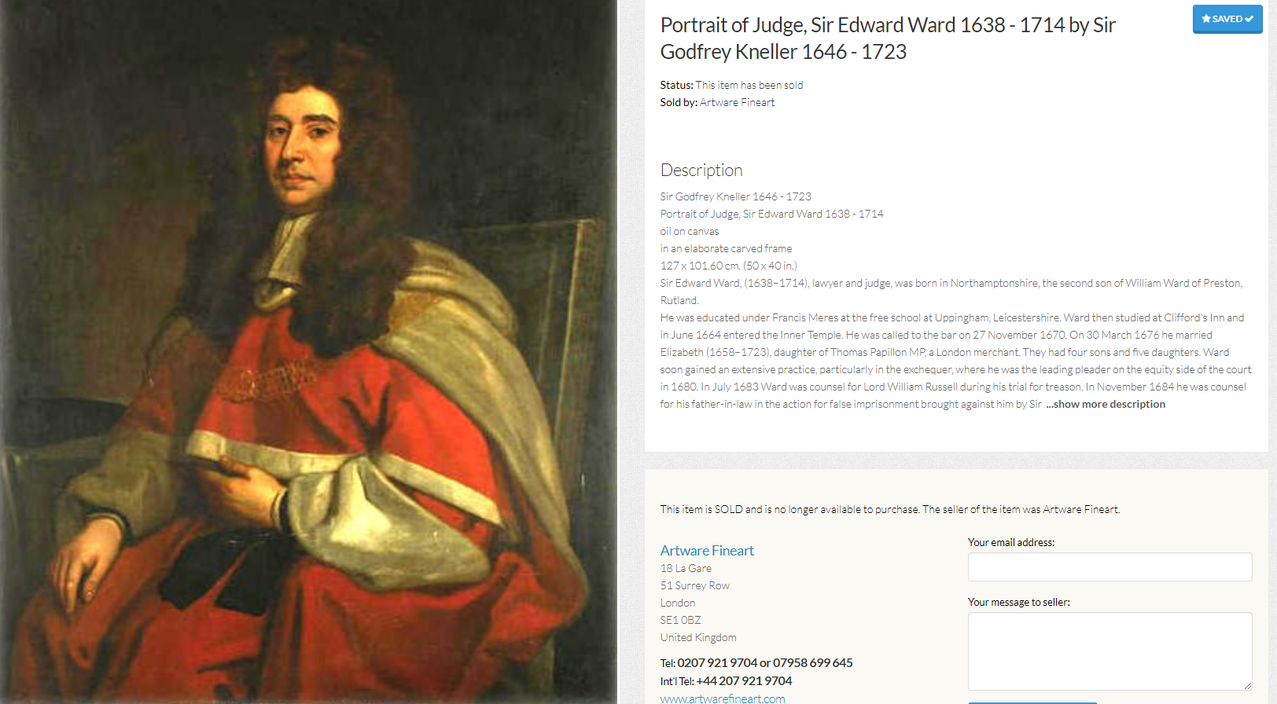
Source: https://www.sellingantiques.co.uk/342095/portrait-of-judge-sir-edward-ward-1638-1714-by-sir-godfrey-kneller-1646-1723/

