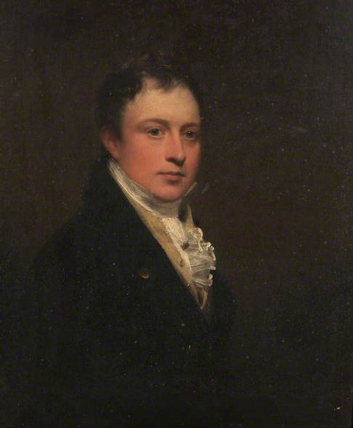 | 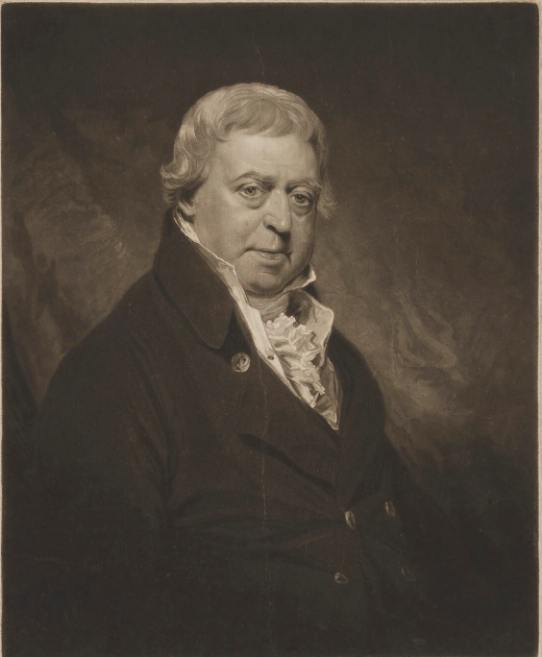 | 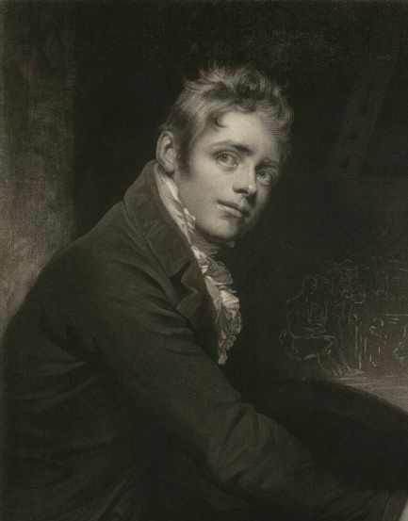
Sir John Owen | James Ferguson by Beechey, published 1818 | Wilkie by Beechey, , published 1810.  In reverse detail

