JERNÆS, 1894

Wooden bark 300T master H P Jensen,

built 1870 ? Risør by N. Olsen Gjernæs

Norwegian, Port of Registry Arendal

Owners J. N. Jensen Thrane

Norwegian description can be found here… <https://digitaltmuseum.org/021176794933/jernaes-1870>

<https://www.sjohistorie.no/no/skip/15583>

This one has a very interesting picture attached. It is similar to the painting in question but emphatically not the same. Here the vessel is ashore in breakers with mountains in the background.



Sunderland Daily Echo and Shipping Gazette - Thursday 26 September 1940

Image © Johnston Press plc. Image created courtesy of THE BRITISH LIBRARY BOARD.

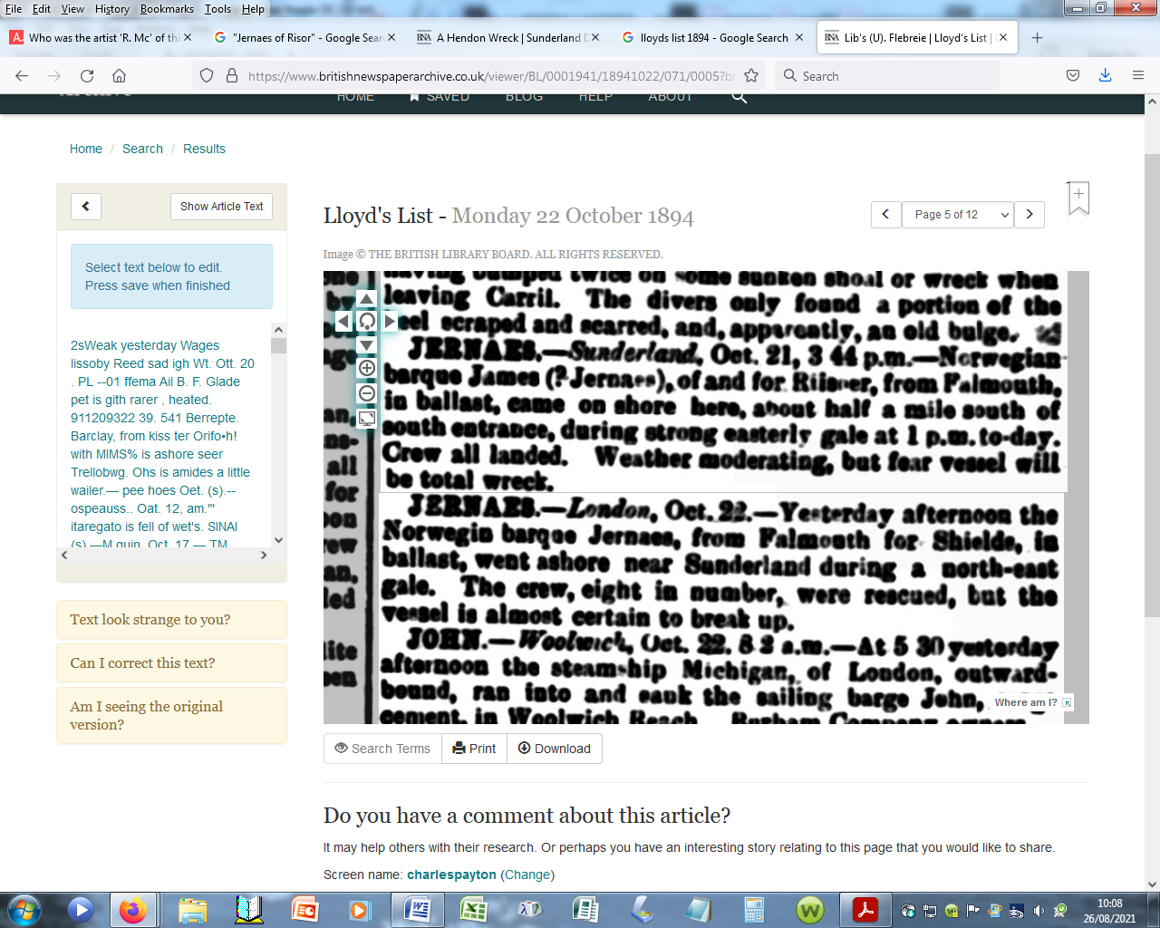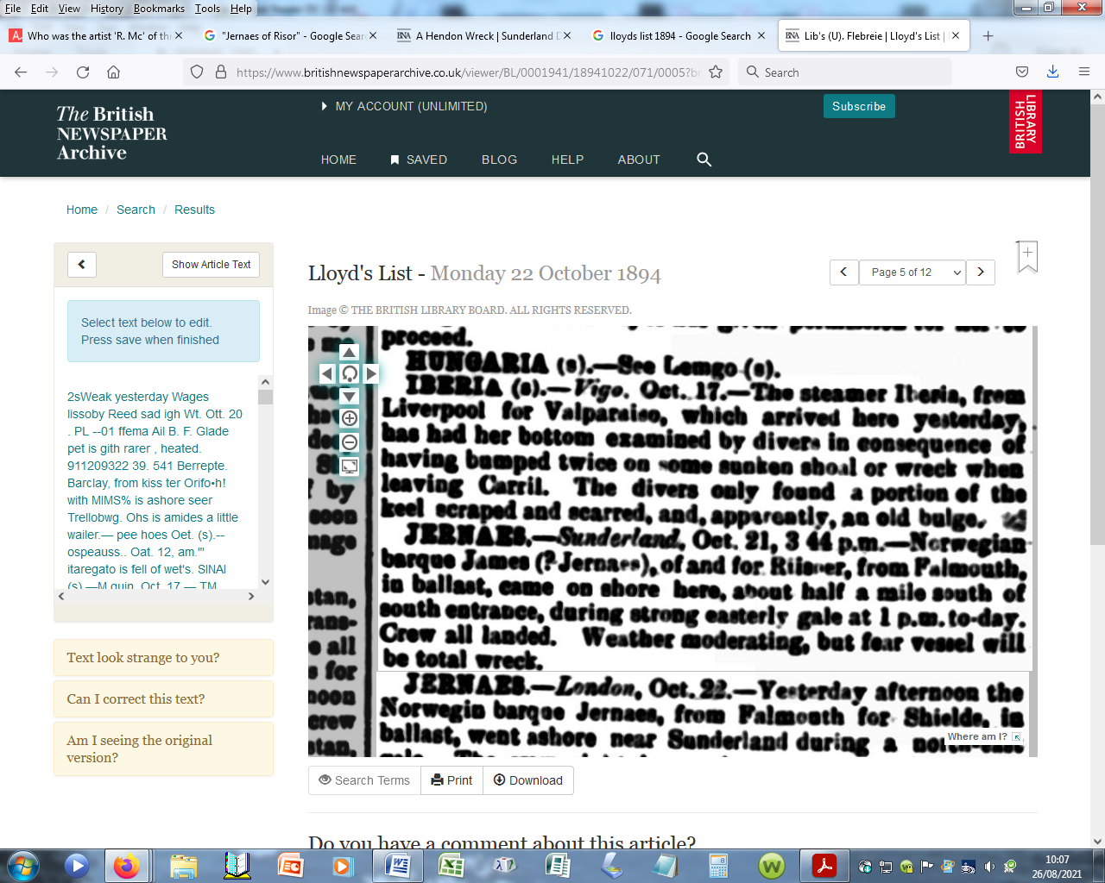

Page 5, column 8

