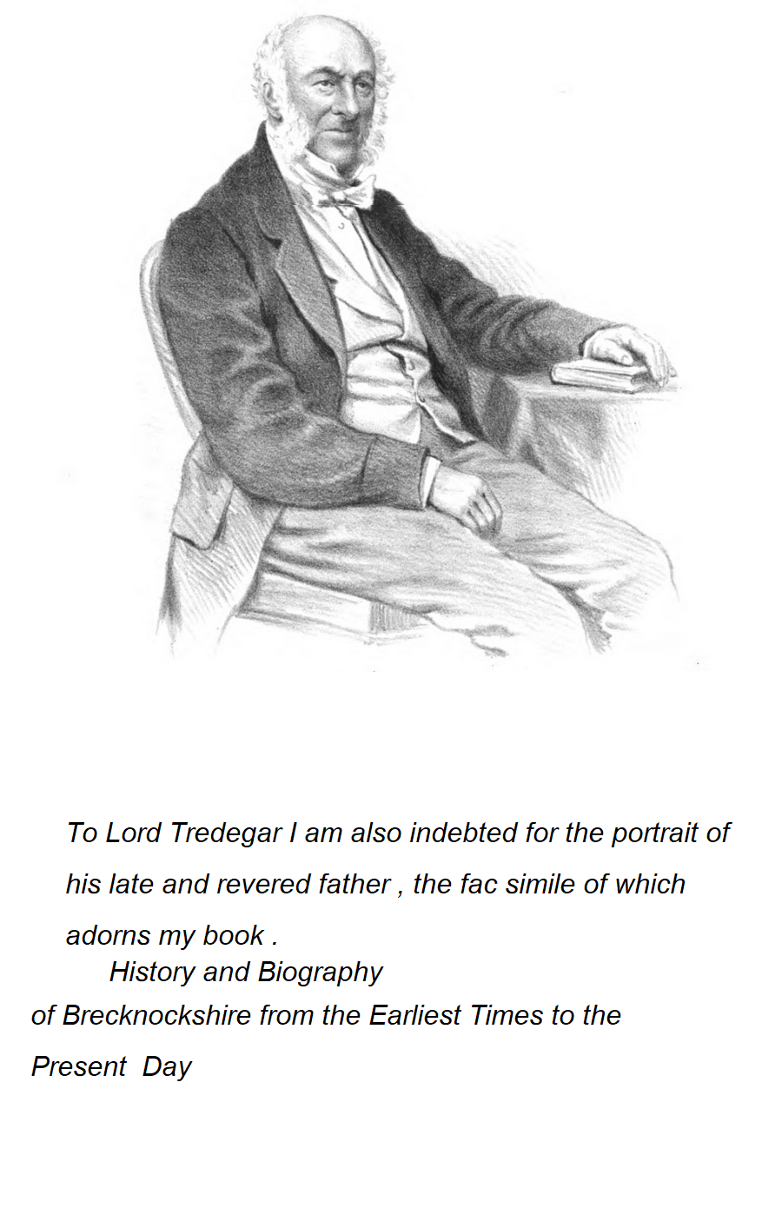
From Edwin Poole’s History and Biography of Brecknockshire

