Christopher Newall, The Grosvenor Gallery, 1995

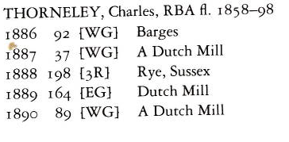

The abbreviations mean West Gallery, Third Room and East Gallery.

a

