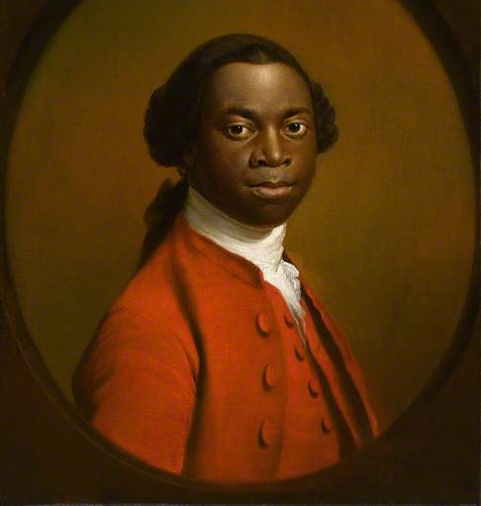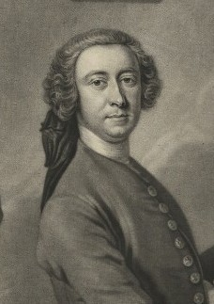
Exeter picture (detail) Henry Clarke (detail), engraved by John Faber after Thomas Hudson, 1739

