Gilbert and Emily had six children, all born at Cambridge:

The eldest Emily Valence, aka Black Nan, born in 1832 was presented at Court by her aunt Mrs Chisenhale Marsh in 1851 and married 1st. Dr Henry Wilkinson Cookson DD Master of Peterhouse Cambridge on 23.1.1855. Cookson came from Kendal and was baptised at the ‘Presbyterian’ there, and his elder brother William was Wordsworth’s lawyer. Wordsworth’s own mother was a Cookson. Henry attended Gilbert's funeral in 1870. Cookson died suddenly on 30.9.1876 aged 67. Cookson had been 7th Wrangler in 1832 and became Master of St Peter's in 1847. He was five times vice-chancellor. He initiated many changes in the academic system, and was sometime examiner for the mathematical Tripos; he established the Natural Sciences Tripos and was a member of numerous University Syndicates and Boards. ‘Active, useful, prominent, a man of business, an originator, reformer---assiduity and integrity put him in the front rank’ recorded his obituarist. They had one daughter Elizabeth born on 19.11.1855 who married Thomas Hesketh Hodgson of Newby Grange, Crosby on Eden, Nr. Carlisle. They had a daughter Kate who shared with her mother great expertise in the archaeology of Cumberland and the Great Wall. Emily Valence married again aged forty-eight, in the September quarter of 1880, at her mother's home at Gaynes Park; the Rev. Joseph Hudson, Vicar of Crosby near Carlisle. Hudson was one of the largest landowners in the north-west, Crosby House had been erected by his grandfather, the Revd. Dr Lowry. Hudson was to survive Emily who died on 29. 4.1895 at Crosby House.

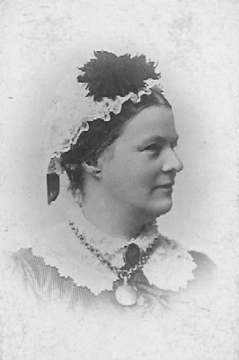 EMILY VALENCE circa 1860-65
Abstract. MPA Ainslie 23.10.17

