........ an attention to the pleasures of paper-folding prompts us to think differently about the sensuous delights of intricate engagements with paper, from building geometrical models or paper instruments to the complex series of folds needed to close a letter (‘Letterlocking’). A seventeenth-century painting, in the style of Jacob Toorenvliet, shows four observers (women and men, children and adults) appreciating a delicate toy, designed to twist and turn in the breeze (figure eighteen).

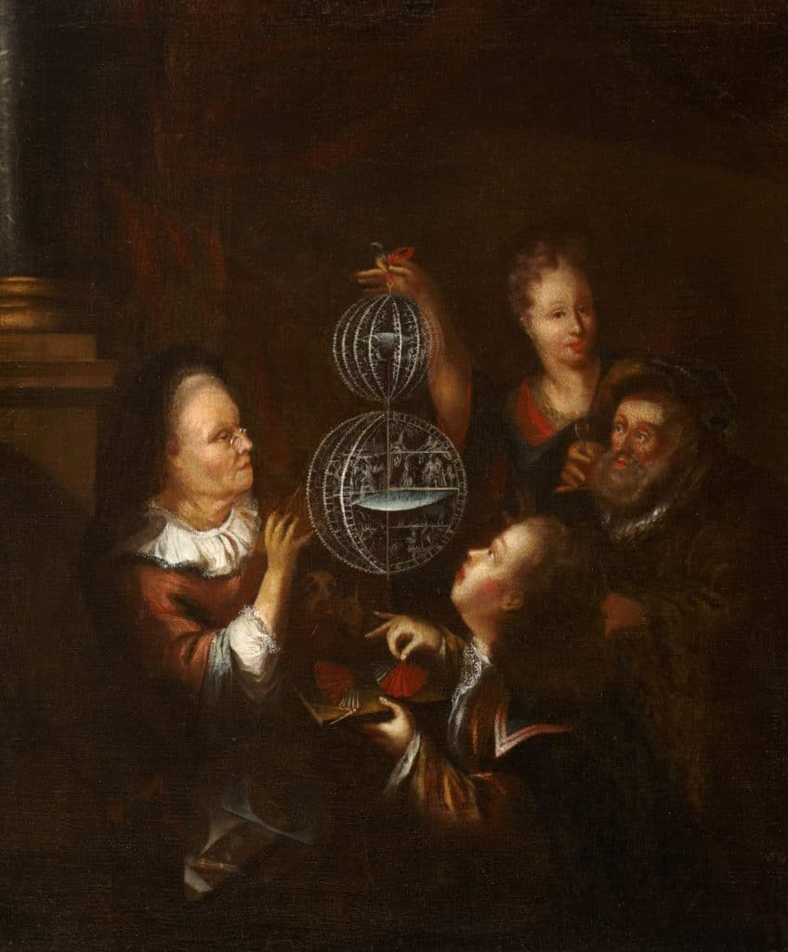

Figure eighteen: ‘Watching a paper wind toy’, style of Jacob Toorenvliet 1640-1719), last quarter of the seventeenth century, British Optical Association Museum, LDBOA1999.178. © The College of Optometrists, London.

The figure in the foreground is pinching a pleated object between two fingers, probably a paper fan used to set the model moving. Letters around the edge of the model read ‘MEMENTO MORI’ and repeat the message in Dutch (‘GEDENCK TE STERV[EN]’), reminding the viewer that she is as fragile as this trembling globe.

