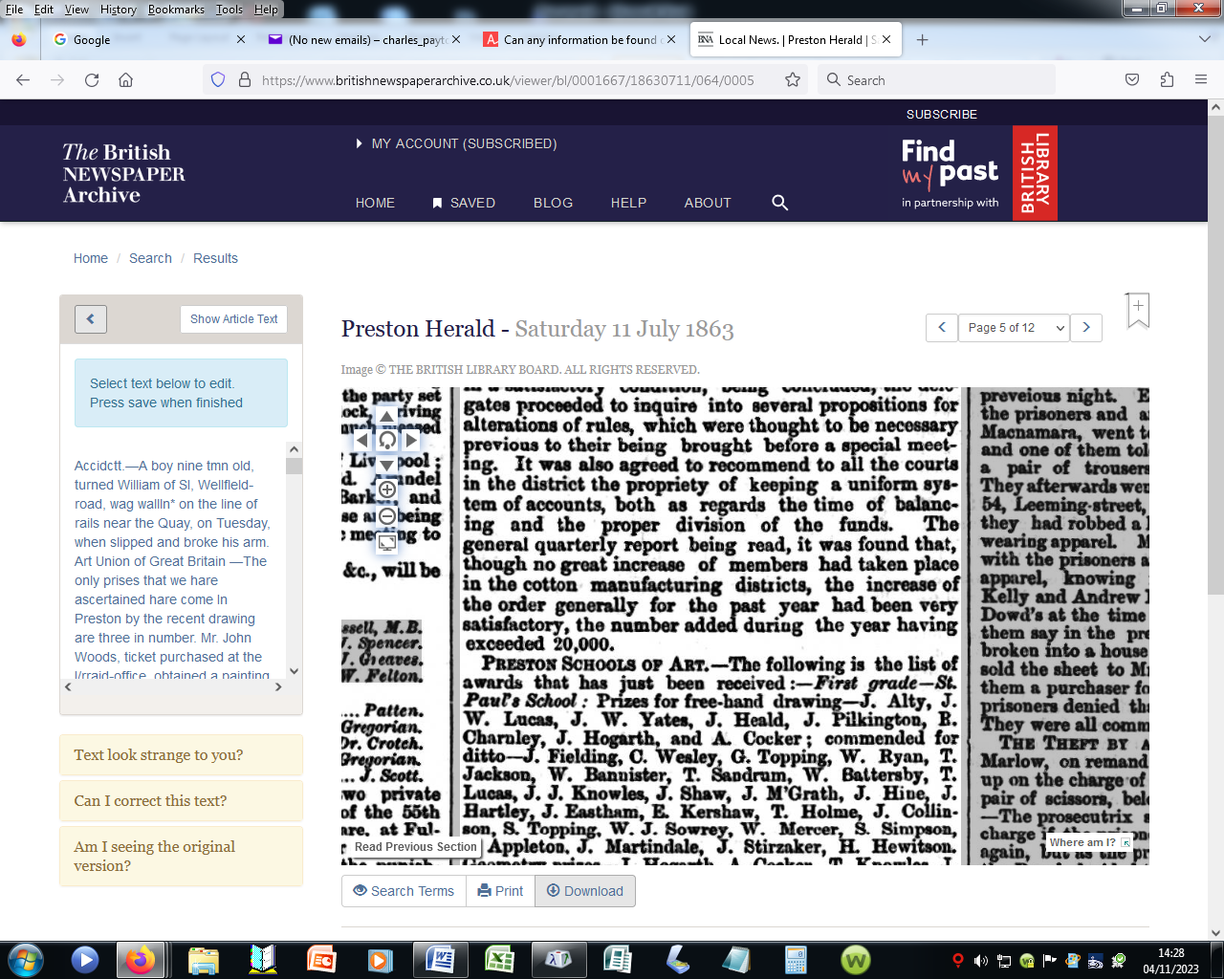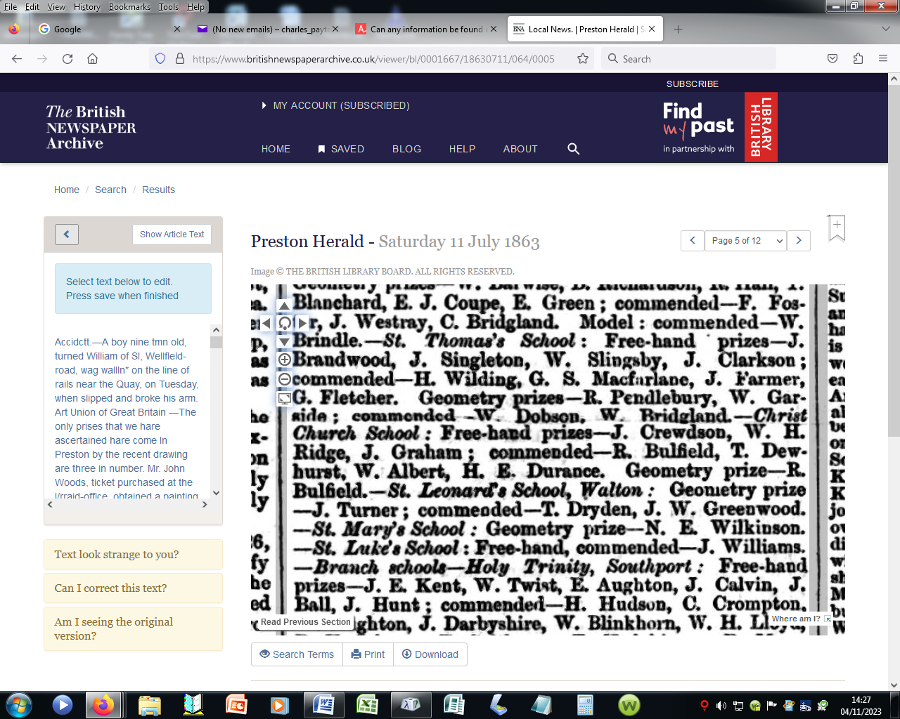



Fleetwood Chronicle - Friday 09 September 1932

Image © Successor rightsholder unknown. Please contact us via support@britishnewspaperarchive.co.uk if you wish to claim rights to this title.. Image created courtesy of THE BRITISH LIBRARY BOARD.



Lancashire Evening Post - Tuesday 18 February 1947

Image © National World Publishing Ltd. Image created courtesy of THE BRITISH LIBRARY BOARD.

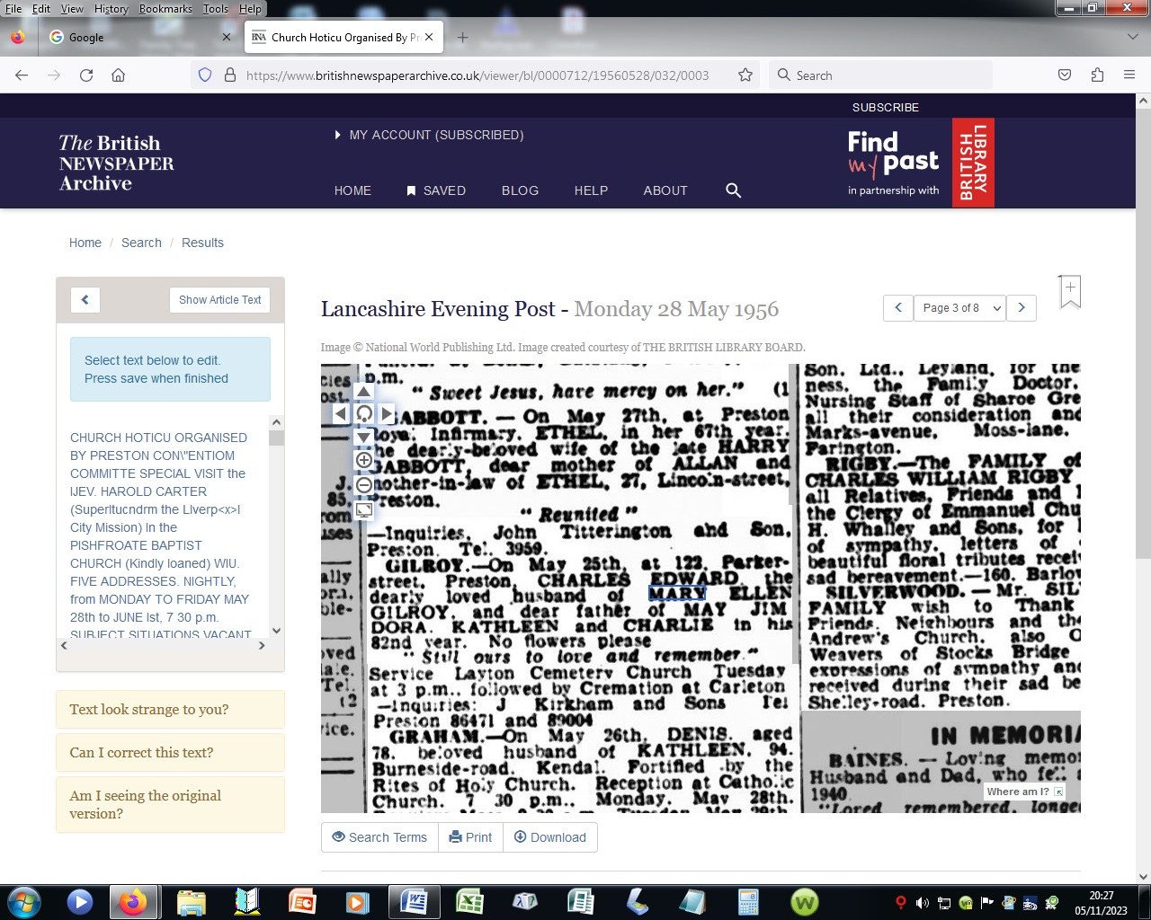

# Preston Herald - Saturday 11 July 1863

**Image © THE BRITISH LIBRARY BOARD. ALL RIGHTS RESERVED.**

