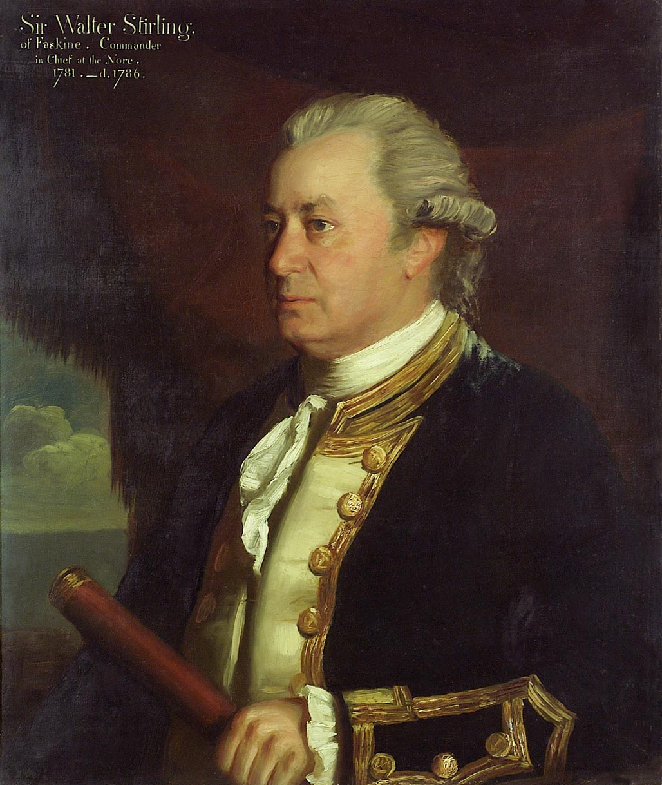
A half-length portrait in captain's, over three years, full-dress uniform, 1774-87. The sitter wears his own hair, powdered, and a scratch wig and holds a telescope in his left hand. At an advanced age, in 1780, he was Captain of the 'Gibraltar', 80 guns, under Sir Samuel Hood and was present at Rodney's capture of St Eustatius in the West Indies from the Dutch in 1781. He was selected to take home dispatches and was knighted on arrival. In 1782, he was Commodore at the Nore. The background consists of rock with a glimpse of the sea on the left. The portrait is inscribed 'Sir Walter Stirling of Faskine, Commander-in-Chief at the Nore 1781-d.1786'. The artist was a pupil and assistant of Reynolds, and practiced portraiture at Plymouth until 1777, when he went to Italy to study before settling in London in 1781. The artist's signature is unseen.
Date made | circa 1780

