Stephen Adye = Clara Anne Payne

(1706-1756)

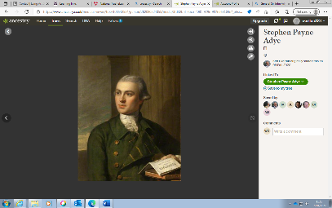

Major Stephen Payne Adye = Elizabeth

(1743-1794) Hitchcock

(1747-1810)

Spranger Adye (1755-1755)

Abraham Charles Adye (1748-1815)

Martha Willett Adye (1747-?)

John Willett Adye

(1744-1815)

Captain Ralph Willett Adye (?-1808)

Major-General Stephen Galway Adye

(1772-1838)

Captain John Miller Adye RN

(1789-1847)

Major James Pattison Adye = Jane Mortimer Kelson

(1783-1831)

Major Ralph Willett Adye

(1764-1804)

William Henry Fitzpatrick = Winifreda Adye

Watson – Armstrong (1860-1914)

(1863 – 1941)

General Sir John Miller Adye = Mary Cordelia Adye

(1819-1900)