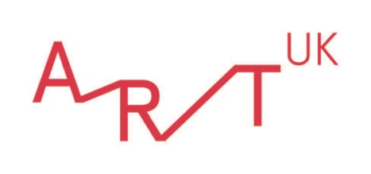

Investigate 3D shapes

About this resource

How is a cube different from a cuboid? What are the properties of a sphere? Where can we see 3D shapes around us?
This resource uses artworks to provide an introduction to common 3D shapes and their properties.
Through whole class discussion and activities students will:
- learn to recognise and describe common 3D shapes
- find out about the properties of 3D shapes
- explore and discuss where we can see 3D shapes around us in everyday life

This Maths and Art and Design resource offers a series of teacher-led, whole class or group activities. The questions and discussion suggestions are voiced directly to students, allowing the resource to be easily presented to the class. Teachers' guidance notes are included as well as activity ideas for exploring shapes.
The resource can be used together as a lesson plan or as individual components to integrate into your own scheme of work. It is designed for CfE Level 1 / KS 1 students / National Curriculum Wales Foundation Phase Yrs 1 & 2, but can also be adapted for younger age groups.

Curriculum links
National Curriculum for England
Mathematics: Geometry - Properties of shapes
Year 1: Pupils should be taught to recognise and name common 3-D shapes, including:
- 3-D shapes [for example, cuboids (including cubes), pyramids and spheres]
Year 2: Pupils should be taught to:
- identify and describe the properties of 3-D shapes, including the number of edges, vertices and faces
- identify 2-D shapes on the surface of 3-D shapes [for example, a circle on a cylinder and a triangle on a pyramid]
- compare and sort common 3-D shapes and everyday objects

Northern Ireland Curriculum
Mathematics and Numeracy: Shape and space
Pupils should be enabled to:
- sort 3-D shapes in different ways;
- make constructions, pictures and patterns using 3-D shapes;
- name and describe 3-D shapes
Art & design
- use a range of processes

Scotland's Curriculum for Excellence
Numeracy and mathematics
- I have explored simple 3D objects and shapes and can identify, name and describe their features using appropriate vocabulary (MTH 1-16a)
Art and design
- I have the opportunity to choose and explore a range of media and technologies to create images and objects, discovering their effects and suitability for specific tasks (EXA 1-02a)
- I can create and present work using the visual elements of line, shape, form, colour, tone, pattern and texture (EXA 1-03a)

National Curriculum for Wales (2008)
Mathematics: Shapes
Year 2
- recognise and name regular and irregular 3D shapes, understand and use the properties of shape

National Curriculum for Wales (2022)
Mathematics
Geometry focuses on relationships involving shape, space and position, and measurement focuses on quantifying phenomena in the physical world.
Progression step 2:
– I have explored two-dimensional and three-dimensional shapes and their properties in a range of contexts.
Expressive Arts
Exploring the expressive arts is essential to developing artistic skills and knowledge and it enables learners to become curious and creative individuals.
Progression step 2:
– I can explore how and why creative work is made by asking questions and developing my own answers.
Responding and reflecting, both as artist and audience, is a fundamental part of learning in the expressive arts.
Progression step 2:
– I can give and accept feedback as both artist and audience.
Creating combines skills and knowledge, drawing on the senses, inspiration and imagination.
Progression step 2:
– I am beginning to demonstrate resilience and flexibility in approaching creative challenges.
– I can use creative materials safely and with some control under supervision.

What are 3D shapes?
https://artuk.org/discover/artworks/from-pyramid-sphere-cube-pyramid-290615

- 3D shapes are solid shapes that have three dimensions – length, depth, and width.
- 3D shapes look like objects that you could pick up. They are different from 2D shapes which are flat.
- 3D shapes have edges and corners (called vertices) where the edges meet.
- 3d shapes also have sides or surfaces which are called faces. These faces are often 2D shapes.

Teacher notes
Introduce 3D shapes to your students. The list above may be helpful to introduce the main properties of 3D shapes. It would also be helpful to have examples of 3D shapes in the classroom so that students can more easily understand their properties as you explain them.
If you don't have fabricated 3D shapes as a classroom resource, you could use everyday objects: e.g. dice, boxes, or books as examples of cubes and cuboid shapes; a ball or an orange as an example of a sphere; and a tin can as an example of a cylinder. (Other 3D shapes may be harder to find!)
- Point out the length, depth and width of 3D shapes using an object.
- Show students where the edges, vertices, and faces of 3D shapes are.

https://artuk.org/discover/artworks/knowing-198405

Cubes
Compare the shapes in these two pictures.
- What shapes can you see?
- How are the shapes different?

https://artuk.org/discover/artworks/homage-to-the-square-r-nw-iv-211100

https://artuk.org/discover/artworks/untitled-256301

Shape comparison
The first picture shows a painting of an orange square (with smaller squares inside it).
There are also some squares in the second picture. Can you find them?
These squares are joined at the edges to become a 3D shape. This shape is called a cube.
The cube in this picture is a sculpture and the artist has decorated its faces with patterns.
Now for some detective work…
- Can you work out how many faces a cube has?
- Can you work out how many edges a cube has?
- Can you work out how many vertices (or corners) a cube has?

Properties of a cube
A cube has 6 faces, 12 edges, and 8 vertices
All of the faces of a cube are squares.
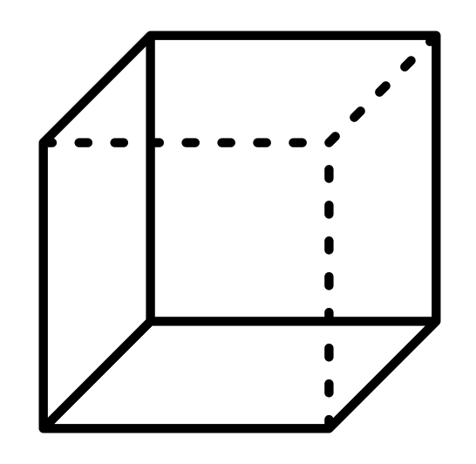

Cuboids
Look at this picture. It shows stone sculptures that are also benches.
https://artuk.org/discover/artworks/benches-301872
- Describe the shape of the benches.
- Can you see any 2D shapes?

The bench looks a bit like a stretched cube. This 3D shape is called a cuboid. A cuboid is different from a cube because not all of its faces are squares.
- Did you spot the rectangles?

Properties of a cuboid
- Like a cube, a cuboid has 6 faces, 12 edges, and 8 vertices.
- 2 of the faces of the cuboid bench are square and the other 4 faces are rectangles. But sometimes all the faces of a cuboid are rectangles.
- The opposite faces of a cuboid are always the same size and shape.
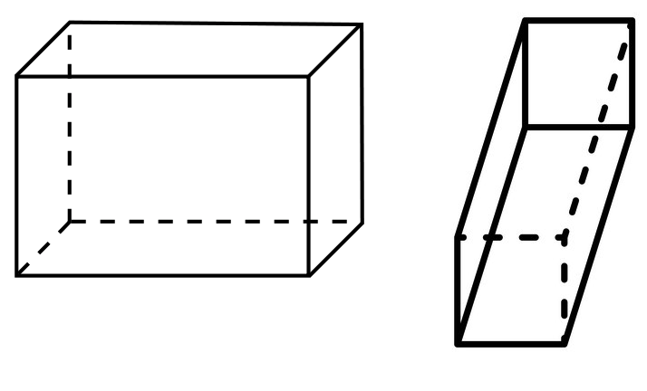

Cuboids are all around us...
- Look around your classroom, can you see any cuboids?
- Look out of the window, can you see any cuboids?

https://artuk.org/discover/artworks/you-see-an-office-building-3-290557

Teacher notes
It might be helpful to have examples of different types of cuboids to show your students. (E.g. books and boxes with different dimensions.)
- Point out the faces of a cuboid, its vertices, and its edges.
- Point out the opposite faces to demonstrate that these are the same size and shape.

Spheres
This 3D shape looks like a ball. It is called a sphere.
- Think of some words to describe a sphere.
- Can you think of any objects that are shaped like a sphere?

https://artuk.org/discover/artworks/oranges-204219
Now let's investigate spheres...
- Does a sphere have any vertices?
- How many faces does a sphere have?
- Where are its edges? (The edges of 3D shapes are where two faces meet.)

Properties of a sphere
A sphere has 1 curved face and no vertices. It doesn't have any edges because it only has 1 face.
Teacher notes
Encourage students to think of descriptive words to describe a sphere. This will help them in understanding its properties. Possible words might be 'round', 'curved', 'smooth' or 'rolling'.
- Use a ball or an orange to point out that the surface of a sphere is its one curved face.
- Explain that edges are where two faces meet, so a sphere doesn't have any edges

Pyramids and cones
Here is another 3D shape. This shape is called a pyramid.
https://artuk.org/discover/artworks/pyramid-and-canopies-247951
- How many faces do you think it has?
- How many vertices do you think it has?

About the pyramid
This pyramid has 1 square face at the bottom and 4 triangular faces that meet at the top.
Pyramid variations
Not all pyramids are the same. Some pyramids have a triangular face at the bottom and 3 triangular faces that meet at the top.
Other pyramids have pentagonal or hexagonal or octagonal faces at one end… with 5, 6 or 8 triangular faces that come to a point opposite!
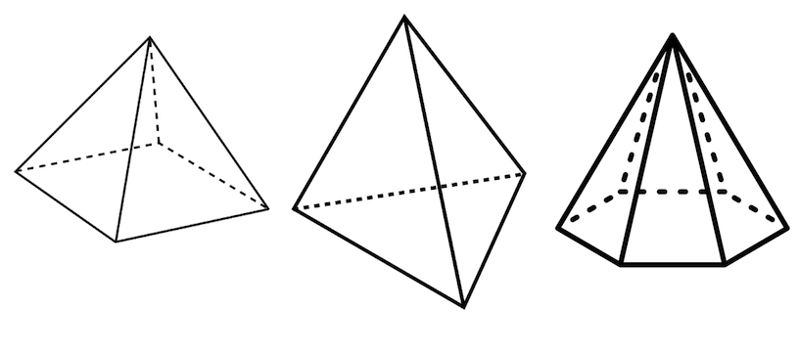
Teacher notes
If you don't have a pyramid-shaped object to explain the properties of a pyramid, use the diagrams above.
Show students where the faces, edges, and vertices are, and how pyramids have a vertex at one end and a shape with three or more sides (a polygon) opposite.
Did you know...?
The Ancient Egyptians built pyramid-shaped tombs where they buried their kings (pharaohs).
The tallest pyramid was 146.5 metres high when it was built – that's one and a half times taller than Big Ben!
https://artuk.org/discover/artworks/the-water-of-the-nile-205080

Cones
Look at this picture. It shows a sculpture made from 3D shapes.
- Do you know what this shape is called?

https://artuk.org/discover/artworks/cones-254446
This sculpture is made of 2 cones.
A cone looks a little bit like a pyramid because it comes to a point (or vertex) at one end. But instead of a square, triangle or another straight-sided shape at the other end, it has a circle.
Spot the difference!
- Can you spot the differences between a cone and a pyramid?
- Compare the edges faces and vertices of the shapes in this picture.

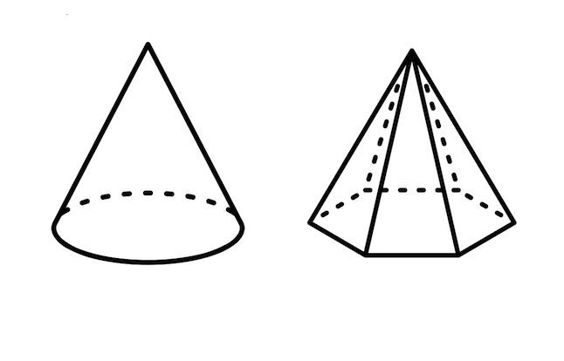
Pyramid vs. cones
A cone has a circle at its base, the pyramid has a shape with straight sides. Do you know what this shape is called? (It might help to count its sides.)
A cone only has 1 edge. This pyramid has 12 edges.
The edge of a cone is curved. All the edges of a pyramid are straight.
A cone only has 2 faces – the circular face and the curved face that rises to a point (or vertex). This pyramid has 7 faces.
Cones are all around us...
This is a painting by Scottish artist Alexander Guy.
- What does the painting show?
- Can you see any cones?

https://artuk.org/discover/artworks/the-ice-cream-van-84343
What does the picture below show? Can you spot the cone?
https://artuk.org/discover/artworks/equestrian-monument-to-the-duke-of-wellington-254058
This sculpture shows the Duke of Wellington on a horse. The Duke of Wellington was a famous soldier and was also prime minister of the United Kingdom 200 years ago.
The statue stands outside the Gallery of Modern Art in Glasgow. The Duke is not meant to have a traffic cone on his head – but people keep putting it there!

Cylinders
This 3D shape is called a cylinder.
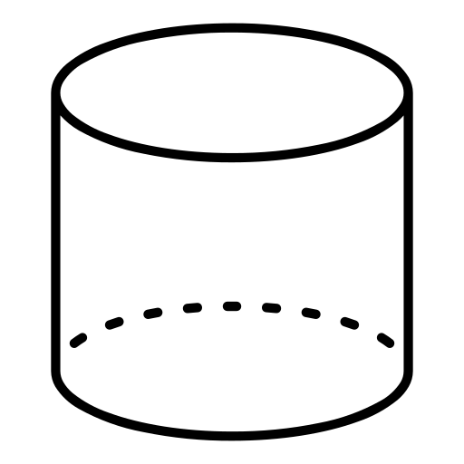
- How many faces does a cylinder have?
- Does it have any vertices?
- Can you see any 2D shapes in this cylinder?

Properties of a cylinder
A cylinder has 2 circles at opposite ends. It has 3 faces altogether – the 2 circles and the curved face that joins them.
A cylinder has 2 edges and no vertices.
Teacher notes
You could use a tin can to point out the properties of a cylinder.
Show students where the faces of a cylinder are, and explain that because a cylinder is formed of 2 circles and a longer curved face, it has no vertices.
Cylinders are all around us...
- Can you see any cylinders in these paintings?
- Can you think of anything else that is shaped like a cylinder?

https://artuk.org/discover/artworks/swiss-roll-199492
https://artuk.org/discover/artworks/crannoch-94232
https://artuk.org/discover/artworks/tea-30219
https://artuk.org/discover/artworks/jacky-ickx-ferrari-canadian-grand-prix-1970-25572

Activity suggestion: 3D modelling challenge
Challenge your students to make 3D shapes from modelling material (such as Plasticine) in response to descriptions of 3D shapes and their properties.
Students could work in groups or pairs so that they can discuss the descriptions and clues.
Descriptions could be, for example:
- This shape has 5 faces and 5 vertices. One of the faces is a square and the other faces are triangles. (Extra clue: The Egyptians built these for their Pharaohs)
- This 3D shape has no vertices and no edges. (Extra clue: this 3D shape can roll really well!)
- This 3D shape has one vertex and a circle shape opposite the vertex. (Extra clue: In the summer you might enjoy an ice cream that is this shape!)

Differentiation
For older or more able students use the descriptions of the shapes' properties only. For younger and less able students, you may need to provide extra clues.

Find out more

Art UK resource: Investigate 2D shapes
https://artuk.org/learn/learning-resources/investigate-2d-shapes

BBC Bitesize: What are 3D shapes?
https://www.bbc.co.uk/bitesize/topics/zjv39j6/articles/zcsjqty

Tate Kids: Who is Barbara Hepworth?
https://www.tate.org.uk/kids/explore/who-is/who-barbara-hepworth

Stories

David Nash: Sculpting with nature
https://artuk.org/discover/stories/david-nash-sculpting-with-nature

Sculpting Lives podcast: Barbara Hepworth
https://artuk.org/discover/stories/sculpting-lives-podcast-barbara-hepworth

Remembering the sculptor Philip King
https://artuk.org/discover/stories/remembering-the-sculptor-phillip-king

Art UK

Art UK is the online home for every public art collection in the UK. We are a charity, and our website represents a collaboration between over 3,300 British institutions. Through our work, we make art available for everyone – for enjoyment, learning and research.

Art UK is the operating name of the Public Catalogue Foundation, a charity registered in England and Wales (1096185) and Scotland (SC048601).

https://www.artuk.org

