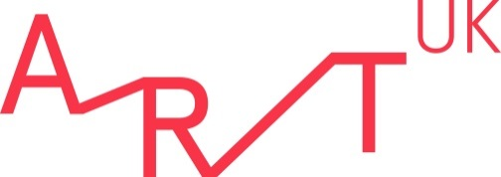

Art UK Work Experience Application Form

Please complete all sections of this form with as much detail as possible and return, along with your completed Equality, Diversity and Inclusion Monitoring Form to recruitment@artuk.org

About You:
Name
Home address
Email address
Mobile telephone number
Date of birth
You must be aged over 16 to apply
Name of school/university
Current year of study
Do you have any access requirements?  If “yes” please include details. | Yes/No

Work Experience Opportunities:
Please indicate your three preferred date options in order of preference i.e. Week 4, Week 7, Week 1
Where did you see the opportunity advertised?

Your Interests:
Please tell us why you’d like to undertake work experience at Art UK?
How do you plan to continue your interest in art history i.e. in your spare time, at FE/HE, or in your future career?
Do you have a favourite artistic style or movement?
Do you use social media? If so, which platforms do you use?
What elements of the work that Art UK does are you particularly interested in?
What do you hope to get out of your work experience with us?

Information in support of your application (200 words max)
Please list any skills that you believe are relevant to the placement (i.e. interpersonal, computer, technical, administrative).

Parent/Guardian Permission:
If you are aged under 18, please ask a parent or guardian to complete this section of the form.
Name
Relationship to work experience applicant
I consent to my child completing an unpaid work experience placement at Art UK | Yes/No
I consent to Art UK processing my child’s personal data in order to process their work experience application. I have read the data protection statement at the bottom of this form and understand. | Yes/No

Data Protection Statement:
The information you give when completing your work experience application form will be used in accordance with the EU General Data Protection Regulation. It will be used to enable the organisation to create electronic and paper records of your application, to enable the application to be processed and to enable the organisation to compile statistics. No statistical information used will be published that would identify you as an individual. The information relating to your application will be kept securely. It will be kept for three months if you are unsuccessful in your work experience application and for the duration of your work experience and three additional months if you are successful. Please read our privacy policy (www.artuk.org/footer/privacy-policy) for more details on how we use personal data and information.

